Dear Parents/Carers,
Here is an overview of what your child will be learning this half term across the different areas of learning. Our topic for the first half of the Spring term is called ‘All Creatures Great and Small’. The topics we choose are led by the children’s interests and usually encompass several areas of learning. For this reason, the topics may change to reflect the direction the children wish to take their learning.
Each week we will be taking on a different animal theme using the following books to introduce our focus animals.
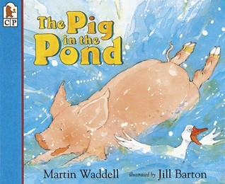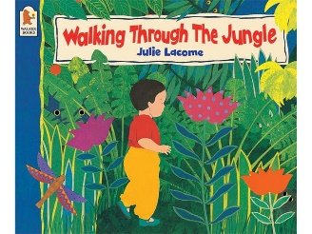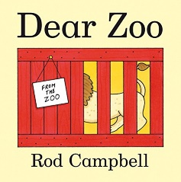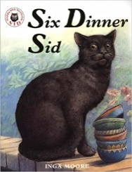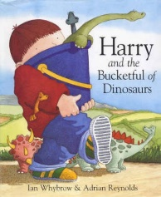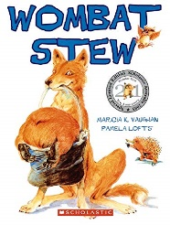
In our Literacy we will be continuing to teach letters and sounds, targeting each of the phonics groups with the letters and sounds they need support with. Throughout each lesson children will continue to recap sounds and learn a new sound, practise blending letter sounds for reading and identifying sounds in words for writing. We will encourage the learning of tricky words which cannot be sounded out e.g. the, was, go. We will continue to practise our correct letter formation.

This half term in our Mathematics we will continue to deepen our understanding of number. We will continue to recognise and write the numerals, break each number down into smaller number (i.e. 3 can be made up of three ones, a two and a one, or a three and a zero), find one more and one less than a number, start adding and subtracting numbers. In addition to number we will be comparing length, weight and capacity. To do this we will begin to compare and order objects by these measures and build up vocabulary so that children are able to compare objects in their play. We will also be learning about 2D and 3D shapes.

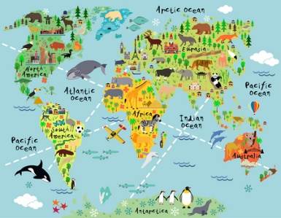
Through our All Creatures Great and Small topic, we will use Understanding the World to recognise some environments that are different to the one in which we live as well as recognising some similarities and differences between life in this country and life in other countries. We will also learn about Chinese New Year, recognising that people have different beliefs and celebrate special times in different ways.

We will continue to have a weekly circle time to encourage the children to talk about their thoughts and feelings as part of our Personal, Social and Emotional Development. This term our focus will be on thinking about our own and others feelings.

In our Physical Development we will continue to develop our fine and gross motor skills using a range of strategies. These will include messy play and dough disco. We will be working on scissor skills. This is essential for all areas of the curriculum with the ultimate aim of every child confidently holding a pencil with a tripod grip and feeling confident whilst forming all of their letters. We will also further develop our ability to move with control and coordination in our PE lessons.

In our Expressive Arts and Design, we will continue to develop storylines in our imaginative play, listen to a variety of music and play percussion instruments. We will be using different materials to create pictures and models of animals.
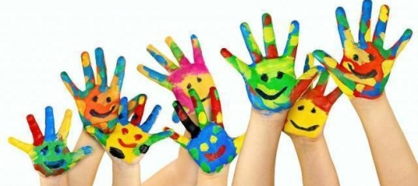

It would be fantastic if you could continue to support your child by reading to them regularly at home and encouraging them to complete reading their school reading books as independently as possible. Please continue to practise recognising the letter sounds and high frequency words that are in your child’s pencil case, as well practising letter formation and spelling words by encouraging your child to write the sounds they can hear.

