Foundation Stage Spring 2 Curriculum News
Dear Parents/Carers,
Here is an overview of what your child will be learning this half term across the different areas of learning. Our topic for the second half of the Spring term is called ‘Here, There and Everywhere’. The topics we choose are led by the children’s interests and usually encompass several areas of learning. For this reason, the topics may change to reflect the direction the children wish to take their learning.
Each week we will be taking on a different transport theme using the following books to introduce our focus vehicle.
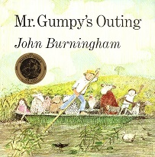
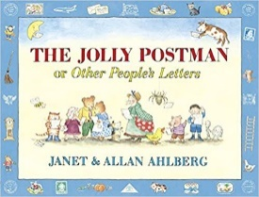
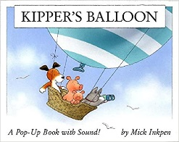
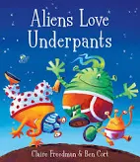
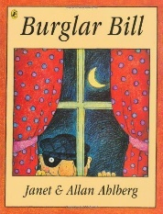

In our Literacy we will be continuing to teach letters and sounds, targeting each of the phonics groups with the letters and sounds they need support with. Throughout each lesson children will continue to recap sounds and learn a new sound, practise blending letter sounds for reading and identifying sounds in words for writing. We will encourage the learning of tricky words which cannot be sounded out e.g. the, was, go. Also, we will be encouraging the continued recognition for reading and writing of the decodable high frequency words. We will continue to practise our correct letter formation.

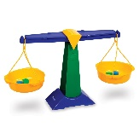
In Mathematics, we will be using the theme of Here, There and Everywhere as a stimulus for many mathematical activities. We will be consolidating one more/one less than a number. Also, sorting objects according to different criteria. We will continue to learn about subitising numbers and we will be exploring the composition of numbers to 10.

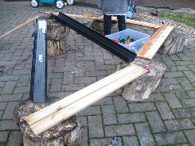
Through our Here, There and Everywhere topic we will be developing our Understanding of the World by observing our local environment and looking at simple maps and globes and Google Earth. We will be investigating forces at work such as ‘pushes and pulls’ when looking at vehicles and using ramps with toy cars. We will be disassembling and assembling an old bike using tools. Also, we will be learning about old and new transport including cars, bicycles and trains. We will also learn why we celebrate Mother’s Day and what Christians celebrate at Easter.

We will continue to have a weekly circle time to encourage the children to talk about their thoughts and feelings as part of our Personal, Social and Emotional Development. This term our focus will be on how to become more confident as speakers and listeners and developing our ability to speak to others about our own wants, needs and opinions thinking about our own and others feelings. We will also learn about life skills, such as road safety.

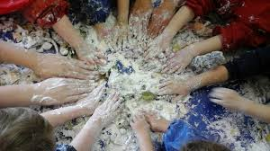
In our Physical Development, during PE lessons, we will be experimenting with different ways of moving to improve control and coordination. We will be using small equipment as obstacles to develop our ability to negotiate space, such as when they are playing chasing games. Within the classroom we will continue to practise fine motor and pencil skills to support the children’s ability to write and form their letters correctly. We will be using a variety of tools, objects and construction equipment to develop increasing physical control.

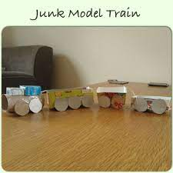
In Expressive Arts we will continue to build a repertoire of songs and dances, such as singing The Wheels on the Bus, The Runaway Train and The Yellow Submarine. We will listen to a variety of music and instruments. We will continue to combine and manipulate different materials in learning activities such as painting, drawing and creating vehicles out of ‘reclaimed materials.’

Please continue to support your child by reading to them regularly at home and encouraging them to complete reading their school reading books as independently as possible. Please continue to practise recognising the letter sounds and high frequency words that are in your child’s pencil case, as well practising letter formation and spelling words by encouraging your child to write the sounds they can hear.

