Homework Grid Year 2 - Summer 2
Compulsory Tasks
Times Tables  -Practise your x tables daily.  x2, x5, x10  Challenge x3, x4  Hit the button is a useful site for this. |  | Spelling  -Practise your spellings on your tricky card every day. If you can’t find your tricky card google Year 1 / 2 common exception words and practise some of those. |  | Reading  -Read daily. You could use Oxford Owl or the online library service if you are short on physical books.
Optional Tasks (you must choose at least 2)
Maths  Practise working out multiplication and division questions using a number line by jumping in groups. Read the symbol carefully to see the difference between the two methods. There is an example at the end of this document.  Challenge: Try some questions that have remainders or use the inverse. | Art  Paint a picture of a famous British royal.  Challenge - can you use the tones skills learnt this year by adding white or black to your colours to create a shade or tint? |  | Topic  Find out about a famous British King or Queen and write your research in your own words ensuring you use capital letters and full stops. |  | Science/ PE  Continuing from our learning during Sport Relief - carry out an investigation of your families PE skills. For example can adults run faster than children? Or can people with longer legs jump higher. Think about what you will measure and how you can record your findings in a table.  Challenge – write a prediction of what you think might happen before you start and a conclusion showing what you found out at the end.
English  Write an information text with subheadings about a King or Queen.  Challenge – Can you use questions as your subheadings? Can you use captions or diagrams? | Topic  Find out about the royal family and investigate their family tree. Create a family tree for your own family. |  | PSHE  Keep a positivity diary for a week. What has been good about your day? For example, enjoying positive friendships. |  | English  Write a letter to the Queen telling her about you and asking some questions about her. If you send it off you might get a reply from her office (this usually takes a while).
Maths  Draw out your day in clocks. What did you do and at what time? Draw the clock and a picture of you doing the activity.  Challenge: Include some things that happened at 5 minute intervals (Not O’ Clock, Half Past or Quarter Past) or some ‘to’ times. | Outdoor Learning:  Using natural materials, create a collage of a famous King or Queen and take a photo of it to share. |  | DT/ History  Find out about royal clothing in history and design a costume for a King or Queen to wear.  Challenge – You could create the costume either life size or for one of your toys to wear. |  | PE  For five days each week, complete a five minute daily exercise activity.
Whilst our homework is not usually presented in this way in Year 2, it may be useful to have these tasks available as part of your home learning.

Choose one or a couple of levels - you do not need to do all of them!

Task:
10 ÷ 2 = 3 x 5 = 20 ÷ 5 = 4 x 10 =

Challenge:
25 ÷ 5 = 6 x 10 = 15 ÷ 3 = 9 x 2 =

Super Challenge:
70 ÷ 10 = 3 x 4 = 65 ÷ 5 = 6 x 3 =

Further Challenge (remainders – remember write what’s left as r e.g. 53 ÷ 10 = 5 r3:
67 ÷ 10 = 8 x 3 = 48 ÷ 5 = 5 x 4 =

Extra Challenge:
Change the super challenge questions around to the inverse (opposite). Think about the biggest number being in the right place.

Extra Extra Challenge:
Use the inverse to solve these missing number problems

÷ 6 = 5 5 x = 35

X 3 = 18 90 ÷ = 10

Examples of the method are on the next page:

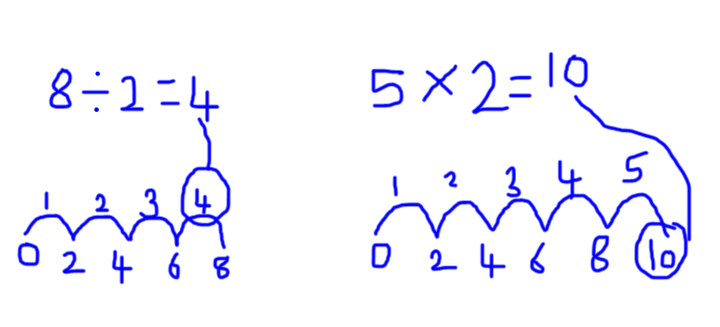

h

