Maths Home-Learning Summer 2, Week 6
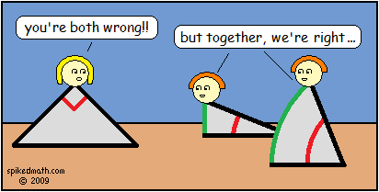
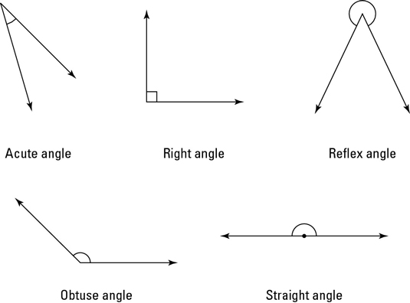
This week’s maths focuses on angles. Remember – we are just recapping aspects of work that we covered earlier on this year. None of these tasks require a protractor, as we know not everyone has one available to them at home, but they do require some background knowledge of angles so it would be really useful to have a look at some of the links on the document ‘Summer 2 – Maths Overview’ for Week 6 before trying the investigations attached.

Investigation 1:

Investigation 2:

