Maths Home-Learning Summer 2, Week 7
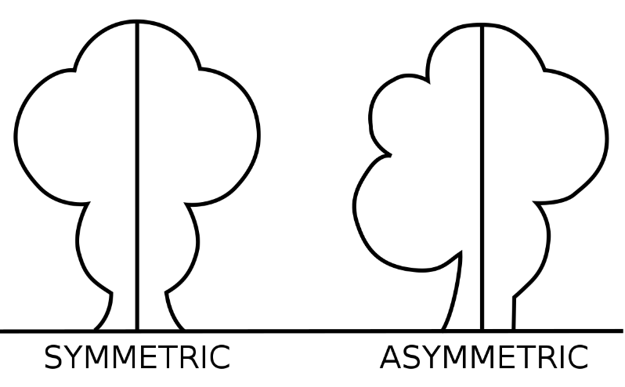
Your focus for your maths work this week is on symmetry and tessellations. As always, it would be really useful to have a look at some of the links on the document ‘Summer 2 – Maths Overview’ for Week 7 before trying the tasks below.
Symmetry Task:
- Have a look at the symmetry investigation attached. How many lines of symmetry can you find in these famous logos?
- Can you create your own logo with at least one line of symmetry?
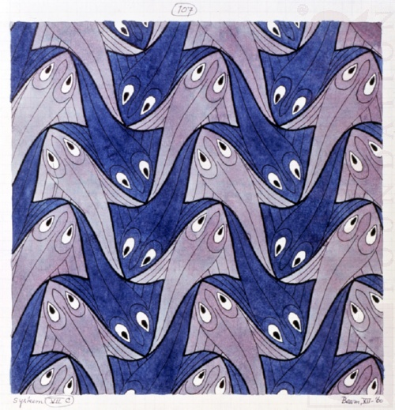
Tessellation Task:
Attached is a link for an interactivity that allows you to create tessellations - can you recreate the patterns using your problem solving skills?
https://nrich.maths.org/13431
ART CHALLENGE
If you’re feeling creative, perhaps you could create a tessellated piece of artwork – MC Escher made some great pieces which could be used to inspire you!

