

***To prepare our children to reach their full potential in a modern, evolving and diverse world.***

HANSLOPE PRIMARY SCHOOL

HEADTEACHER’S WEEKLY NEWSLETTER

**Spring 2 2025 – Week 2**

Comic Relief Information from School Council

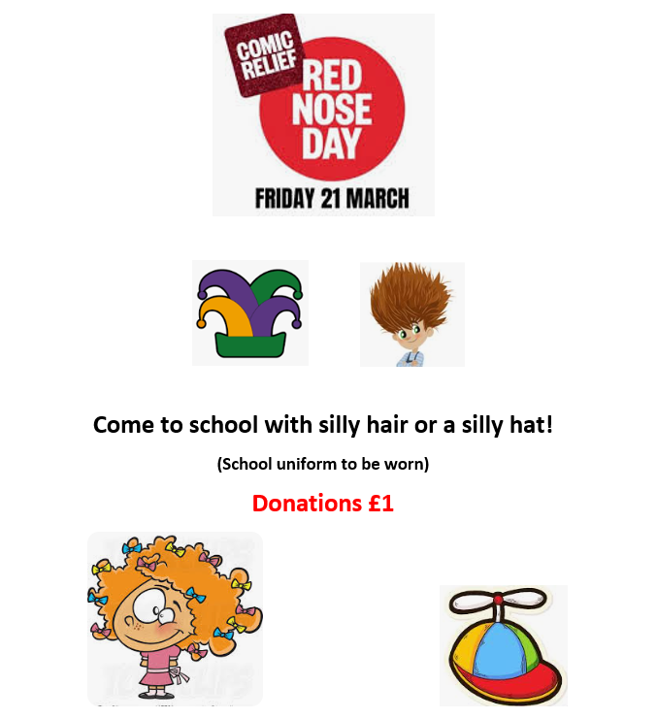



Hanslope School’s Facebook Page

Please join our Facebook group where we post about upcoming events. It’s the best way to keep posted! To join, scan the QR code, or follow the link below!

<https://www.facebook.com/groups/385370060554710/>





Celebrating the Weekly Winners

**TTRockstars**



Winners from last week were Hawthorn.

**House-Points**

Winners from last week were Squirrel House.

Our whole school attendance target is 95% or more for the end of this academic year. Below is a breakdown of each class’s attendance **from the last week of last half term**. Well done to Hazel and Rowan Class for having the highest attendance rate!

Weekly Attendance Figures

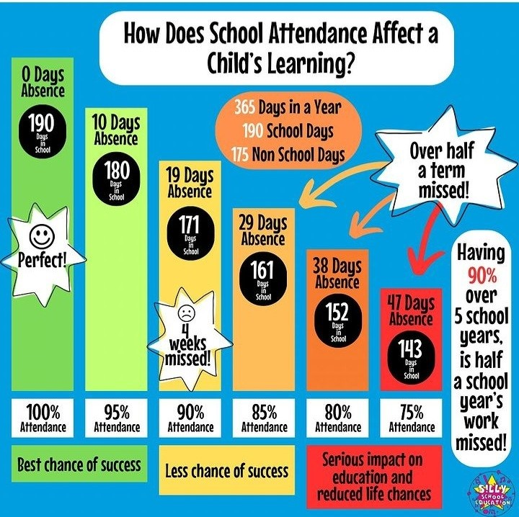

|  |  |  |
| --- | --- | --- |
|  | Holly | 99.5 |
|  | Maple | 99.4 |
|  | Larch | 98.8 |
|  | Laurel | 97.5 |
|  | Alder | 98.9 |
|  | Elm | 99.4 |
|  | Hazel | 100 |
|  | Rowan | 100 |
|  | Cedar | 95.7 |
|  | Redwood | 95.2 |
|  | Blackthorn | 96 |
|  | Hawthorn | 96.4 |
|  | Lime | 94.4 |
|  | Poplar | 90.8 |
| **School Total** | | **97.2%** |

**Did you know…**

If your child finishes the year with **95% attendance** they will still have missed 10 school days, which equates to around **55 hours of learning time**?

In fact, if your child misses just one day in the week it equates to them missing **20%**, with their weekly attendance sitting at just **80%**.

Remember: every day counts!



As a school, we have recently signed up to a fundraising site to help gather support to fund the purchasing of new library books. We are currently raising funds for a bespoke collection of around 50 fiction and non-fiction books to help support the teaching of diversity and inclusion, and inspire our children from different backgrounds. Please follow the link below to support this super important cause!

Thank you so much to those who have donated already – so far we have raised £50! We’d love to hit our target by 25/04 😊

[**Support Our School by Clicking Here!**](https://supportyourschool.org.uk/support-hanslope-primary-school/diverse-and-inclusive-primary-selection)

Fundraising for Books!

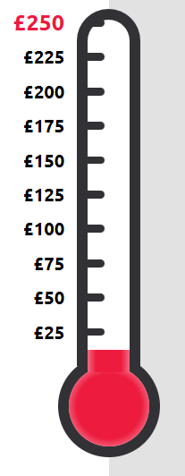



Drawing Competition – Mythical Madness!

What Mythical Madness can you create?

From goblins and giants to unicorns and fairies, your children are invited to pick up their pencils, activate their imaginations and have some creative fun.

Drawings will feature in a special Mythical Madness book series showcasing artwork from across the country, alongside cool fact pages where children will learn all things mythical! Plus, the favourite drawing from each book will be chosen to feature as the front cover.

If your child would like to enter, their teacher has an entry form.

Please complete the information at the top of the form with your child and hand the completed form (with incredible drawing on) to their class teacher who will pass on to Mrs Johnston.

Happy drawing! Mrs Johnston.

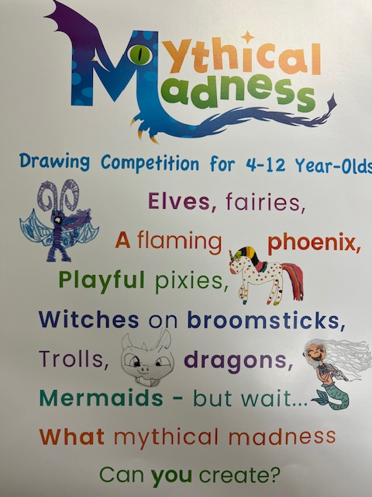

*Recently, we have noticed a significant increase in incorrect and occasionally inappropriate uniform that does not follow the expectations outlined in the parent handbook (available on the website* [*here.*](https://hanslopeschool.co.uk/our-school/prospectus)*) This is especially on days when PE kit is worn. Please see the following reminder below of our key uniform expectations:*

All students are expected to wear their uniform with pride, to and from school and during the school day. The school requires every child to be dressed in the following uniform. All items of clothing should be clearly marked with the child’s name.

**EYFS**

* **Navy or black pair of plain joggers**
* **Polo shirt** – white or light blue with collar
* **Pullover or school sweatshirt** – navy
* **School Shoes (not boots)** – plain black
* **Summer dress/shorts** (not compulsory)

**KS1/KS2**

* **Pinafore dress or Uniform Skirt** – grey or black
* **Long or short uniform trousers** – grey or black
* **Polo shirt or blouse** – white or light blue with collar
* **Pullover, cardigan or school sweatshirt** – navy (red in Yr 6)
* **Summer dress** – blue gingham or striped (this item is not compulsory)
* **Shoes (not boots)** – without heels, plain black
* **Headbands** – black or navy blue

**PE Kit**

* **Plain** black or navy shorts (not branded)
* Navy blue T-shirt
* Plimsolls and trainers (for sport, not fashion trainers)
* Plain dark tracksuit (not branded) **– Winter only – not Foundation Stage**
* We ask that earrings are **not to be worn** on PE days.

**Items which are not part of school uniform**

* Training shoes, fashion shoes, jelly shoes or leisure boots
* Sportswear – e.g. football kit
* Jewellery – except stud earrings. Watch - a simple analogue or digital wrist watch can be worn to school although the school cannot take responsibility for any losses. NO SMART WATCHES CAN BE WORN.
* Nail Varnish – coloured varnish must not be worn.
* No make-up must be worn.
* Hairstyles – pupils are asked to avoid extremes of fashion in either style or colour; any colouring of hair must be of a natural colour. **Long hair must be worn up.**

School Uniform Expectations



Remember, it is possible to sync the school calendar on our website onto your phone by following this link: <https://www.hanslopeschool.co.uk/calendar-help>

Here is a reminder of the upcoming diary dates for you to plan ahead. Please note that all the dates and times shown here are accurate at the time of publication - alterations to the information listed below may happen due to unforeseen circumstances; if this does occur, we will endeavour to let you know as quickly as possible.

**Monday 10th March** – Year 6 SATS talk

**Friday 21st March** – Red Nose Day – come to school with silly hair or wear a silly hat!

**Friday 4th April** – Term Ends

**Tuesday 22nd April** – Term Starts

**Wednesday-Friday 23rd-25th April** – Year 5 Bikeability

**Monday 28th April – Wednesday 30th April** – Year 4 school trip to Liddington

**Monday 5th May** – Bank Holiday

**w.b Monday 12th May** – Year 6 SATS week

**Monday 19th May** – Class and Year 6 Individual Photos

**Wednesday 21st May –** Year 5/6 Residential Parent’s Talk (more details to follow)

**Friday 23rd May** – Term Ends

**Monday 2nd June** – INSET day

**Tuesday 3rd June** – Term Starts

**Wednesday 4th June** – Sports Day (more details to follow)

**Wednesday 11th and 18th June** – Sports Day (reserve days)

**Tuesday 24th June** – School Play @ 6.30 (ticket details to follow)

**Wednesday 25th June** – School Play @ 6.30 (ticket details to follow)

**Wednesday – Friday 2nd – 4th** **July** – Year 5/6 to Osmington Bay

**Friday 11th July** – Reports Out

**Saturday 12th July** – School Summer Fayre

**Monday 14th July** – Transition Afternoon

**Tuesday 15th July** – Transition Morning and ‘Meet the Teacher’ from 3.30-4.30pm

**Thursday 17th July** – Year 6 Leavers’ Assembly (am) and Leavers’ Party (pm)

**Monday 21st July** – Year 6 Enterprise

**Tuesday 22nd** **July** – Term Ends

Dates for your calendar



Website: <https://www.hanslopeschool.co.uk/>

Contact: 01908 510245

Email: [ryan.brown@hanslope.milton-keynes.sch.uk](mailto:ryan.brown@hanslope.milton-keynes.sch.uk)

