*Recall and use the multiplication and division facts up to 12 x 12, multiply and divide mentally. We shall be continuing with our daily timetables practise.

* Place value focus on rounding whole and decimal numbers to the nearest whole number, 10 and 100. We will also be counting in 25s, 100s, 1000s from any given number. We will learn how to read and write Roman numerals.

*Find area and perimeter of rectilinear shapes by counting squares.

*Recognise and be able to add and subtract fractions. Consolidate our knowledge of fractions of amounts and ordering fractions.

* Use our knowledge of formal methods of addition and subtraction and apply them to problems.

**We shall be focussing on maths ‘mastery’ concepts and ensuring that the children are thinking conceptually and recognising numbers presented in a variety of ways, as well as explaining their answers using reasoning.**

**Maths**

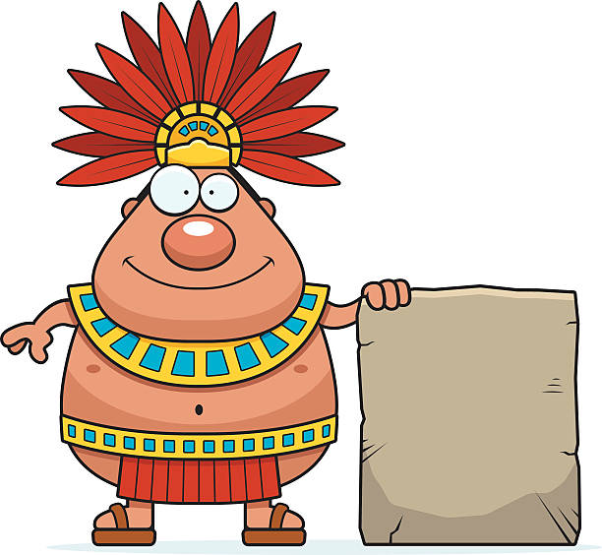Our topic for this half term is ‘The Ancient Maya.’

To kickstart this topic in a fun and interesting way we will, create Mayan headdresses using coloured paper and gel pens. We will also taste different chocolates, created by the teachers, and see if we can tell what ingredients have been added. We will then complete a fun chocolate quiz.

We shall use our historical skills to answer questions such as ‘Who are the Mayan people?’ and ‘What impact do they have on our lives today?’ We shall also be using our knowledge and understanding of chronology to compare and contrast the Mayan period with other periods we have learnt about, for example, the Stone Age. As geographers we shall be looking at where the Mayan people originated from, where they lived and how this is different to where we live. We will look at human and physical characteristics of geography as well as land patterns and we will be using maps to help further our understanding of cities, countries and capital cities.

As scientists, we shall be exploring electricity and learning how to make circuits and learning about conductors and insulators. This shall also involve making careful predictions and conclusions. We will be building upon our knowledge from previous learning to consolidate and extend our skills in scientific enquiry and circuit components.

During RE lessons, we shall be considering whether a holy journey is necessary for believers. This will involve looking at the different holy journeys and assessing how important they are in people’s beliefs and religions. In art we shall be using a variety of techniques and mediums, for example Papier Mâché. We shall evaluate our final results alongside our initial designs. During DT lessons we shall be using our creative skills and design knowledge to create a new packaging idea using different tools and techniques. We will focus closely on the design and finishing techniques of the product as well as evaluate existing products and compare them to our own.

**Home Learning** 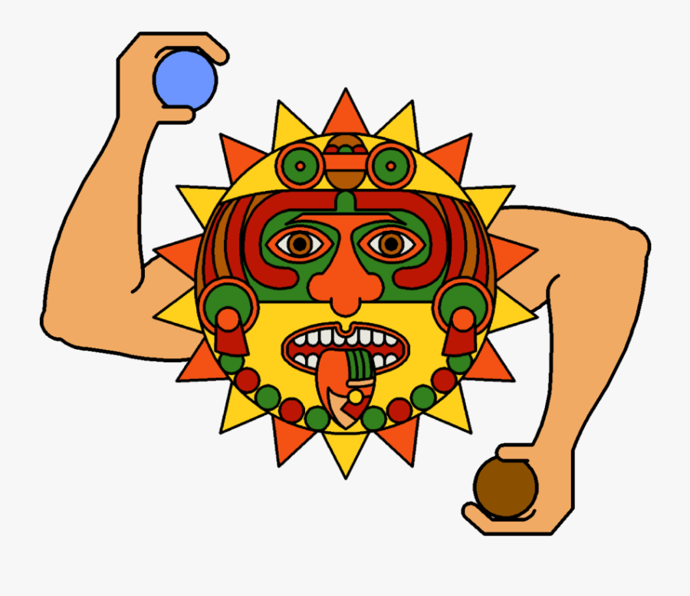

Homework will be set weekly. Spellings, reading and times tables should be done on a daily basis.



*Read a range of texts as a stimulus for our learning (both fiction and non- fiction). Our DEAR book for this term is ‘The Chocolate Tree, a Mayan Folk tale.’ Reading daily and for pleasure will continue to be encouraged both at school and at home.

*Plan and write a myth based on traditional Mayan tales using key writing skills.

* Write a non-chronological report about a chosen element of Mayan life.

* To write a recount of the journey of a cocoa bean, ensuring writing is informal, cohesive and in chronological order.

* We will continue to have weekly spellings and focus will be on transferring these into our written work.

**Topic**

**Spring One 2022**

**Year 3/4 Curriculum News**

**Year 4 The Maya.**