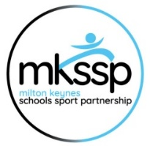
Cross country - Parents Guidance

It is great for the children to have your support at the Cross-Country event. Due to the large number of people, it is necessary for us to ensure that the safety of the children comes first. Please read this document carefully before attending.

- Please note that parking at the event is free public parking, however this means it is not marshalled so please be careful when arriving and departing for the safety of the children!

- Turn up on time and drop your child off at the entrance to the school’s team area. (see map at the bottom)

- Please ensure your child has everything they need (Drink, coat, suncream, snacks etc) as you will not be able to go into the school's area.

- Show respect to everyone – other teams, marshals and officials. Respect decisions made by the officials.

- ALL parents and spectators must stay in the allocated viewing areas (see map). Please do not cross the track or taped areas.

- Schools will agree a process with parents for collecting their child. Please do not enter the school's area once your child is finished as this can cause issues or a safeguarding concern.

- There will be refreshments to buy on site and a photographer.

- Encourage the children taking part to do well and show great sportsmanship.

- It is against the rules to run alongside any of the competitors while they are racing - this could lead to the disqualification of team members.

- Anyone not complying with this guidance will incur point penalties for their school team.

Most importantly
HAVE FUN!!!
Thank you for your time and support.

Milton Keynes Primary School Athletics Association
