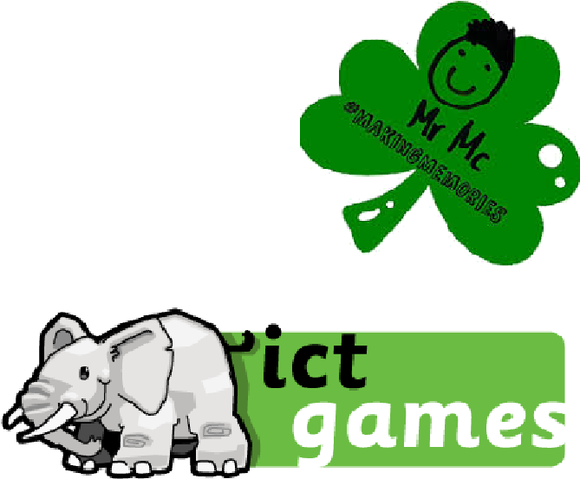
Websites
http://www.ictgames.com/literacy.html
Can be used on computers and soon to be made available on tablets/ipads.
https://www.teachyourmonstertoread.com/
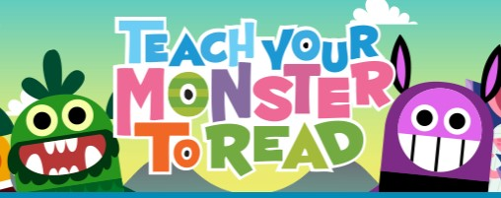
Website is free, just register!
You can download the app on phones, tablets and ipads (costs around £4.99).
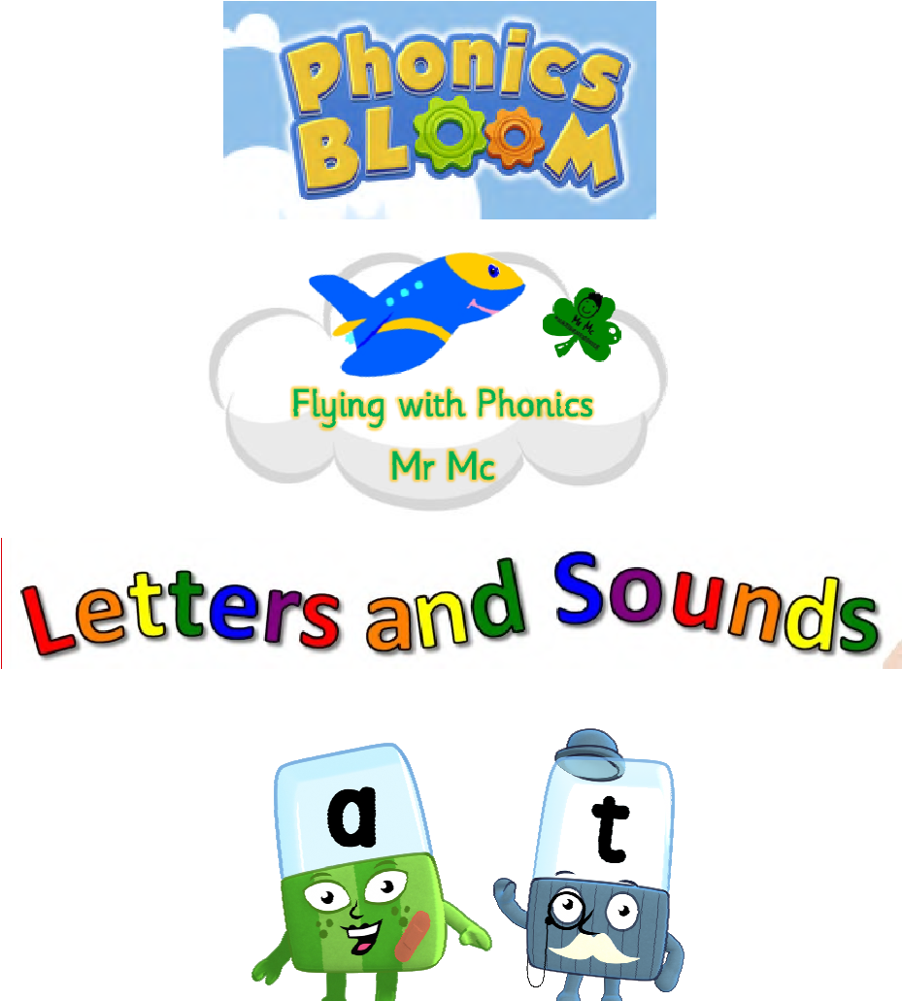
https://www.phonicsplay.co.uk/ freeIndex.htm
https://www.phonicsbloom.com/
https://www.mrmcmakingmemories.com/
http://www.letters-and-sounds.com/
Website and App list compiled by Mr Mc #makingmemories

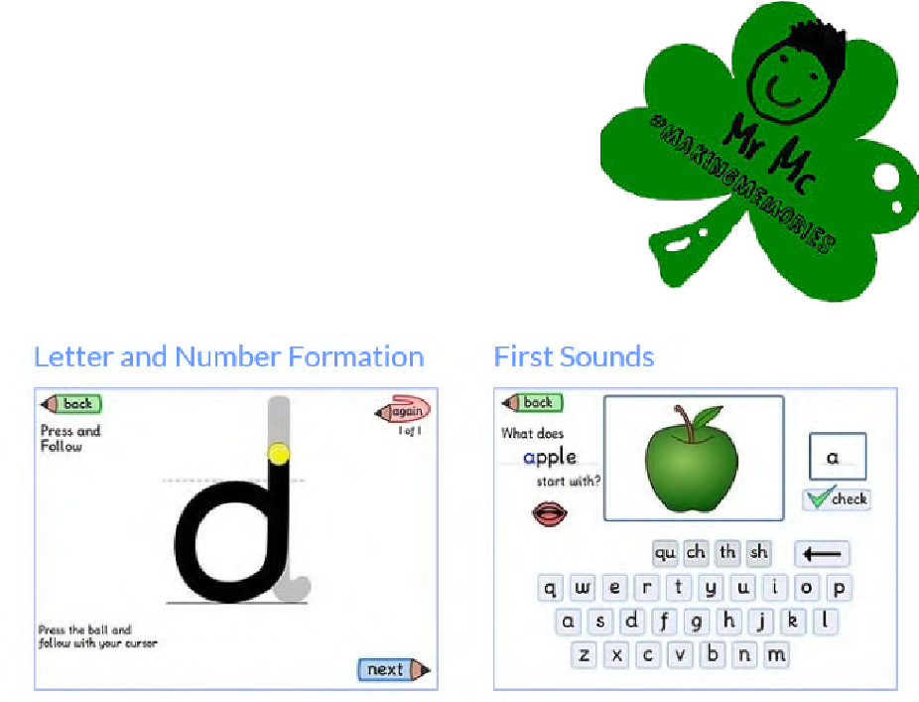
Websites
https://www.bbc.co.uk/cbeebies/shows/
http://epicphonics.com/
http://www.doorwayonline.org.uk/
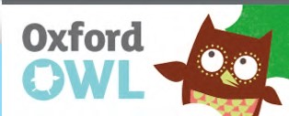
https://www.oxfordowl.co.uk/forhome/find-a-book/library-page/
Free E-Books and linked games!

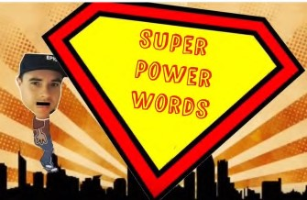
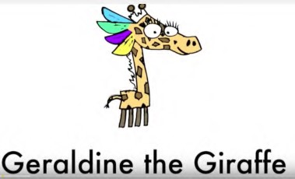
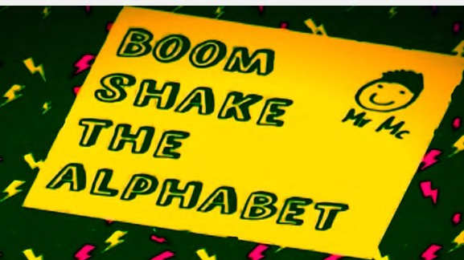
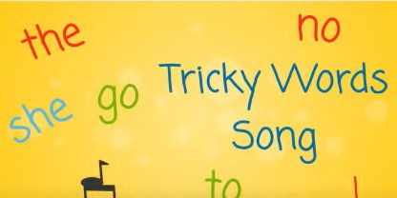
https://www.topmarks.co.uk/english-games/5-7-years/letters-and-sounds
Mr Mc Super Power
Words
Boom Shake
Mr Thorne-
Geraldine the Giraffe
Epic Phonics
Tricky Words Song
The Alphabet
Website and App list compiled by Mr Mc #makingmemories

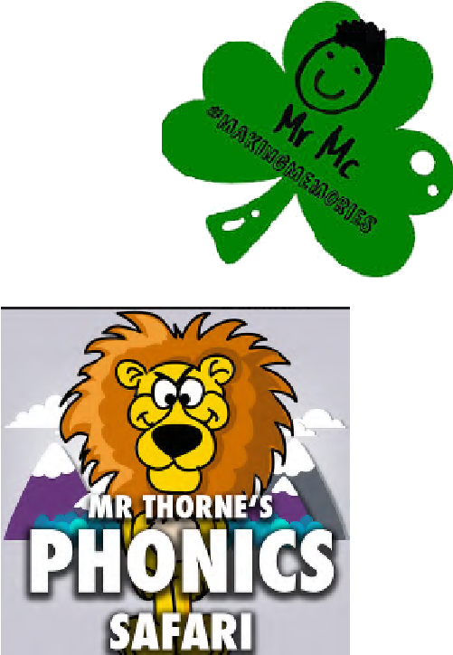
Apps
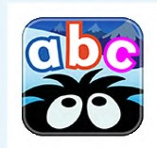
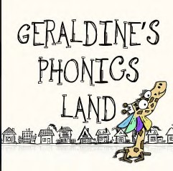
Hairy Letters | Mr Thorne—  Geraldine’s Phonics Land | Mr Thorne—  Phonics Safari
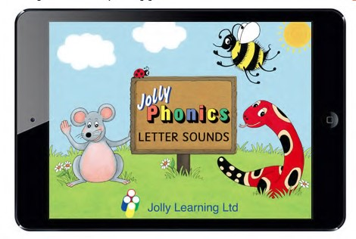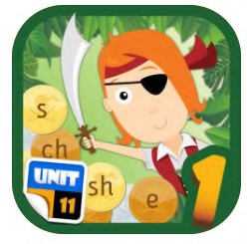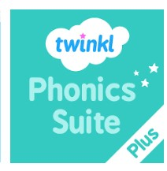
Jolly Phonics | Pirate Phonics | Twinkl Phonics
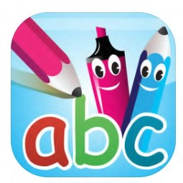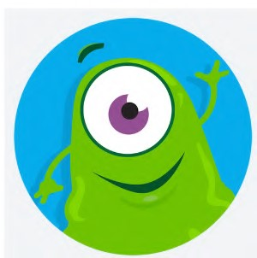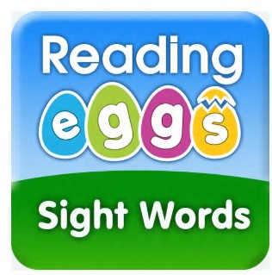
Pocket Phonics | Readwithfonics | Eggy Words
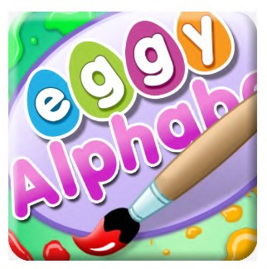
Eggy Alphabet
Website and App list compiled by Mr Mc #makingmemories

