RELATIONSHIP AND SEX EDUCATION POLICY

Date policy reviewed | Autumn Term 2023
Date for next review | Autumn Term 2024
Committee responsible | FGB
Authorisation | Ryan Brown

INTRODUCTION
The RSE / PSHE Leader, Head Teacher and Governing Body of Hanslope Primary School have referred to the Government guidance which provides information on what schools should do and sets out the legal duties with which schools must comply when teaching Relationships Education, Relationships and Sex Education (RSE) and Health Education (statutory from September 2020) when drawing up and agreeing this policy. The school governors have taken the decision to provide some formal RSE, in addition to National Curriculum science, in line with the age of the children.

At Hanslope School we recognise the importance of children developing healthy and respectful relationships, focusing on family. We aim to teach children how to be healthy, understanding that mental health and wellbeing are paramount to a child’s happiness and potentially to their progress. RSE is taught as part of regular PSHE lessons which are delivered by class teachers. Progressively taught units of work ensure that pupils develop their understanding of health, including areas such as drugs and alcohol, as well as introducing knowledge about other topics such as keeping safe online when developing online relationships and peer pressure. Over the course of primary school, pupils will be taught aspects of financial capability and given opportunity to learn about careers. Our PSHE curriculum should be complemented by pupils’ development of personal attributes including kindness, integrity, generosity, and honesty.

Children at Hanslope Primary School are encouraged to have a growth mind-set and be resilient. Central to this is: pupils’ ability to believe that they can achieve goals, both academic and personal; to stick to tasks that will help them achieve those goals, even when the reward may be distant or uncertain; and to recover from knocks and challenging periods in their lives. They can put this knowledge into practice as they develop the capacity to make sound decisions when facing risks, challenges and complex circumstances. Everyone faces difficult situations in their lives and our PSHE curriculum can support young people to develop resilience, to know how and when to ask for help, and to know where to access support.

Specific teaching about identity, society and equality will ensure that all pupils will have the chance to celebrate differences as well as learn how to deal with issues such as stereotyping or discrimination. They will know who to talk to in order to get support for themselves and others. We will also help our young people to learn to respect themselves and others. They will learn about the significance of marriage and stable relationships to family life and society.

These subjects represent a huge opportunity to help our children and young people develop. The knowledge and attributes gained will support their own, and others’, wellbeing and attainment and help young people to become successful and happy adults who make a meaningful contribution to society.

As they develop, children have a growing interest in, and understanding of, many social and moral issues. They have a natural curiosity about themselves – their bodies, their feelings and their relationships. They have a need to explore the meanings and implications of their emerging sexuality and the related physical and emotional changes they experience.

At Hanslope Primary School, our teaching takes into account the maturity of the children and aims to help and support them with the physical, mental and emotional changes of growing up. We aim to give them an appropriate understanding of puberty, human reproduction, relationships and family life within a moral and ethical framework. Our RSE programme draws on experiences and activities covered by other curriculum subjects, particularly aspects of science (for example, life and living processes).

Questions that children ask are treated seriously and sensitively; teachers and caregivers are coached to respond appropriately to the needs of the children and use appropriate language. The teacher’s personal knowledge and understanding of the child will be a guide. We recognise that some children have given little thought to such issues and would not be ready for detailed explanations. Proper consideration needs to be given to religious and cultural factors and to the wishes of parents. Homophobic bullying, or targeted and discriminatory bullying of any sort, will not be tolerated and will be dealt with in accordance with the behaviour policy. This is also in accordance with Ofsted’s updated guidance:
‘All primary and secondary schools, whether state-funded or independent, should be able to demonstrate that no form of discrimination is tolerated and that pupils show respect for those who share the protected characteristics.’

THE ROLE OF PARENTS
It needs to be recognised that school is not the only setting in which children gain information and awareness of this subject, with school and parents having complementary roles. We are aware that, as children get older, parents become more concerned about the content and delivery of RSE. Therefore, the parents of children will be informed, in advance, of the content of the planned programme for RSE in that year. They can then follow up on information given and carry on discussions at home at this important time in their child’s development.

Parents have the right to withdraw children from RSE lessons which are not taught in accordance with the statutory curriculum. It is important to note that the only non-statutory elements that we cover in Hanslope School are taught in Year Six. Parents requesting withdrawal are invited to discuss their concerns with the teacher or head teacher. They need to understand that the right of withdrawal does not apply to the National Curriculum and related activities. Separate supervision will be arranged for the child during the RSE lessons if you request for withdrawal.

CONFIDENTIALITY
If a child seeks to confide in an adult at school, the adult must decide if the child is “at risk” either emotionally or physically and if so the adult has a duty to relate the incident to the Designated Safeguarding Lead..

If a teacher/member of staff is approached by a primary age child who is sexually active or contemplating sexual activity, this should be viewed as a child protection issue.

1. Aims of Policy
The aims of relationships and sex education (RSE) at our school are to:
- Provide a framework in which sensitive discussions can take place
- Prepare pupils for puberty and give them an understanding of sexual development and the importance of health and hygiene
- Help pupils develop feelings of self-respect, confidence and empathy
- Create a positive culture around issues of sexuality and relationships
- Teach pupils the correct vocabulary to describe themselves and their bodies

2. Statutory requirements
As a maintained primary school we must provide relationships education to all pupils as per section 34 of the Children and Social work act 2017.

Although we are not required to provide sex education, we do need to teach the elements contained in the science curriculum.

In teaching RSE, we must have regard to guidance issued by the secretary of state as outlined in section 403 of the Education Act 1996.
At Hanslope Primary School we teach RSE as set out in this policy.
In teaching RSE, we are required by our funding agreements to have regard to guidance issued by the secretary of state as outlined in section 403 of the Education Act 1996.

3. Policy development
This policy has been developed in consultation with staff, pupils and parents. The consultation and policy development process involved the following steps:

- Review – a member of staff or working group pulled together all relevant information including relevant national and local guidance

- Staff consultation – all school staff were given the opportunity to look at the policy and make recommendations

- Parent/stakeholder consultation – parents and any interested parties were invited to attend a meeting about the policy

- Pupil consultation – we investigated what exactly pupils want from their RSE

- Ratification – once amendments were made, the policy was shared with governors and ratified

4. Definition
RSE is about the emotional, social and cultural development of pupils, and involves learning about relationships, sexual health, sexuality, healthy lifestyles, diversity and personal identity. RSE involves a combination of sharing information, and exploring issues and values. RSE is not about the promotion of sexual activity.

5. Curriculum
At Hanslope, our ethos is to have clear policies and systems in place to protect all children and adults and engender an atmosphere that shows tolerance and respect for all, in line with British Values. We ensure that we are compliant with the Equalities Act by teaching our pupils about different protected characteristics in order to inform them of the different relationships that are allowed under the law of the country and openly discussing the structure of different family units (see section 6).

Our curriculum is set out as per Appendix 1, but we may need to adapt it as and when necessary.

We have developed the curriculum in consultation with parents, pupils and staff, taking into account the age, needs and feelings of pupils. If pupils ask questions outside the scope of this policy, teachers will respond in an appropriate manner so they are fully informed and don’t seek answers online.
Primary sex education is not compulsory in primary schools, however, at Hanslope Primary School there will be certain elements of sex education which are set out in the science curriculum. These two lessons only taught in Year 6 will focus on:

- Conception and birth (Year 6)
The elements of this lesson go beyond the teaching requirements of the statutory guidance however the DfE recommends that:
“all Primary schools should have a sex education programme tailored to the age and the physical and emotional maturity of the pupil. It should ensure both boys and girls are prepared for the changes that adolescence brings and – drawing on knowledge of the human life cycle set out in the National Curriculum for Science – how a baby is conceived and born” (point 67 page 23).
For more information about our curriculum, see our curriculum map in Appendix 1.

6. Delivery of RSE
RSE is taught within the personal, social, health and economic (PSHE) education curriculum. Biological aspects of RSE are taught within the science curriculum, and other aspects are included in religious education (RE).

Pupils also receive stand-alone sex education sessions delivered by either the class teacher or a trained health professional. Relationships education focuses on teaching the fundamental building blocks and characteristics of positive relationships including:

- Families and people who care for me
- Caring friendships
- Respectful relationships
- Online relationships
- Being safe
- Understanding and respect for protected characteristics in line with the Equalities Act 2010

For more information about our RSE curriculum, see Appendices 1 and 2.
These areas of learning are taught within the context of family life taking care to ensure that there is no stigmatisation of children based on their home circumstances (families can include single parent families, LGBT parents, families headed by grandparents, adoptive parents, foster parents/carers amongst other structures) along with reflecting sensitively that some children may have a different structure of support around them (for example: looked after children or young carers).

7. Roles and Responsibilities

7.1 The governing board
The governing board will approve the RSE policy and hold the headteacher to account for its implementation.

7.2 The headteacher
The headteacher is responsible for ensuring that RSE is taught consistently across the school, and for managing requests to withdraw pupils from non-statutory/non-science components of RSE (see section 8).

7.3 Staff
Staff are responsible for:

- Delivering RSE in a sensitive way
- Modelling positive attitudes to RSE
- Monitoring progress
- Responding to the needs of individual pupils
- Responding appropriately to pupils whose parents wish them to be withdrawn from the non-statutory/non-science components of RSE

Staff do not have the right to opt out of teaching RSE. Staff who have concerns about teaching RSE are encouraged to discuss this with the headteacher.

7.4 Pupils
Pupils are expected to engage fully in RSE and, when discussing issues related to RSE, treat others with respect and sensitivity.

8. Parents’ right to withdraw
Parents do not have the right to withdraw their children from relationships education or the sex education that is part of the science curriculum. There is only one non-statutory element of our PSHE/RSE curriculum in Hanslope School, which is found over the course of two lessons in Year 6.

9. Training
Staff are trained on the delivery of RSE as part of their induction and it is included in our continuing professional development calendar.

The headteacher will also invite visitors from outside the school, such as school nurses or sexual health professionals, to provide support and training to staff teaching RSE.

10. Monitoring arrangements
The delivery of RSE is monitored by the PSHE subject leader through:

- Scrutiny of planning
- PSHE teaching and planning evidence found in exercise and floor books
- Learning visits

Pupils’ development in RSE is monitored by class teachers as part of our internal assessment systems.

This policy will be reviewed annually by the PSHE Lead. At every review, the policy will be approved by the governing body.

Appendix 1: Curriculum map
Relationships and sex education curriculum map

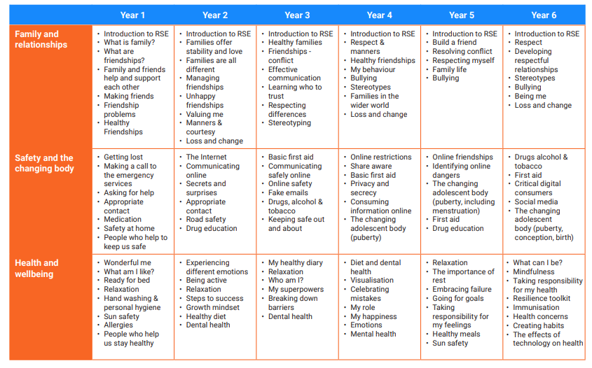
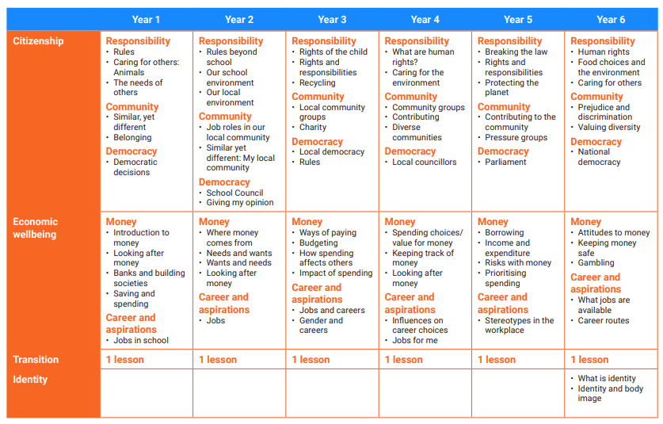

Appendix 2: By the end of primary school pupils should know
Topic | Pupils should know
Families and people who care about me | - That families are important for children growing up because they can give love, security and stability  - The characteristics of healthy family life, commitment to each other, including in times of difficulty, protection and care for children and other family members, the importance of spending time together and sharing each other’s lives  - That others’ families, either in school or in the wider world, sometimes look different from their family, but that they should respect those differences and know that other children’s families are also characterised by love and care  - That stable, caring relationships, which may be of different types, are at the heart of happy families, and are important for children’s security as they grow up  - That marriage represents a formal and legally recognised commitment of two people to each other which is intended to be lifelong  - How to recognise if family relationships are making them feel unhappy or unsafe, and how to seek help or advice from others if needed
Caring friendships | - How important friendships are in making us feel happy and secure, and how people choose and make friends  - The characteristics of friendships, including mutual respect, truthfulness, trustworthiness, loyalty, kindness, generosity, trust, sharing interests and experiences and support with problems and difficulties  - That healthy friendships are positive and welcoming towards others, and do not make others feel lonely or excluded  - That most friendships have ups and downs, and that these can often be worked through so that the friendship is repaired or even strengthened, and that resorting to violence is never right  - How to recognise who to trust and who not to trust, how to judge when a friendship is making them feel unhappy or uncomfortable, managing conflict, how to manage these situations and how to seek help or advice from others, if needed
Respectful relationships | - The importance of respecting others, even when they are very different from them (for example, physically, in character, personality or backgrounds), or make different choices or have different preferences or beliefs  - Practical steps they can take in a range of different contexts to improve or support respectful relationships  - The conventions of courtesy and manners  - The importance of self-respect and how this links to their own happiness  - That in school and in wider society they can expect to be treated with respect by others, and that in turn they should show due respect to others, including those in positions of authority  - About different types of bullying (including cyberbullying), the impact of bullying, responsibilities of bystanders (primarily reporting bullying to an adult) and how to get help  - What a stereotype is, and how stereotypes can be unfair, negative or destructive  - The importance of permission-seeking and giving in relationships with friends, peers and adults
Online relationships | - That people sometimes behave differently online, including by pretending to be someone they are not  - That the same principles apply to online relationships as to face-to face relationships, including the importance of respect for others online including when we are anonymous  - The rules and principles for keeping safe online, how to recognise risks, harmful content and contact, and how to report them  - How to critically consider their online friendships and sources of information including awareness of the risks associated with people they have never met  - How information and data is shared and used online
Being safe | - What sorts of boundaries are appropriate in friendships with peers and others (including in a digital context)  - About the concept of privacy and the implications of it for both children and adults; including that it is not always right to keep secrets if they relate to being safe  - That each person’s body belongs to them, and the differences between appropriate and inappropriate or unsafe physical, and other, contact  - How to respond safely and appropriately to adults they may encounter (in all contexts, including online) whom they do not know  - How to recognise and report feelings of being unsafe or feeling bad about any adult  - How to ask for advice or help for themselves or others, and to keep trying until they are heard  - How to report concerns or abuse, and the vocabulary and confidence needed to do so  - Where to get advice e.g. family, school and/or other sources

Appendix 3: Parent form: withdrawal from the non-statutory elements of sex education within Year 6 RSE lessons

To be completed by parents
Name of child |  | Class | (Year 6)
Name of parent |  | Date
Reason for withdrawing from sex education within relationships and sex education
Any other information you would like the school to consider
Parent signature

To be completed by the school
Agreed actions from discussion with parents

