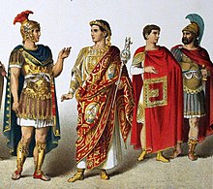

We shall be learning how to:

*read a range of texts as a stimulus for our learning (both fiction and non- fiction). Focus texts include: ‘Demon Dentist by David Walliams, a range of Roman stories and information books.

*use story mapping techniques to help rewrite stories and plan/write our own

*identify the features of a non-fiction text and apply this knowledge *use different key spelling, punctuation and grammar skills. These will include identifying *nouns, and expanded noun phrases, adjectives, verbs, adverbs adverbial phrases, past tense, present tense future tense, use of effective word choices, rich varied vocabulary, paragraphs and conjunctions.*

[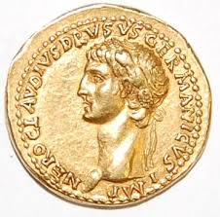](https://www.google.co.uk/url?sa=i&rct=j&q=&esrc=s&source=images&cd=&ved=2ahUKEwiHm_qi0cLhAhWtxoUKHdlTBw8QjRx6BAgBEAU&url=https://www.mylearning.org/stories/the-raging-romans-/435&psig=AOvVaw3klzN99GzJqI_EvE_Jwnd_&ust=1554885962125053)We shall be learning how to:

Year Three:

*show and explain how counting is useful for addition and subtraction.

* make appropriate decisions about when to use understanding of place value for solving problems, including adding and subtracting.

* use multiplication by repeated addition and scaling.

*use division as both sharing and grouping.

* derive facts and solve problems.

*show an angle as a measure of a turn.

* make, draw and identify shapes with right angles.

Year Four:

*use understanding of place value, counting and rounding to solve problems involving addition and subtraction.

*solve addition and subtraction problems in different contexts.

*know the properties of triangles and quadrilaterals.

*explain the relationship between multiplication and division.

*use this understanding to derive facts and solve problems.

**In Year Three and Four we shall also develop our ability to explain and justify methods and solutions**.

**Home Learning**

-Spellings, reading and times tables should be completed on a daily basis. Please record when your child has read in their Home/School Book.

.

**Maths** [](https://www.google.co.uk/url?sa=i&rct=j&q=&esrc=s&source=images&cd=&ved=2ahUKEwjAnNTugc3fAhVG4YUKHWSIBNEQjRx6BAgBEAU&url=https://www.kisspng.com/png-one-fish-two-fish-red-fish-blue-fish-bluefish-clip-567946/preview.html&psig=AOvVaw1iwNHI2FacZG722jXo2tBx&ust=1546446878352145)[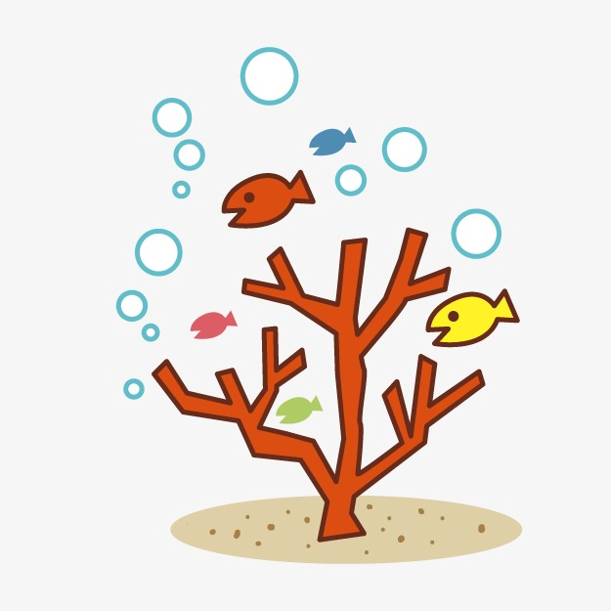](https://www.google.co.uk/url?sa=i&rct=j&q=&esrc=s&source=images&cd=&ved=2ahUKEwiwro2Ggc3fAhUNCxoKHW54AdgQjRx6BAgBEAU&url=https://pngtree.com/freepng/cartoon-coral_1297295.html&psig=AOvVaw3khGrLhQmiVXOrEj_2XAlB&ust=1546446682874168)

**Topic**

[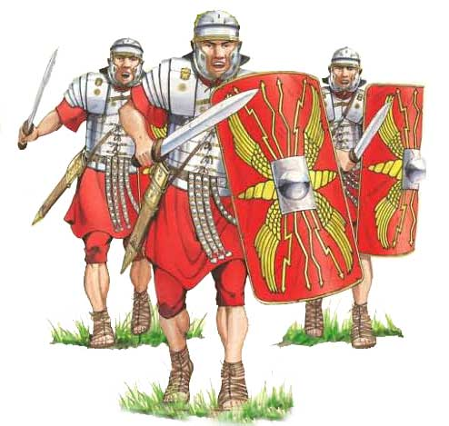](https://www.google.co.uk/url?sa=i&rct=j&q=&esrc=s&source=images&cd=&cad=rja&uact=8&ved=2ahUKEwjLiK7R0MLhAhVSxhoKHcHRCngQjRx6BAgBEAU&url=https://www.romanobritain.org/index.php&psig=AOvVaw3klzN99GzJqI_EvE_Jwnd_&ust=1554885962125053)Our topic for this half term is the Romans and how they impacted Britain. We shall be using evidence to find out about their way of life such as housing and settlements, culture and leisure activities. We shall also be learning about the similarities and differences between people in the past, events and objects (artefacts). We shall consider how change occurred during this time period. In Art and Design Technology we shall be planning, making and evaluating Roman armour and considering how the structure of Roman buildings were so successful. We shall use a range of tools, materials and equipment.

As part of our Art focus, we shall be using the work of painters Lucien Freud and Pablo Picasso to inspire our own portrait work.

During RE lessons, we shall be discussing whether Murtis help Hindus understand God. Our focus in PSHE shall be identifying and celebrating our differences. In computing we shall be revisiting the importance of E-safety. We shall be using a music scheme to develop our ability to listen, appraise and perform a range of music. The unit is called ‘Let your Spirit Fly.’ During French lessons we shall be enjoying developing our speaking and listening skills. We will learn how to respond to basic instructions and will begin to construct some simple sentences in French using a writing frame.

As scientists, we shall be finding out about our teeth and digestion. This will include investigations. Lessons will be based around exploration, such as investigating how teeth respond to different liquids. We shall also find out about the work of famous scientists linked to our studies.

**Autumn 2020**

**Year 3/4 Curriculum News**

**Year Three and Four Romans**