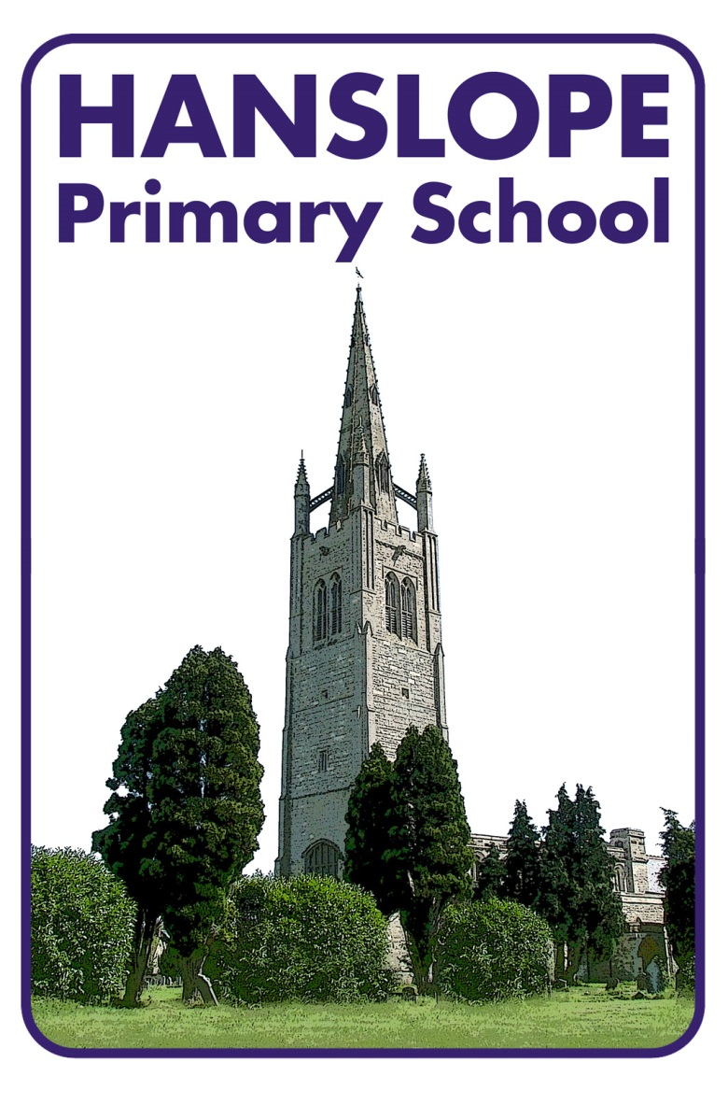

SPIRITUAL, MORAL, SOCIAL AND CULTURAL POLICY

Date Policy Approved | 17 May 2016
Date Policy Reviewed | 11 May 2021
Date for Next Review | Summer 2024
Committee responsible | Curriculum
Authorisation | Ryan Fensham-Brown

At Hanslope Primary School the pupils are encouraged to develop Spiritual, Moral, Social and Cultural (SMSC) awareness and to begin to make personal decisions and choices which reflect this development. Opportunities for the pupils to develop spiritually, morally, socially and culturally are provided throughout the curriculum, during learning sessions, in collective worship, at lunch time, playtime and extra-curricular activities.

Aims:
- To ensure that everyone connected with the school is aware of our values and principles
- To ensure a consistent approach to the delivery of SMSC issues throughout the curriculum and the general life of the school.
- To ensure that pupil’s education is set within a context that is meaningful and appropriate to their age, aptitude and background.
- To ensure that pupils know what is expected of them and why.
- To give pupils a range of opportunities to reflect upon and discuss their beliefs, feelings and responses to personal experience.
- To enable pupils to develop an understanding of their individual and group identity.
- To enable pupils to begin to develop an understanding of their social and cultural environment and an appreciation of the many cultures that now enrich our society.
- To give each pupil the opportunity to explore social and moral issues, and develop a social and moral responsibility.

Hanslope Primary School uses the following definitions of Spiritual, Moral, Social and Cultural development taken from the OFSTED school inspection handbook August 2015.

The Spiritual development of pupils is shown by their:
- ability to be reflective about their own beliefs, religious or otherwise, that inform their perspective on life and their interest in and respect for different people’s faiths, feelings and values
- sense of enjoyment and fascination in learning about themselves, others and the world around them
- use of imagination and creativity in their learning
- willingness to reflect on their experiences.

The Moral development of pupils is shown by their:
- ability to recognise the difference between right and wrong and to readily apply this understanding in their own lives, recognise legal boundaries and, in so doing, respect the civil and criminal law of England
- understanding of the consequences of their behaviour and actions
- interest in investigating and offering reasoned views about moral and ethical issues and ability to understand and appreciate the viewpoints of others on these issues.

The Social development of pupils is shown by their:
- use of a range of social skills in different contexts, for example working and socialising with other pupils, including those from different religious, ethnic and socio-economic backgrounds
- willingness to participate in a variety of communities and social settings, including by volunteering, cooperating well with others and being able to resolve conflicts effectively
- acceptance and engagement with the fundamental British values of democracy, the rule of law, individual liberty and mutual respect and tolerance of those with different faiths and beliefs; they develop and demonstrate skills and attitudes that will allow them to participate fully in and contribute positively to life in modern Britain.

The Cultural development of pupils is shown by their:

- understanding and appreciation of the wide range of cultural influences that have shaped their own heritage and those of others.
- understanding and appreciation of the range of different cultures within school and further afield as an essential element of their preparation for life in modern Britain.
- knowledge of Britain’s democratic parliamentary system and its central role in shaping our history and values and in continuing to develop Britain.

How the curriculum can contribute to SMSC:

English contributes to pupils SMSC development through:

- Developing confidence and expertise in language, which is an important aspect of individual
and social identity.
- Enabling students to understand and engage with the feelings and values embodied in high
quality poetry, fiction, drama, film and television.
- Developing students’ awareness of moral and social issues in fiction, journalism, magazines, radio, television and film.
- Helping students to understand how language changes over time, the influences on spoken
and written language and social attitudes to the use of language.

Mathematics contributes to pupils SMSC development through:

- Moral development: helping students recognise how logical reasoning can be used to consider the consequences of particular decisions and choices and helping them learn the value of mathematical truth.
- Social development: through helping students work together productively on complex mathematical tasks and helping them see that the result is often better than any of them could achieve separately.
- Cultural development: through helping students appreciate that mathematical thought contributes to the development of our culture and is becoming increasingly central to our highly technological future, and through recognising that mathematicians from many cultures have contributed to the development of modern day mathematics.

Science contributes to pupils SMSC development through:

- Encouraging students to reflect on the wonder of the natural world.
- Awareness of the ways that Science and Technology can affect society and the environment.
- Consideration of the moral dilemmas that can result in scientific developments.
- Showing respect for differing opinions, on creation for example.
- Co-operation in practical activity.
- Raising awareness that scientific developments are the product of many different cultures.

Computing contributes to pupils SMSC development through:

- Preparing the students for the challenges of living and learning in a technologically enriched, increasingly interconnected world.
- Making clear the guidelines about the ethical use of the internet.
- Acknowledging advances in technology and appreciation for human achievement.

History contributes to pupils SMSC development through:

- Looking at the creation and evolution of British society.
- Enabling students to reflect on issues such as slavery, the holocaust and Imperialism.
- Showing an awareness of the moral implications of the actions of historical figures.

Geography contributes to pupils SMSC development through:

- Opportunities for reflection on the creation of earth and its’ origins, future and diversity are given.
- Reflection on the fair distribution of the earth’s resources and issues surrounding climate change.
- A study of people and physical geography gives pupils the chance to reflect on the social and cultural characteristics of society.

Modern Foreign Languages contributes to pupils SMSC development through:

- Gaining insights into the way of life, cultural traditions, moral and social developments of other people.
- Social skills are developed through group activities and communication exercises.
- Listening skills are improved through oral/aural work.

RE makes a distinctive and substantial contribution to the delivery of SMSC:

- Students learn about beliefs, values and the concept of spirituality.
- RE reflects on the significance of religious teaching in their own lives.
- Develops respect for the right of others to hold beliefs different from their own.
- Shows an understanding of the influence of religion on society. Fosters appreciation and understanding of different cultures, religions and traditions.

Art contributes to pupils SMSC development through:

- Art lessons which develop students' aesthetic appreciation.
- In turn, Art evokes feelings of 'awe' and 'wonder'.
- Giving students the chance to reflect on nature, their environment and surroundings.
- Studying artists with a spiritual or religious theme, issues raised by artists which concerns ethical issues, such as War paintings.

Design and Technology contributes to pupils SMSC development through:

- Reflecting on products and inventions, the diversity of materials and ways in which design can improve the quality of our lives.
- Awareness of the moral dilemmas created by technological advances.
- How different cultures have contributed to technology.
- Opportunities to work as a team, recognising others strengths, sharing equipment.

Music contributes to pupils SMSC development through:

- Teaching that encourages students to be open to the music of other cultures.
- Discussing and reflecting upon a range of personal experiences (own performance) and observed experiences (trips, concerts and peer performances).
- Lead students to appreciate aesthetic order, beauty and on occasion ambiguity, for example through listening activities, where possible beyond their common experience.
- Looking at the way music can change moods and behaviour.
- Offer a range of high quality music enrichment activities, for example access to individual
instrumental lessons with specialist peripatetic teachers.

PE contributes to pupils SMSC development by:

- Activities involving co-operation, teamwork, competition, rules, self-discipline and fair play.
- Exploring the sports and traditions of a variety of cultures.
- Individual activities that provide the opportunity for self-reflection, awareness and challenge.

Promoting British Values at Hanslope Primary School
The Department for Education expects schools to have a clear strategy to promote British values to ensure young people leave school prepared for life in modern Britain and has reinforced the need to:

“Create and enforce a clear and rigorous expectation on all schools to promote the fundamental British values of democracy, the rule of law, individual liberty and mutual respect and tolerance of those with different faiths and beliefs.”

British values are:
- Democracy
- The rule of law
- Individual liberty
- Mutual respect for and tolerance of those with different faiths and beliefs and for those without faith.

At Hanslope Primary School these values are at the heart of all we do and are encompassed in our Vision and Values.

Democracy

Democracy is embedded at the school. Pupils are always listened to by adults and are taught to listen carefully and with concern to each other, respecting the right of every individual to have their opinions and voices heard. Pupils also have the opportunity to air their opinions and ideas through the ‘School Council’ whose members are elected by classmates at the start of each year. The elections of House Captains are based solely on pupil votes, reflecting our British electoral system and demonstrating democracy in action. In the classroom children learn about Britain’s democratic system and law-making– this includes why we need rules and laws and the responsibilities that we have as British Citizens. As well as following the schools Golden Rules, at the beginning of each academic year, classes in Key Stage 1 and Key Stage 2 draw up their own class rules.

The Rule of Law

The importance of laws, whether they are those that govern the class, the school or the country, are consistently reinforced. Pupils are taught from an early age the Golden Rules of the school. They are taught the value and reasons behind rules and laws. They learn that rules are used to govern and protect us, the responsibilities that this involves and the consequences when laws are broken. Each family signs the Home School Agreement which outlines expectations.

Individual Liberty

Within school, pupils are actively encouraged to make choices, knowing that they are in a safe and supportive environment. As a school we educate and provide boundaries for our pupils to make choices safely, through the provision of a safe environment for example through our E-safety program and PSHE lessons. Whether it is through; choice of challenge, participation in our extra- curricular clubs and activities, pupils are given the freedom to make choices.

Respect and Tolerance

We encourage our children to show kindness, respect and consideration towards others. The pupils know and understand that it is expected and imperative that respect is shown to everyone, whatever differences we may have. Respect underpins our work every day, both in and out of the classroom and is modelled by all staff. The school supports events such as Anti Bullying Week, and Internet Safety is an integral part of the computing curriculum.
Tolerance of those with different Faiths and Beliefs is achieved through enhancing pupils’ understanding of their place in a culturally diverse society and by giving them opportunities to experience such diversity. The religious education curriculum is designed to enhance pupils understanding of different faiths and beliefs, of Christianity and other principal religions represented in Great Britain. Educational visits are made to places of worship and children also learn about seasonal festivals such as Diwali and Harvest through the broad and balanced curriculum.

This policy will be reviewed every three years or as appropriate.

Democracy  - Provide pupils with a broad general knowledge of and promote respect for public institutions and services.  - Teach pupils how they can influence decision-making through the democratic process.  - Include in the curriculum information on the advantages and disadvantages of democracy and how it works in Britain.  - Encourage pupils to become involved in decision-making processes and ensure they are listened to in school.  - Organise visits to the local council and parliament.  - Hold ‘mock elections’ so pupils learn how to argue and defend points of view  - Help pupils to express their views.  - Teach pupils how public services operate and how they are held to account  - Model how perceived injustice can be peacefully challenged. | Rule of Law  APPENDIX 1  - Ensure school rules and expectations are clear and fair  - Help pupils to distinguish right from wrong  - Help pupils to respect the law and the basis on which it is made  - Help pupils to understand that living under the rule of law protects individuals  - Teach pupils aspects of both civil and criminal law and discuss how this might differ from some religious laws  - Develop restorative justice approaches to resolve conflicts
Individual liberty  - Support pupils to develop their self-knowledge, self-esteem and self-confidence  - Encourage pupils to take responsibility for their behaviour, as well as knowing their rights.  - Model freedom of speech through pupil participation, while ensuring protection of vulnerable pupils and promoting critical analysis of evidence.  - Challenge stereotypes  - Implement a strong anti-bullying culture  - Follow the UNICEF rights respecting schools agenda | Mutual respect for and tolerance of those with different faiths and beliefs and for those without faith.  - Promote respect for individual differences  - Help pupils to acquire and understanding of, and respect for, their own and other cultures and ways of life  - Challenge prejudicial or discriminatory behaviour.  - Organise visits to places of worship  - Develop links with faith communities  - Develop critical personal thinking skills  - Discuss differences between people, such as differences of faith, ethnicity, disability, gender or sexuality and indifferences of family situations, such as looked after children or young carers
British Values
APPENDIX 2
SPIRITUAL  Ofsted – The spiritual development of pupils is shown by their:  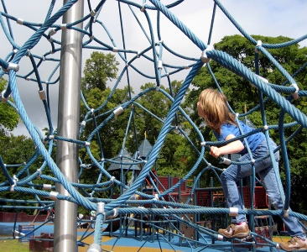  - ability to be reflective about their own beliefs, religious or otherwise, that inform their perspective on life and their interest in and respect for different people’s faiths, feelings and values  - sense of enjoyment and fascination in learning about themselves, others and the world around them  - use of imagination and creativity in their learning  - willingness to reflect on their experiences. | MORAL  Ofsted – The moral development of pupils is shown by their:  - ability to recognise the difference between right and wrong and to readily apply this understanding in their own lives, recognise legal boundaries and, in so doing, respect the civil and criminal law of England  - understanding of the consequences of their behaviour and actions  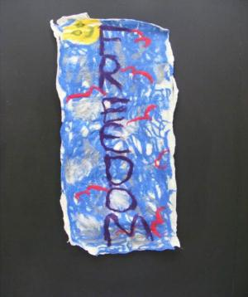  - interest in investigating and offering reasoned views about moral and ethical issues and ability to understand and appreciate the viewpoints of others on these issues.
SOCIAL  Ofsted – The social development of pupils is shown by their:  - use of a range of social skills in different contexts, for example working and socialising with other pupils, including those from different religious, ethnic and socio-economic backgrounds  - willingness to participate in a variety of communities and social settings, including by volunteering, cooperating well with others and being able to resolve conflicts effectively  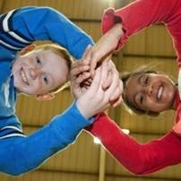  - acceptance and engagement with the fundamental British values of democracy, the rule of law, individual liberty and mutual respect and tolerance of those with different faiths and beliefs; they develop and demonstrate skills and attitudes that will allow them to participate fully in and contribute positively to life in modern Britain. | CULTURAL  Ofsted – The cultural development of pupils is shown by their:  - understanding and appreciation of the wide range of cultural influences that have shaped their own heritage and those of others  - understanding and appreciation of the range of different cultures within school and further afield as an essential element of their preparation for life in modern Britain  - knowledge of Britain’s democratic parliamentary system and its central role in shaping our history and values, and in continuing to develop Britain  - willingness to participate in and respond positively to artistic, musical, sporting and cultural opportunities  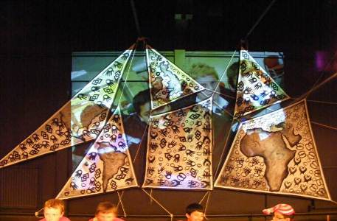  - interest in exploring, improving understanding of and showing respect for different faiths and cultural diversity and the extent to which they understand, accept, respect and celebrate diversity, as shown by their tolerance and attitudes towards different religious, ethnic and socio-economic groups in the local, national and global communities.
The school’s thoughtful and wide ranging promotion of pupils’ spiritual, moral, social and cultural development and their physical wellbeing enables pupils to thrive - Ofsted: School Inspection Handbook Outstanding Overall Effectiveness September 2015

