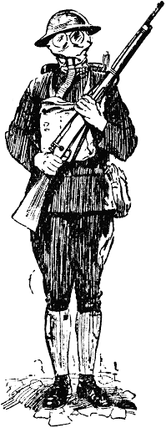
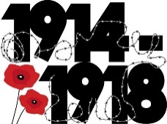
Year 6 self-isolation or school closure work – Summer 1
Missing you all and very proud!
Firstly, well done for all the work you have already completed! I have been so impressed with some of the work which has been sent to us via email! Keep up the good work Year 6!
Our topic for Summer 1 was going to be… Britain at war. For the first half term we were going to concentrate on World War One.
Please find below the skills we would be looking at, ideas for research and work for the Summer 1 term.
World War One  History Focus for this topic  -What lead to the outbreak of World War One.  -Trench warfare  -Which countries were involved in the war.  -Nurses and medical care of soldiers  -The development of weapons such as tanks.  -How animals were used in the war.  - Science- Diet and exercise and how it effects the body | These are the just some topics the children could be researching for the topic.  Some good websites for this topic are:  https://www.bbc.co.uk/bitesize/topics/zqhyb9q  https://www.ducksters.com/history/world_war_i/  https://www.dkfindout.com/uk/history/world-war-i/  https://www.historyforkids.net/world-war-one.html  https://www.history.com/news/life-in-the-trenches-of-world-war-i  https://www.iwm.org.uk/history/15-animals-that-went-to-war  https://www.rspca.org.uk/whatwedo/whoweare/history/firstworldwar/animals
History:  -Working on timelines  -Changes in history (comparisons to other eras and modern day)  -Understanding how events from the past have impacted modern life.  -Understanding the different types of sources (primary and secondary) and their reliability.  -Different perspectives from the same account (for example perspective of a German soldier and the perspective from an English soldier)  -Asking questions of your own to research  Science:  - What happens to the body while exercising? (Heart rate etc)  - recognise foods in different food groups and understand the need of a balanced diet.  - Recognise the important things required in order to remain healthy.  Art:  - experience artwork from different times and understand how art is used to express feelings.  - research how art was used to recruit soldiers.  Geography:  -Name, locate and find facts about specific countries involved in World War One  -Using digital mapping  -Physical geography  -How did the borders and names of countries change during and after the war. | These are the skills which we would be teaching the topic through.  Topic ideas:  - Create timeline of key events leading up to the outbreak of war. Could you do this on a computer somehow?  - Make a model of a trench.  - Find out how animals were used during the war and create a booklet about them (hint hint how were tortoises and dolphins used?)  - Research the importance of nurses and the role of women during the war at home and on the frontline.  - Read War Horse and write a review of the book.  - Research uniforms of soldiers and nurses in the war. Draw a picture and label it. Also find out about the development of protective equipment such as gas masks.  - Find a recruitment poster and scale it, using a grid.  - Design your own recruitment poster or public announcement poster from the war period.  - Create your own tank.  Science – Diet and exercise and how to remain healthy.  https://www.bbc.co.uk/bitesize/topics/zrffr82  - Could you design a healthy, balanced meal?  - Could you be given a budget and shop on line keeping within budget?  - Learn how to take your pulse and then log rate before, during and after exercise?  - What activities impact heart rate the most?
I have attached the links again for good websites!
The following you may need to sign up for a free account but have made home packs:
https://www.twinkl.co.uk/resource/year-2-school-closure-home-learning-resource-pack-t-e-2549911 - Twinkl free home learning pack
https://primarystarseducation.co.uk/covid-19-year-2/ - primary stars home learning pack
https://www.tts-group.co.uk/home+learning+activities.html - TTS KS2 activity pack
https://classroomsecrets.co.uk/free-home-learning-packs/ - classroom secrets home learning packs
To help children’s learning/games supporting learning you could look at:
Youtube (type in what the child is looking for with KS2)
https://www.bbc.co.uk/bitesize/levels/zbr9wmn
https://www.mathsisfun.com/
https://www.topmarks.co.uk/
Free e-books can be found:
https://www.oxfordowl.co.uk/for-home/find-a-book/library-page/?view=image&query=&type=book&age_group=Age+9-11&level=&level_select=&book_type=&series=#
More ideas:
- Research an artist and try and replicate their drawings/paintings/sculptures
- Do a power point on something important to you to share with the class later
- Go on TT Rockstars and practice your speed!
- https://ttrockstars.com/
- Learn a new skill! Baking, football skills, poetry writing, juggling… the list is endless!
- How many books can you read challenge! Not just fiction! Newspapers, poems, magazines, recipes!
- Do a Joe Wicks workout on youtube (he does special child-friendly workouts)
- https://www.youtube.com/watch?v=d3LPrhI0v-w
- Go on GoNoodle and do some Zumbas! (Cha cha swing is our year favourite!)
- https://family.gonoodle.com/
I have also added below the NEW Year 6 Summer 1 homework grid as children could also try and complete the tasks on there.
Compulsory Tasks
Maths - https://www.bbc.co.uk/bitesize/topics/zghp34j/articles/z2p6tyc
Maths  Have a look at ratio and proportion remember ratio is comparing two things ( 1:2) and proportion is looking at the whole (fraction)  Challenge:  https://nrich.maths.org/9003  Practice addition, subtraction, multiplication and division methods (look on website for calculation policy if unsure)  Also you can look on the school website for maths – band 6 for more year 6 maths. Think of what we have looked at this year – what have you been unsure about?  If you need any particular help or work for maths, email me. | Times Tables  Practise your x tables from 2-12. If you’ve mastered this, practise your squares and cubes (up to 12) and prime numbers (up to 50). Written evidence is necessary.  Remind yourselves what a multiple is and what a factor is. What is the difference? | English  Research the term passive voice – remind yourself what is it? Can you remember how to use it?  Look through the grammar glossary and look for terms you don’t understand. Choose 2 you don’t understand and find a way of learning it. | Reading  Read a book (I recommend War Horse by Michael Morpurgo) and do the following:  Summarise in less than 50 words.  Write a retrieval (fact finding question)  Write an analysis question.  Write a diary entry from the perspectives of one of the other characters  Also look on the various websites above for more reading comprehensions to try!
Optional Tasks (you must choose at least 2)
Maths  Challenge:  https://nrich.maths.org/quadrilaterals | Music  Find a piece of music from World War One.  Review the piece of music. Did you like it? Is it similar to any other style you have listened to? What instruments were used? | Computing/film/PSHE  DO ANOTHER!!!  Create a film on a topic which is important to you.  This maybe the importance of sport, or importance of family.  Can you use apps such as iMovie to help? | Drama  Perform a dramatic reading of a short story book or poem for your parents/siblings! How dramatic can you be? Can you remember the words off by heart?
English  Create a set of creative instructions based on How to survive the trenches in World war One. | Geography  Create a map of Europe. What are the important features that you would have on your map?  Extra Challenge!  Can you name any major rivers or capital cities in countries in Europe? | PSHE  Could you create a piece of art, music or piece of writing to show what keeps you calm and happy.  Would you recommend what you have done to anyone else?  Can you persuade someone in your family to do the same activity? | English  Write an story based on World War One. It could be from a soldiers perspective or a loved one at home.
Maths  Have a go at the 2019 Arithmetic Sat’s paper.  https://www.gov.uk/government/publications/key-stage-2-tests-2019-mathematics-test-materials | Maths  Have a go at a 2019 reasoning Sat’s paper.  https://www.gov.uk/government/publications/key-stage-2-tests-2019-mathematics-test-materials | Art  Take pictures of your local environment focussing on textures. Take one of those images and replicate the texture with sketching. | English  Write a Letter for a loved one as though you were a nurse or soldier in the war.  Challenge: age the letter using coffee/ tea and slightly burn the edges.
Maths  Can you use scale to scale up different images? | Computing  Create your own horrible history video about World War One. | PE  Learn why football was important on one particular day in the war.  Learn about famous football stars of the past and create a poster. | Loo Roll challenge!  Using the cardboard tube from a loo roll make the most interesting item! Use your imagination! What could you create?

Maths activities
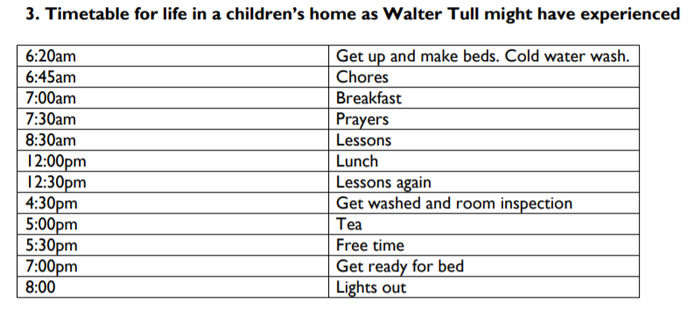
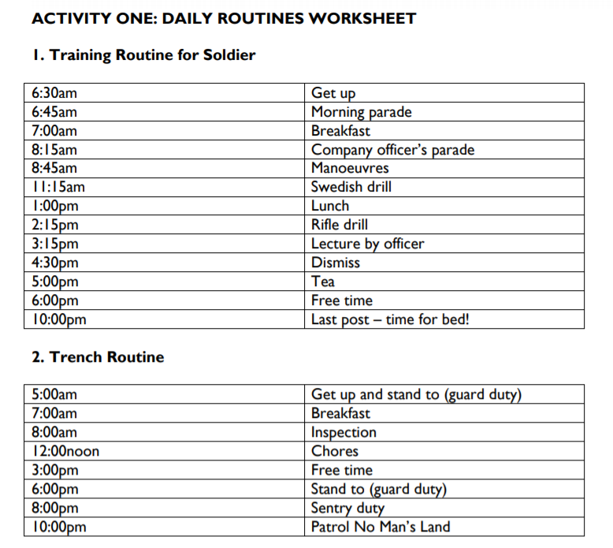

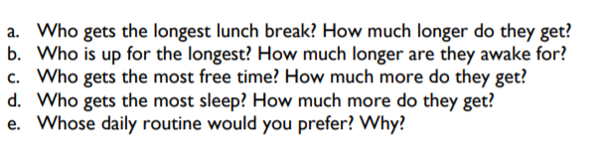

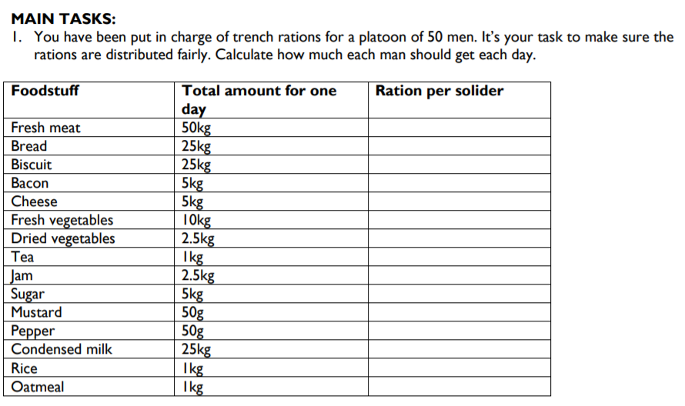

Have a go at some questions on via the web link below.
https://whiterosemaths.com/homelearning/year-6/

