**Topic**

**Home Learning**

The children are encouraged to read and practise their spellings and

times tables daily.

Homework shall be set regularly on Teams Classroom, My Maths and/ or Spelling Shed.

**Maths**

We shall be learning how to:

* Describe positions on a full coordinate grid.
* Solve problems involving the calculation of percentages.
* Use, read, write and convert between standard units, covering measurements of length, mass, volume and time from a smaller unit of measure to a larger unit, and vice versa, using decimal notation to up to three decimal places.
* Convert between miles and kilometres.
* Solve problems involving the calculation and conversion of units of measure, using decimal notation up to three decimal places where appropriate.
* Use ratio and scale factors.

Through this learning, reasoning skills will be developed.

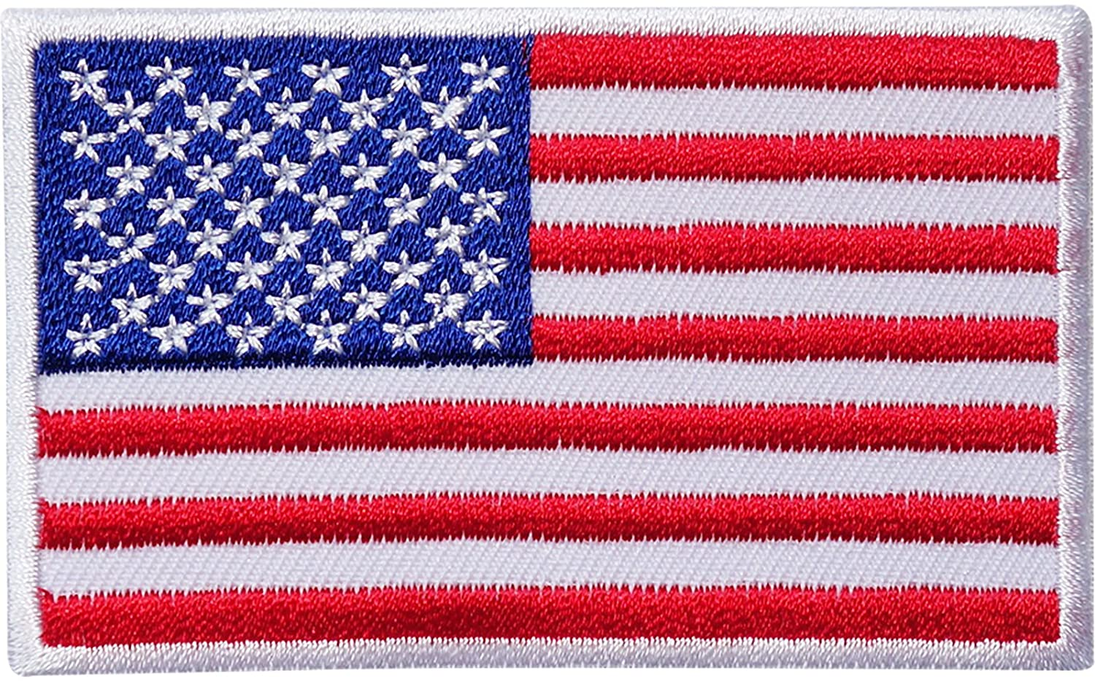

Our topic this half -term is ‘What a State they are in: The USA?’ In Geography we shall locate North America on a world map and explore the varied landscapes across the different states. In addition, we shall make a comparison between a particular area of the USA with the area in which we live. As historians, we shall find out about the European settlement of America and how pioneers crossed the Western frontier. Also, we will explore what happened to the Native American way of life. Through this topic, we will consider how historical events can be interpreted in different ways. As scientists, we shall be developing our ability to work scientifically, undertaking various investigations, that recap previous scientific knowledge. In Art, we shall create rural and urban landscapes, using colour and tone to match those that are natural and man-made. For DT, we will be using our research to design and create a purposeful product based on famous bridges in the USA. Our final product will aim to include pulleys, gears and levers. In Computing, we shall design our own webpage and evaluating it against those of our peers. Within French sessions, our topic is ‘School’. The children will learn to say how they come to school and at what time. They will also use times to talk about routine activities. During our RE lessons our discussions will be exploring the question: do clothes express beliefs? In our music lessons, children will explore the musical concept of theme and variations and discover how rhythms can ‘translate’ onto different instruments. Within PSHE, we shall be covering Health and Wellbeing and understanding the importance of a healthy lifestyle. We shall also be looking at building our resilience toolbox up, drawing on skills we have learnt before. In PE, children will be developing skills and techniques in hockey and dance.



We shall read a range of texts as a stimulus for our learning, (fiction and non- fiction). These texts shall include: Holes by Louis Sachar.

Through our learning we will:

*write for a variety of purposes, such as writing creatively using a range of sentence structures for impact, to inform and to write in a journalistic style.

*use ‘Holes’ (our key text) as a stimulus to write an extended piece of narrative, practising how to develop character and create atmosphere

* develop our understanding of how to identify different verb forms and more complex verb tenses

**Spring One 2022**

**Year 3/4 Curriculum News**

**What a State they are in!**