**Year 6 Curriculum News**

**Spring 2020**

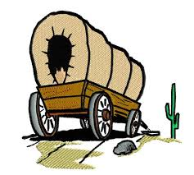

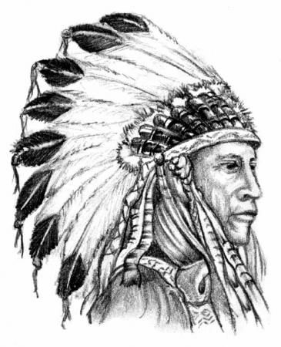

Our topic is Wild, Wild West. In this half term we are focusing on different aspects of American culture. We will start of by looking at how the Native Americans used to live and what they used to believe. Children will then learn why people migrated to America and the impact the new settlers had on this new land. They will also consider what life was like for these early settlers.

In the other half term, we will also look at modern America and look at influential characters such as Martin Luther King. We will be focusing in particular on the way in which the black community were treated and how this impacted modern laws.

A lot of the subjects this term will be connected with our main topic of the Wild Wild West. In Art, we will be exploring the use of Haida symbols and how we can use these in our own pieces of art. In Design and Technology, we will plan and construct our own totem poles which were important to Native Americans. We will also create dream catchers. The children will also be exploring the culture of the Native Americans and settlers by their music.

In Science this term, we are learning about inheritance and adaptation and linking this with our topic. Children will learn about the animals and plants of America, how they have evolved and adapted to the impact of the changing country.

**Please see the school website for further information about curriculum skills covered throughout the academic year.**

**English**

* The children will be exploring the novel ‘Holes’ by Louis Sachar in class.
* Children will be using the text as a basis for their work with figurative language, description, characterisation and persuasive texts.
* They will also be writing non-chronological texts based on the Wild Wild West.
* Throughout each focus children will be drafting, editing and writing final drafts.
* Through these lessons they will also be consolidating their understanding of grammar terms and learning to use the full range of sophisticated punctuation expected in year 6.

In the lead up to SATs we will be going through most of the curriculum again – place value, operations, fractions, percentages, decimals proportion, ratio, time, graphs and charts, probability and shape problems.

We will be looking at using our knowledge in reasoning questions which sometimes use more than one maths skills.

We will also be looking at being efficient but careful when completing mental math questions.

**It is important that at home children are still practising times tables.**

**Maths**

**Home Learning!**

Spellings, reading and times tables should be done on a daily basis.

English and Maths will be set on a weekly basis.

Children are to take the theme of ‘wagons’ and create a piece of their choice. This could be a model, a sketch, a fact sheet or even a story. Due date Monday 24th February

**Wild Wild West**