Menu Items Containing Allergens
23rd February 2026
 | 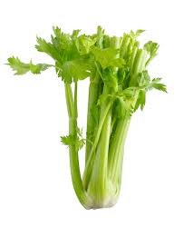 | 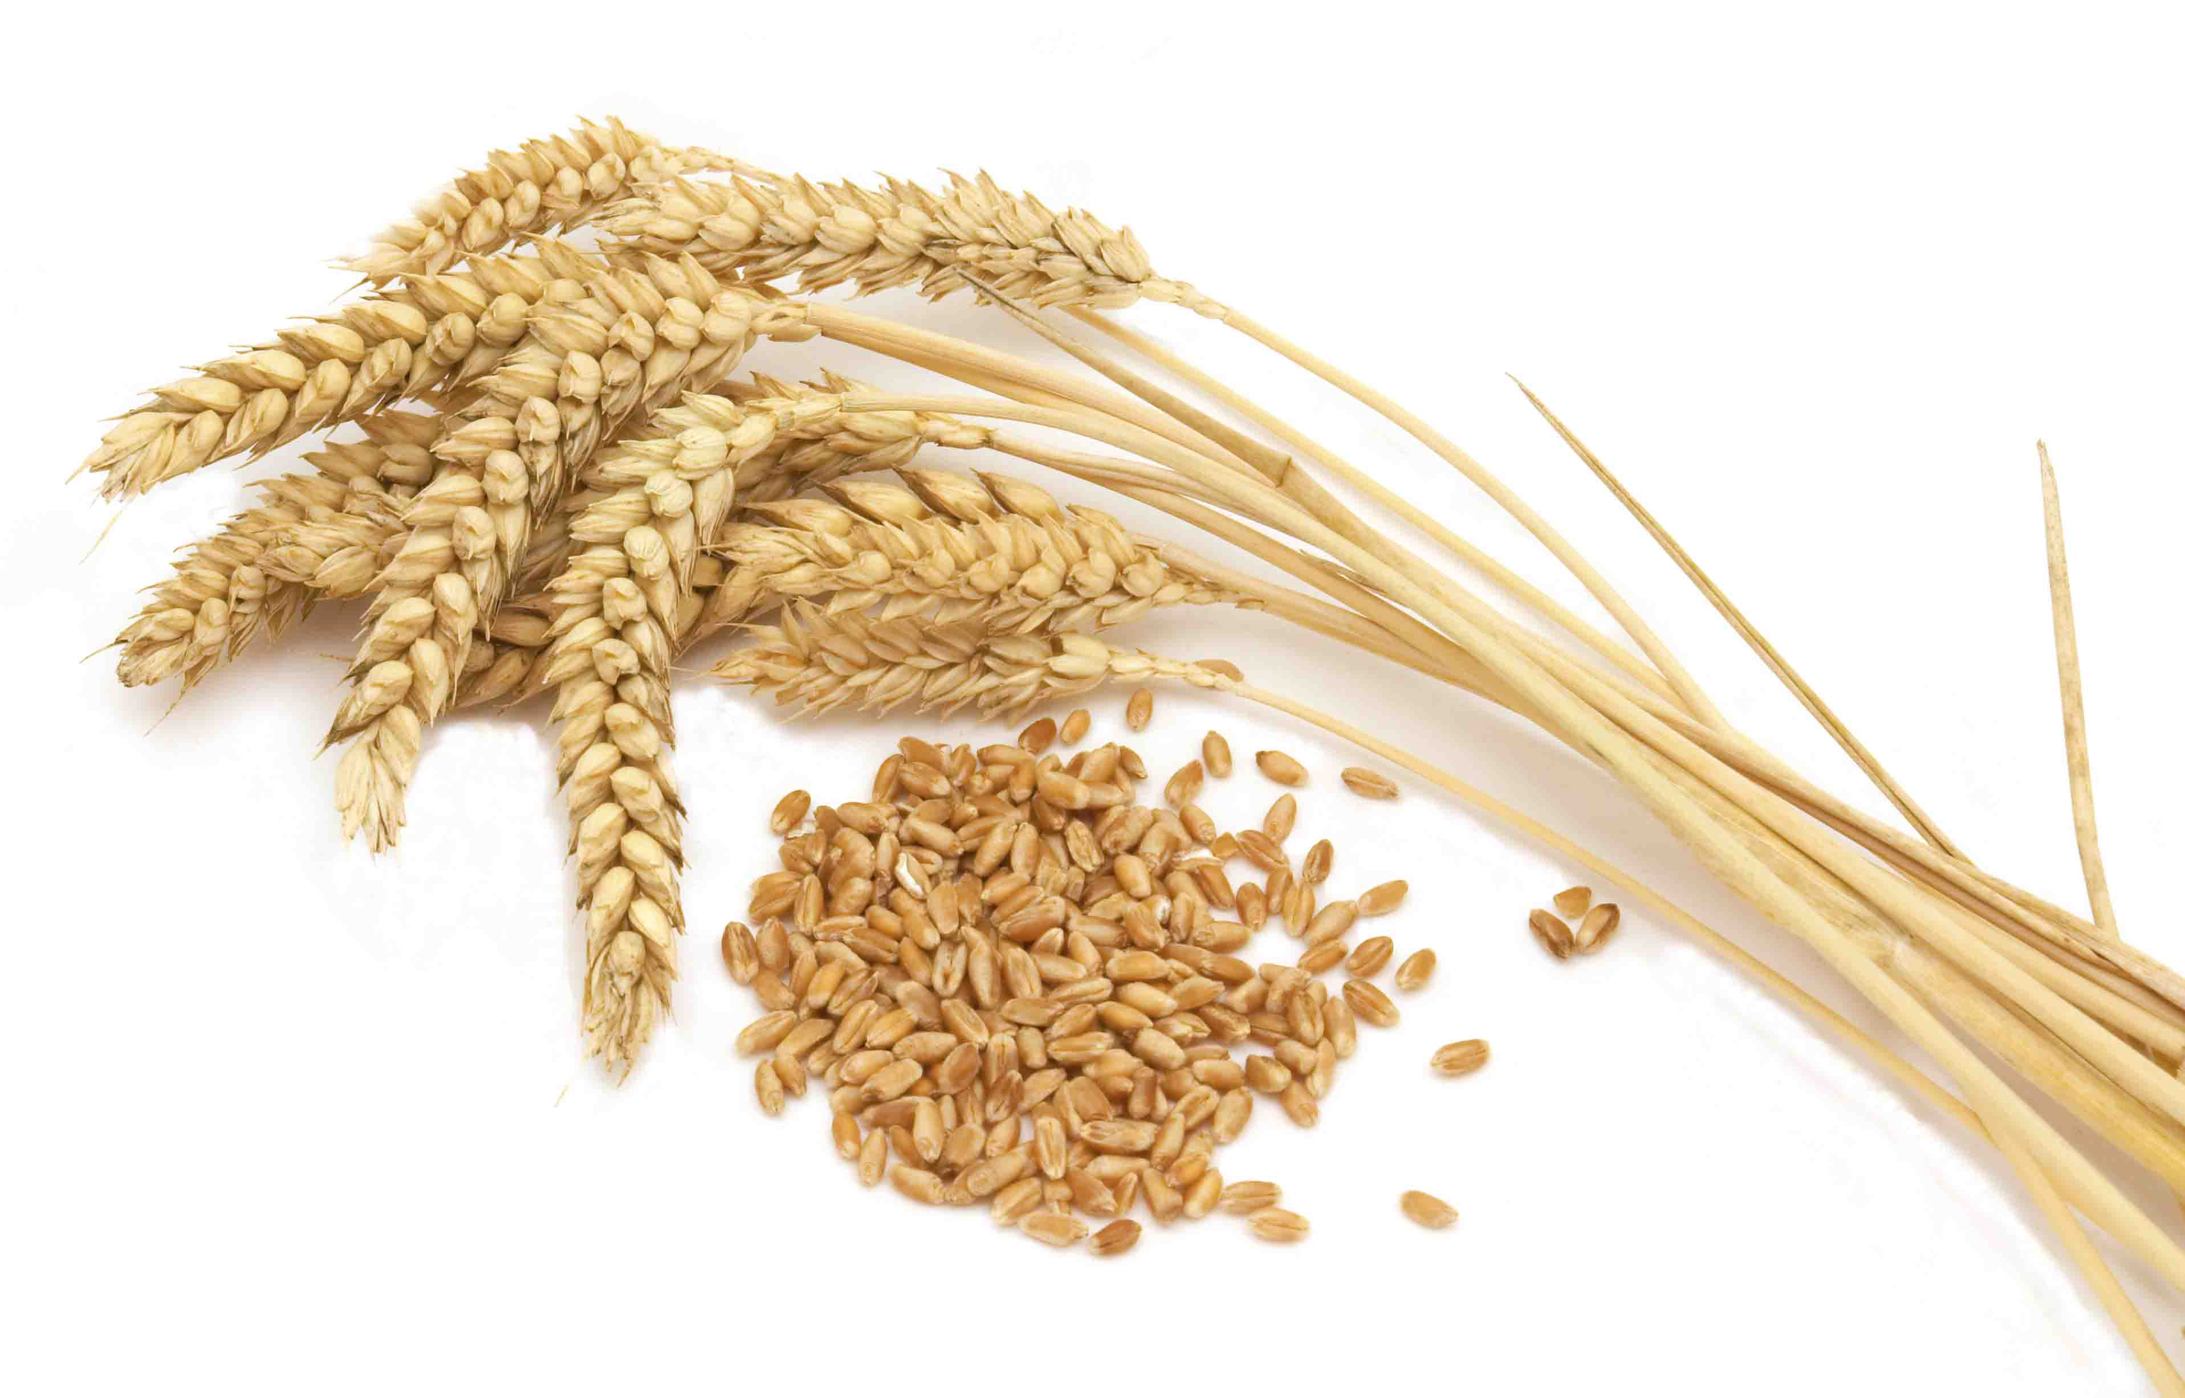 | 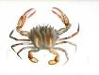 |  | 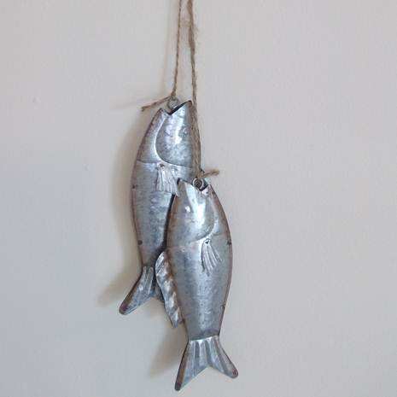 |  |  | 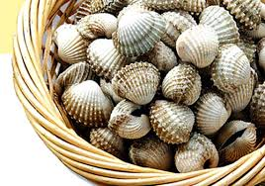 | 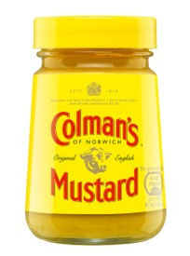 | 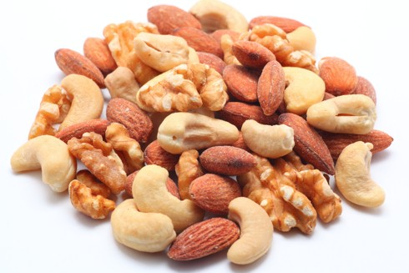 | 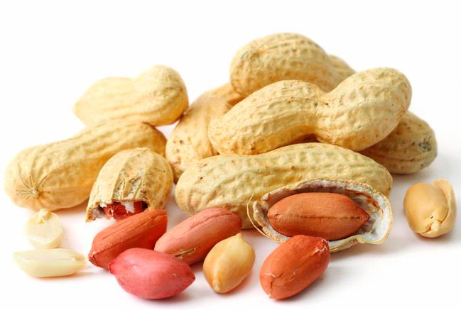 | 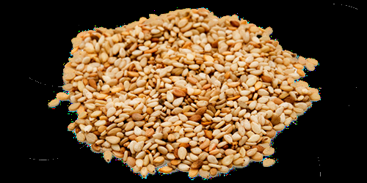 | 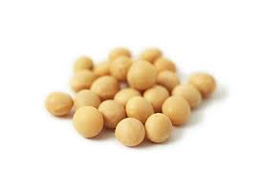 | 
Menu Item | Celery | Gluten | Crustacean | Eggs | Fish | Lupin | Milk | Mollusc | Mustard | Nuts | Peanuts | Sesame  Seeds | Soya | Sulphur  Dioxide
Naan |  | x |  |  |  |  |  |  |  |  |  |  | x
Quorn |  |  |  | x
Pasta/Pastry |  | x |  | x |  |  | x
Cheese |  |  |  |  |  |  | x
Curry Sauce |  |  |  |  |  |  | x
Sausages |  | x |  |  |  |  | x
Fish Fingers |  | x |  |  | x
Heinz Ketchup | x
Mayonnaise |  |  |  | x |  |  |  |  | x
Pork Meatballs |  | x |  |  |  |  | x |  | X |  |  |  | X
Mashed Potato P/F |  |  |  |  |  |  | X
Veggie nuggets |  | x
Sponge |  | x |  | x |  |  | x
Ice Cream |  |  |  |  |  |  | x
pancakes |  | x |  |  |  |  | x
Sausage |  | x |  | x |  |  | x
Vegan
sausage

Menu Items Containing Allergens
2nd March 2026

Menu Item | Celery | Gluten | Crustacean | Eggs | Fish | Lupin | Milk | Mollusc | Mustard | Nuts | Peanuts | Sesame  Seeds | Soya | Sulphur  Dioxide
Quorn |  |  |  | x
Pasta/Pastry |  | x |  | x |  |  | x
Cheese |  |  |  |  |  |  | x
Chicken nuggets |  | x |  |  |  |  | x
Veggie nuggets |  | x |  |  |  |  | x
Lasagne | x | x |  | x |  |  | x |  | x |  |  |  | x
Fish Fingers |  | x |  |  | x
Mac ‘N’Cheese | x | x |  | x |  |  | x |  |  |  |  |  | x
Heinz Ketchup | x
Mayonnaise |  |  |  | x |  |  |  |  | x
Pork Meatballs |  | x |  |  |  |  | x |  | X |  |  |  | X
Mashed potato P/F |  |  |  |  |  |  | X
Vegan Meatballs |  | x |  |  |  |  |  |  |  |  |  |  | x
Veggie Grill |  | x |  |  |  |  | x
Sponge |  | x |  | x |  |  | x
Ice Cream |  |  |  |  |  |  | x
pancakes |  | x |  |  |  |  | x

Menu Items Containing Allergens
9th March 2026
Menu Item | Celery | Gluten | Crustacean | Eggs | Fish | Lupin | Milk | Mollusc | Mustard | Nuts | Peanuts | Sesame  Seeds | Soya | Sulphur  Dioxide
Naan |  | x |  |  |  |  |  |  |  |  |  |  | x
Quorn |  |  |  | x
Pasta/Pastry |  | x |  | x |  |  | x
Cheese |  |  |  |  |  |  | x
Curry Sauce |  |  |  |  |  |  | x
Sausages |  | x |  |  |  |  | x
Fish Fingers |  | x |  |  | x
Heinz Ketchup | x
Mayonnaise |  |  |  | x |  |  |  |  | x
Mashed Potato p/food |  |  |  |  |  |  | X
Cheese Pizza |  | x |  |  |  |  | x
Vegie nuggets |  | x
Sponge |  | x |  | x |  |  | x
Ice Cream |  |  |  |  |  |  | x
pancakes |  | x |  |  |  |  | x
Sausage |  | x |  | x |  |  | x

Menu Items Containing Allergens
16th March 2026
Menu Item | Celery | Gluten | Crustacean | Eggs | Fish | Lupin | Milk | Mollusc | Mustard | Nuts | Peanuts | Sesame  Seeds | Soya | Sulphur  Dioxide
Naan |  | x |  |  |  |  |  |  |  |  |  |  | x
Quorn |  |  |  | x
Pasta/Pastry |  | x |  | x |  |  | x
Cheese |  |  |  |  |  |  | x
Curry Sauce |  |  |  |  |  |  | x
Garlic Slice |  | x
Sausages |  | x |  |  |  |  | x
Fish Fingers |  | x |  |  | x
Heinz Ketchup | x
Mayonnaise |  |  |  | x |  |  |  |  | x
Pork Meatballs |  | x |  |  |  |  | x |  | X |  |  |  | X
Mashed Potato P/F |  |  |  |  |  |  | X
Veggie Nuggets |  | x
Sponge |  | x |  | x |  |  | x
Ice Cream |  |  |  |  |  |  | x
pancakes |  | x |  |  |  |  | x
Sausage |  | x |  | x |  |  | x

Menu Items Containing Allergens
23rd March 2026
Menu Item | Celery | Gluten | Crustacean | Eggs | Fish | Lupin | Milk | Mollusc | Mustard | Nuts | Peanuts | Sesame  Seeds | Soya | Sulphur  Dioxide
Naan |  | x |  |  |  |  |  |  |  |  |  |  | x
Quorn |  |  |  | x
Pasta/Pastry |  | x |  | x |  |  | x
Cheese |  |  |  |  |  |  | x
Curry Sauce |  |  |  |  |  |  | x
Sausages |  | x |  |  |  |  | x
Fish Fingers |  | x |  |  | x
Heinz Ketchup | x
Mayonnaise |  |  |  | x |  |  |  |  | x
Pork Meatballs |  | x |  |  |  |  | x |  | X |  |  |  | X
Mashed Potato P/F |  |  |  |  |  |  | X
Cheese Pizza |  | x |  |  |  |  | x
 |  | x |  |  |  |  | x
Sponge |  | x |  | x |  |  | x
Ice Cream |  |  |  |  |  |  | x
pancakes |  | x |  |  |  |  | x
Sausage |  | x |  | x |  |  | x

