

We shall: *read a range of texts as a stimulus for our learning, (fiction and non- fiction). These texts include: ‘There’s a Viking Under My Bed,’ by Jeremy Strong and ‘The Philosopher’s Stone’ by JK Rowling. *write in a range of genres such as traditional poetry, imaginary world stories and non-chronological reports. *use different key skills. These will include: teaching prefix and subordinate clauses, plural and possessive-s, appropriate choice of pronouns and nouns, expanded noun phrases, apostrophes to mark plural possession, using commas with fronted adverbials, determiners and direct speech punctuation.

We shall be learning how to:

Year Three:

* solve problems involving addition and subtraction using fractions.

* solve addition and subtraction problems in different contexts, including data.

* make, draw and identify shapes with right angles.

Year Four:

*count backwards through zero to include negative numbers and solve practical problems involving them

*solve addition and subtraction problems in different contexts

*solve problems with fractions including equivalent fraction families, addition and subtraction and begin to explain the relationship between fractions and decimals

* locate points on a grid in the first quadrant

**\*In Year Three and Four we shall also develop our ability to explain and justify methods and solutions**.

**Maths**

**Topic**

**Home Learning** 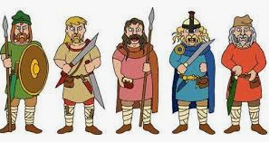

The children are encouraged to read and practise their spellings and

times tables daily. (Year Three: x3, x4, x8/ Year Four: All tables up to x12)

Homework will be set regularly on Teams Classroom and/ or MyMaths.

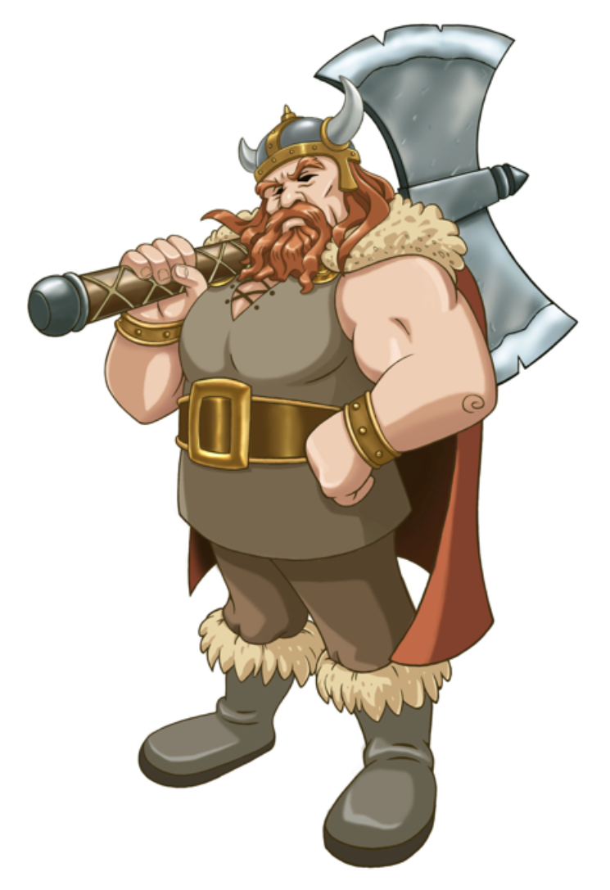Our topic this half term is ‘Incredible Invaders.’ We shall be finding out about the Anglo Saxon and Viking reigns in British history. We shall also consider whether the Viking invasion changed Britain for the better. As scientists, we shall be learning about electricity. We shall undertake experiments, during which we shall make predictions and compare and make observations. Through their learning, the children will develop their ability to report their findings and conclusions, both orally and in a written form.

In Art, we shall be looking at Anglo- Saxon jewellery as a stimulus for this term’s project. The children shall have the opportunity to develop their designs for a brooch or buckle. In computing, we shall be using Scratch to create simple games, at all times using the internet responsibly. Within French sessions, we shall continue to use a bilingual dictionary. During our lessons, the children shall apply and extend their understanding of some grammatical areas: adverbial, nouns, verbs, adjectives and conjunctions to their own simple written sentences. Also, we shall learn more about some of the famous Paris landmarks and be able to speak about them.

Within our RE sessions, we shall be considering whether a pilgrimage is necessary for believers. Through discussion, we shall be discussing Christian pilgrimages in order to compare these with those of the Hindu faith. In PHSE sessions, we shall be finding out why exercise is important to our health. Part of this learning will involve keeping an ‘Activity Diary’ for a week.

.

**Spring One 2021**

**Year 3/4 Curriculum News**

**Incredible Invaders!**