**Topic**

As **Scientists,** we shall be exploring **Magnetism** by naming different kinds of forces, describing properties of magnets**,** grouping magnetic and non-magnetic materials and learning to explain magnetism.

As **Landscape** **Artists**, we will learn who **Turner** was know who Turner was and explain his style of artwork. Using sketchbooks, we will record ideas with different grades of pencils and will make choices about which colours to use by mixing.

As **Geographers**, we will be carrying out some local field work including a traffic survey that we can link to statistics in Maths. Our **Historian** work will continue with the **Anglo-Saxons**.

As **Builders** in **Design Technology**, we shall research and design a shelter to meet a brief. We will choose materials to construct a shelter, - test a structure and evaluate its suitability. After testing, we’ll make improvements to reinforce our structures.

As **Computer Scientists** in **IT**, we shall be using data to create a branching database and learning to present information.

As **Linguists** in French we shall continue to use a bilingual dictionary. During our lessons, the children shall apply and extend their understanding of some grammatical areas: adverbial, nouns, verbs, adjectives and conjunctions to their own simple written sentences. Also, we shall learn more about some of the famous Paris landmarks and be able to speak about them.

As **Cultural explorers,** in RE, we will answer the question ‘Should believers give things up?’ as part of our understanding of Lent, in Christianity.

As **Global Citizens** in **PSHE**, we will learn how to: call emergency services; respond to bites and stings; become a responsible digital citizen; learn about cyberbullying and identify unsafe digital content; explore influences and make independent choices and develop our awareness of road safety.

We shall focus on **Length and Perimeter** and **Money**.

We will learn how to:

Measure length  
Use equivalent measures of mm, cm and m  
Compare lengths  
Add lengths  
Subtract lengths  
Measure perimeter  
Calculate perimeter

Count money in pence and pounds  
Add money  
Subtract money  
Give change

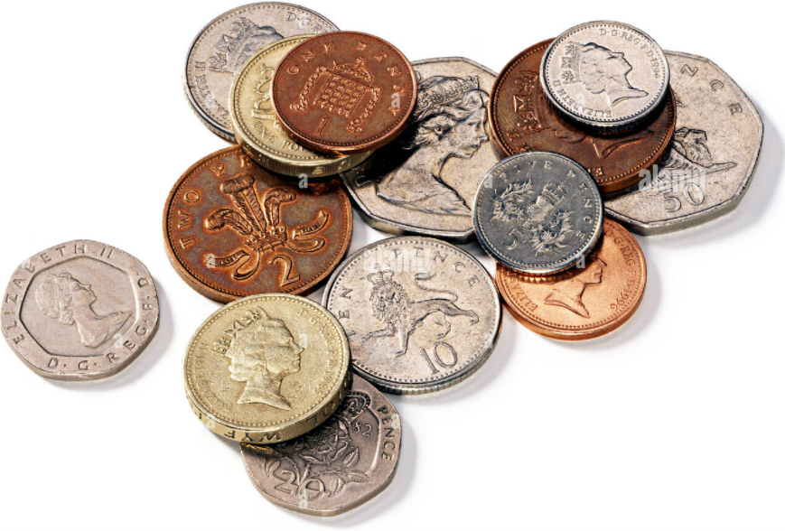

**Maths**

**English**In **Reading,** we shall:

Use dictionaries to check the meanings of words  
Read books in different forms and for different purposes  
Discuss words and phrases that capture the reader’s interest

In **Writing,** we shall learn to use:  
Prepositions   
Headings and sub-headings  
The present perfect form of verbs  
Plural nouns  
Plural to show possession   
Prefixes – super, anti, auto

The texts we’ll base our learning are:  
**True Story of 3 Little Pigs by Jon Scieszka** (Narrative, comedy)  
**How a Robot Dog Works** (Non-Fiction Explanation Text)

**Home Learning**

The children are encouraged to read and practise their spellings and

times tables daily.

Homework shall be set regularly on Teams Classroom

**Year 3 - Artists and Builders!  
Spring Two 2022**

**Year 3/4 Curriculum News**