**Topic**

**Home Learning**[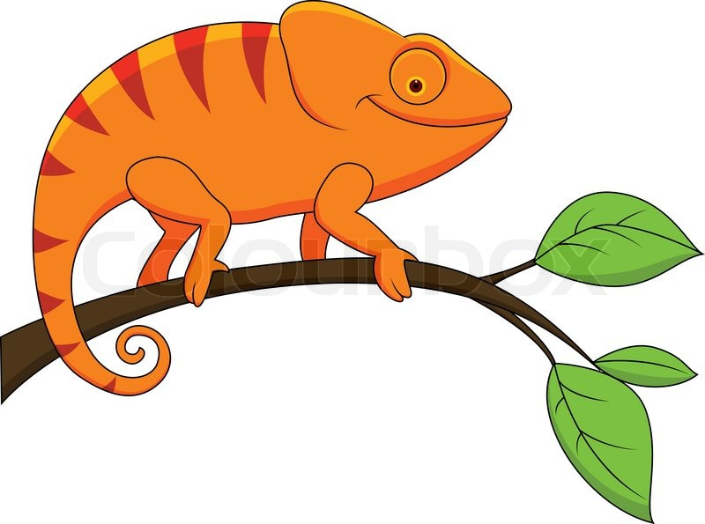](https://www.google.co.uk/url?sa=i&rct=j&q=&esrc=s&source=images&cd=&cad=rja&uact=8&ved=0ahUKEwityNjahpPWAhWGPxQKHUmxAXQQjRwIBw&url=https://www.pinterest.com/pin/443604632029651982/&psig=AFQjCNFVUGcOADvq8x9jfkCyKlet6juLeg&ust=1504872940786590)

Homework will be set half termly-see homework choice table.

Spellings, reading and times tables should be practised on a daily basis.

**Maths**

We shall be learning how to:

**\*explain how we know an observation is correct and explain methods and solutions.**

Year 3:

*explain the representation of two digit positive numbers as Roman Numerals,

*solve addition and subtraction problems in different contexts, including data, measurement using number facts, place value, counting, mental and written methods.

* identify that fractions are numbers and to understand the meaning of the denominator and numerator.

*solve problems involving multiplication and division.

*recognise horizontal, vertical, parallel and perpendicular lines.

Year 4:

* explore the concept of area through counting squares

*secure our formal written methods of multiplication and division recognise and show, using diagrams, families of common equivalent fractions. *solve problems involving increasingly harder fractions to calculate quantities, and fractions to divide quantities, including non-unit fractions where the answer is a whole number.

*add and subtract fractions with the same denominator. *recognise decimal equivalents of 1/2,,¾ and ¼

[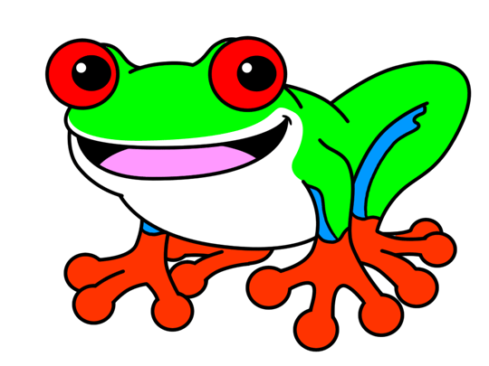](http://www.google.co.uk/url?sa=i&rct=j&q=&esrc=s&source=images&cd=&cad=rja&uact=8&ved=0ahUKEwinwqT0hpPWAhXE7xQKHWoOBsoQjRwIBw&url=http://www.how-to-draw-cartoons-online.com/how-to-draw-a-frog.html&psig=AFQjCNFIbj6BYcv2uRD5QI8VzCYuirjMdg&ust=1504872992890059)Our topic is ’The Rainforest’ and we shall be learning about rainforests around the world using many geography skills. We shall identify where rainforests are found using maps, globes, atlases and digital images. As scientists, we shall be finding out about the four layers of the rainforest. This will include the study of plants and in particular, the function of flowering plants.We shall be considering the requirements that plants need for life and growth. This will include investigating how water is transported. We shall be exploring the habitats of the rainforest and the living creatures to be found there. In History we shall be learning about the ancestry of rainforest tribes and compare their lives’ to ours. This will include learning about tribal music and having a go at our own tribal dance! A stimulus for our art lessons will be looking at the shapes and colours within the rainforest. We shall be using a variety of mediums to transform our classroom into a rainforest. As a botanical illustrator, William Keble Martin’s work will help to inform our learning. During RE lessons, we shall be considering whether Easter makes sense without Passover. In PSHE we shall be considering how important it is to understand others’ differences. The pupils will learn how to celebrate diversity and to recognise the need for equality in our society. During French sessions based on sea animals and the city of Paris, children will describe in French using adjectives and adverbs, understanding the importance of adjectival agreement. The skills of speaking, listening, reading and reading will be further developed. In computing we shall be focusing on creating simple games using variables.



We shall: *read a range of texts as a stimulus for our learning such as ‘Where the Forest Meets the Sea’ by Jeannie Baker and ‘The Great Kapok Tree’ by Lynne Cherry. *use different key skills. These will include: teaching the difference between compound and complex sentences; exploring how to include powerful adjectives, verbs and adverbs in our writing: express time, place and cause using conjunctions and knowing when to make a new paragraph. *write in a range of genres such as recount, poetry, letters and report.

**Spring 2020**

**Year 3/4 Curriculum News**

**The Rainforest**