

**Newsletter**

**Summer Term 1 2022**



ATTENDANCE Article 28 -right to education

At the time of writing, whole school attendance was 93.8% (the national expectation is 95%). Compared to other schools nationally, we are doing well. Our whole school target for attendance for the school year 2021-22 is 96%. A consultation is underway with a proposal that attendance intervention at school level will be triggered by 10 sessions (5 days) of unauthorised absences in term time. We suggest, therefore, that you are even more mindful of this when considering any leave. Just to remind you that holiday requests will not be authorised and other requests for leave, unless exceptional circumstances, will also be unauthorised. We are guided by the LA, but the school’s position on absence has not really changed over time. We empathise, but we will and are expected to challenge absences that are avoidable. Every lesson counts. At the start of the new academic year, as we have done previously, you will be issued with a standard communication outlining the school and LA’s approach to absences.

**Bikes, Scooters and Dogs**

A reminder, to ensure the safety of all our school pupils, staff and visitors, dogs are not permitted to enter the school premises at any time. In addition, scooters and bicycles must not be ridden on school premises. Please dismount and walk the scooter / bicycle across the school site.

**Healthy Lunchboxes and Water Bottles**

Please ensure that you are sending your children to school with a healthy packed lunch. Please try to include a piece of fruit and a healthy snack bar and not contain sweets. All food must be nut free; this includes peanut butter and chocolate spread which contain hazelnuts. For healthy lunchbox ideas, please visit the [NHS Better Health](https://www.nhs.uk/healthier-families/) website. Key Stage Two children must bring a **reusable** water bottle into school each day.  This should have their name on and be taken home daily for cleaning.

**Sun hat and Sun cream**

Please could all children bring a sun hat to school (with their name in) and please apply sun cream to your child before school.  There is very little shade on the playground and children need to be protected from the sun during playtime.

**PE Kits**

A polite reminder regarding the school **PE** kit. This must consist of the following items/colours

* Plain black or navy shorts
* Navy blue T-shirt
* Plimsolls and trainers
* Plain (dark) tracksuit
* We ask that earrings are **not to be worn** on PE days
* Hair must be tied up at all times

**Staffing**

I am pleased to inform you that Mr Young has joined the site team and we welcome him.

**Sports Day**

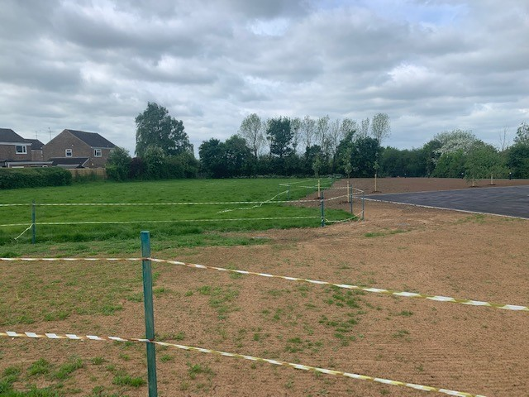

As you can see from the photograph, following on from the new build we are waiting for the grass to grow in order to have a bigger field again. Because of the lack of space at the moment we are unable to hold our usual sports day where we invite parents.

As the **Year Six pupils** will be leaving us we will be having a sports day to which the Year six parents are invited. This will take place on **Tuesday 14th June at 9:30am.**

Instead we will be holding an in-house sports day in Key Stages. More information will follow regarding this event.

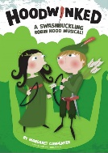**School Play**

Rehearsals are well under way for our KS2 summer performance of ‘Hoodwinked’ by Margaret Carpenter. Robin Hood is back in town, along with Maid Marian, the Sheriff of Nottingham, Friar Tuck and Richard the Lionheart. Will he succeed in his plight to free the nation from the tyranny of the wicked Sheriff? Will King Richard return from the Crusades in time? And, will Maid Marian get her man? The answers to these questions and more will be available on Wednesday 22nd June and Thursday 23rd June. Please watch out for a letter regarding how to purchase tickets coming to you soon.

**Leavers Assembly**

The Year six leavers assembly will take place in Salcey Hall on Tuesday 19th July at 1:15pm.

**Jubilee**

We are looking forward to celebrating the Queen’s Jubilee in school on Monday 23rd May. Don’t forget to come to school dressed in red, white and blue. We will be holding our Jubilee parade where there will be a winner from each class for the best crown! Don’t forget to send your child in with a picnic lunch if you haven’t ordered one.

**Picnic Lunch Last Day**

On Wednesday 20th July, the last day of this academic year, we would like to invite you to a have a picnic lunch with your child/ren at school. The children in Foundation, Year One and Year Two will have their picnic lunch on Linford Playground. Year Three and Year Four will have their picnic lunch on Salcey Playground and Year Five and Year Six will have their picnic lunch on the school field. If you have children in different year groups you may of course picnic together. Any children without a parent/family member attending the picnic will be able to eat with their class teacher.

**At 1pm the children will return into school to gather their belongings and you will then be able to take them home with you. If you are unable to attend the picnic or take your child home at 1 pm they of course can stay in school until the normal end of day finishing time.**

**Diary Dates**

*Details for key events will follow nearer to the time.*



**Monday 23rd May -** Queens Platinum Jubilee celebrations in school

**Wednesday 25th – Friday 27th May** – Year 6 residential

**Friday 27th May -** Last day of Summer 1

**Monday 30th May – Friday 3rd June –** Half Term holiday

**Monday 6th June –** INSET Day

**Tuesday 7th June –** Summer 2 begins

**Wednesday 22nd June and Thursday 23rd June @ 6:30pm** – KS2 School Play Hoodwinked

**Friday 24th June –** Non-Uniform

**Monday 4th July –** School Book Fair

**Friday 15th July -** School reports out

**Friday 15th July** – Image Musical Theatre presents ‘The Sword in the Stone’

**Monday 18th July** – Transition afternoon

**Tuesday 19th July** – Transition morning

**Tuesday 19th July** – Year 6 Leavers assembly

**Tuesday 19th July -** Open evening to meet your child’s new teacher.

**Wednesday 20th July –** Last day of the academic year – finish at 1pm.

- Non-Uniform

- Picnic lunch with family

**Monday 5th September** – Start of the Autumn Term

* ***Please note all the dates and times shown here are accurate at the time of the publication of this newsletter. Any unforeseen event may happen that could cause alterations to the information listed below; if this does occur we will endeavour to let you know as quickly as possible.***

**Ryan Brown** ryan.brown@hanslope.milton-keynes.sch.uk