**Maths**

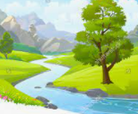

**Home Learning**

The children are encouraged to read and practise their spellings and

times tables daily.

(Year Three: x3, x4, x8/ Year Four: All tables up to x12)

**Homework will be set via Teams on a weekly basis.**

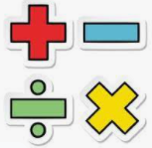

**\*In Year Three and Four, we shall develop our ability to explain and justify methods and solutions**.

We shall be learning how to:

Year Three:

*add and subtract numbers mentally.

*use formal methods of addition, subtraction, multiplication and division.

*use diagrams to recognise and show equivalent fractions.

*solve problems involving multiplication and division, including missing number, scaling and correspondence problems.

Year Four:

*identify, represent and estimate different representations of different numbers

*estimate length and capacity when problem solving

*solve multi step problems- addition, subtraction and multiplication

*round decimal numbers to the nearest whole number and compare decimal numbers

*count in multiples of 6, 7, 9, 25 and 1000.

*recap multiplication and division methods and use these in problem solving including scaling down and money problems.

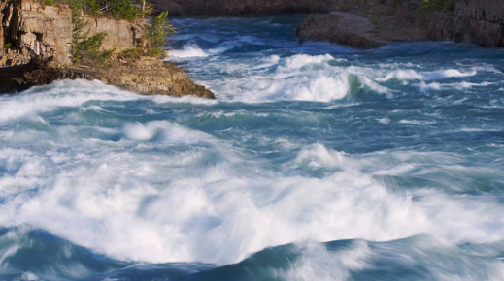 **Topic** 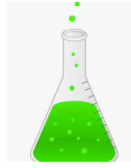This half term, our topic is ‘Raging Rivers.’ During our learning, we shall find out about the journey of a river. As Geographers, we shall consider how a river starts and what key features a river has. Through observation and discussion, we shall identify how they change over time. We shall also develop our understanding of how the water cycle works and the important part it plays in creating water systems, whilst sustaining the planet. As scientists, we shall undertake a range of targeted investigations such as how magnetic forces act through different materials. We shall predict and compare, and continue to develop our observation skills. Throughout our learning, we shall further our ability to report findings and conclusions, both orally and in written form.In Art, we shall consider the work of the famous artist Joseph William Turner. Using a range of important art skills, we shall create pieces in his style. Within French sessions, we shall continue to respond to classroom instructions given in French. During our lessons, we shall learn how to ask someone how old they are and where they live. We shall learn more about some of the famous British capital landmarks and name them in French. We shall also find out about the circumflex accent. During our RE sessions, we shall consider whether miracles actually happen. Through discussion, we shall explore our own thoughts and feelings about some of the Christian stories in which Jesus is believed to have performed miracles; such as ‘The Feeding of the Five Thousand.’ In PSHE lessons, we shall focus on how it is part of the human condition to make mistakes and we hope to develop further strategies to support our own resilience and approach to this. In Computing, we shall develop our understanding of word processing through the creation of our own work on laptops. During PE sessions, we shall focus our learning on athletics and football. In Music, we shall be developing a range of skills, alongside listening to and appraising instrumentals and melodies.

 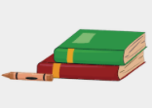

We shall: *read a range of texts to support our learning (fiction and non- fiction). Our DEAR book this half term is: ‘Cliffhanger’ by Jacqueline Wilson. *use a ‘cross-curricular approach’ to write in a range of genres such as persuasive letters, poetry and playscripts. *use a range of key skills. These will include: teaching different sentence structures and length, including the use of subordinate clauses and their effect on the reader. Also, the following grammatical features will be taught and revised: plural and possessive-s, appropriate choice of pronouns and nouns, expanded noun phrases, apostrophes to mark plural possession, using commas with fronted adverbials, determiners and direct speech punctuation.

**Summer One 2021**

**Year 3/4 Curriculum News**

**Raging Rivers!**