**Maths**

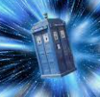

**Home Learning**

The children are encouraged to read and practise their spellings and

times tables daily.

(Year Three: x3, x4, x8/ Year Four: All tables up to x12)

**Homework will be set via Teams. MyMaths homework may also be set on occasion.**

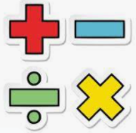

**\*In Year Three and Four, we shall develop our ability to explain and justify methods and solutions**.

We shall be learning how to:

Year Three:

*add and subtract numbers mentally.

*use formal methods to solve problems involving addition, subtraction, multiplication and division, (including money).

*measure the perimeter of simple 2-D shapes.

*measure, compare, add and subtract: lengths (m,cm,mm); mass (kg, g) volume (l,ml )

*tell the time from an analogue clock: 12 hour and 24 hour clocks

Year Four:

*calculate the area and perimeter of 2d shapes and use this in problem solving

*read, write and convert time between analogue and digital 12 hour and 24 hr clocks

*identify lines of symmetry in 2d shapes and complete a simple symmetric figure

* solve addition and subtraction problems in different contexts including measure

* solve problems involving multiplication, division and fractions in different contexts

**Topic** 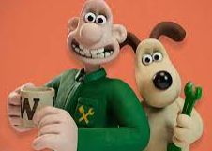This half term, our topic is ‘Incredible Inventions.’ During our learning, we shall find out about inventions and how they have helped shape our lives. As Historians, we shall consider how items from the past help us build up an accurate picture of how people lived. Through observation and discussion, we shall identify how thoughts and ideas have been built upon and developed over time. We shall also secure our understanding of chronological order by creating a timeline of inventions. As scientists, we shall undertake a range of targeted investigations focused on our learning about light and dark; such as creating shadows. We shall predict and compare, and continue to develop our observation skills. Throughout our learning, we shall further our ability to report findings and conclusions, both orally and in written form.In Art, we shall complete our learning about William Turner by creating our own watercolour pictures. Following that, we shall be designing and creating our own weave patterns. Within French sessions, we shall be learning to ask and respond to questions about where we live and in what type of dwelling. We shall also be using the negative ‘ne…pas’ when talking and writing. During our RE lessons, we shall consider whether prayer changes things. Through discussion, we shall learn about prayer and what it is. We shall consider the similarities and differences between Hindu and Christian prayer, whilst exploring our own thoughts and feelings.’ In PSHE lessons, we shall focus on transition into the next academic year. There will also be a short unit to complete our RSE learning for the year. (Parents/ carers will receive further information about this). In Computing, we shall develop our understanding of programming by writing, debugging and creating our own programmes. During PE sessions, we shall focus our learning on rounders, cricket and athletics. In Music, we shall be developing a range of skills within Covid 19 restrictions. These will continue to include listening to and appraising instrumentals and melodies.

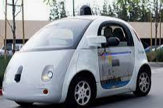

 

We shall: *read a range of texts to support our learning (fiction and non- fiction). Our DEAR book this half term is: ‘Operation Gadgetman’ by Malorie Blackman. *use a ‘cross-curricular approach’ to write in a range of genres such as explanation texts, descriptive and persuasive writing. *use a range of key skills. These will include: teaching different sentence structures and length, including the use of subordinate clauses and their effect on the reader. Also, the following grammatical features will be taught and revised: plural and possessive-s, appropriate choice of pronouns and nouns, expanded noun phrases, apostrophes to mark plural possession, using commas with fronted adverbials, determiners and direct speech punctuation.

**Summer Two 2021**

**Year 3/4 Curriculum News**

**Incredible Inventions!**