Summer term 2 - Week 6 Year 6 (Week starting 6.7.20)
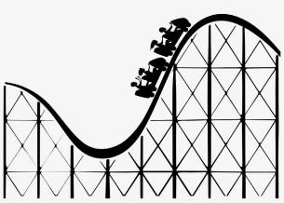
We are now into the sixth week of Summer 2!
This week you may still well be carrying on with your Theme Park project! We are still finishing off a few things in the classroom.
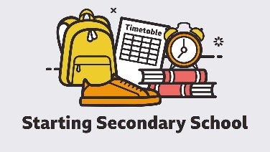
There is work on the website from last week still on the website for English and maths but if you do need more please let me know. There will also be new MyMaths tasks.
This week we will be starting to look at transition to secondary school.
We know that this can be a worrying time (even without the current situation) and we want to give a few ideas of what you could be doing to relieve some of that worry.
A pack has been put on the website which children can do and relate it to their own secondary school.
Some secondary schools have sent work or information regarding their own transitions. In school, we will look at the general transition and where possible make it personalised.
Here are some extra ideas for children to get started thinking about secondary school:
- Do the walk/bike ride/car journey to the new secondary school to see how long it might take and what they might see on the way
- Create your own secondary school top tips poster – what might you expect when you are there?
- Write yourself a letter about this year and what you expect for next year. Keep it safe and when you have finished year 7 open it and see if what you thought was correct!
- Write down your worries. Discuss them with your family and see if you can dispel some of your worries.
- Have a look through the videos on the BBC Starting Secondary pages:
- https://www.bbc.co.uk/bitesize/tags/zh4wy9q/starting-secondary-school/1
- https://www.bbc.co.uk/teach/teacher-resources-for-students-transitioning-to-secondary-school/zb68y9q
- Any questions that you cannot answer make sure you save them. Your parents may well be able to contact the secondary school to ask them or you might have to wait till September. Mrs Knight and I will also help where we can answering any questions you are unsure about.

If you need any help or want to show me your work feel free to contact me and Mrs Knight would still love to see work from the children as well. BBC Bitesize will still be doing their online lessons which we will sometimes be using.
Jenny.broughton@hanslope.milton-keynes.sch.uk
Donna.knight@hanslope.milton-keynes.sch.uk
Have a good week!
Mrs Broughton

