Larch Timetable Summer 2 Week 7
 |  | 9.20 - 10.30am | 10.30 – 10.45 | 10.45am - 12pm | 12 – 1pm | 1 – 2pm | 2 – 3pm
Monday | Warm up  Zumba | English Bitesize  What is a story?  Story time and fruit snack | BREAK | Maths Bitesize  Time: o’ clock | LUNCH | Andy Goldsworthy – create a scene in his style.  Look at the ppt to find out a bit about Andy Goldsworthy. Discuss what ‘natural’ means. He uses natural materials. Can you make a sculpture by using natural material? Draw a simple picture first – like a fish or a spiral.  Next collect natural materials to use in your work. Then construct your sculpture. Take a photo of it and send it to Mrs Fox!
Tuesday | Warm up  Zumba | Maths Bitesize  Time: half past  Story time and fruit snack |  | English Bitesize  Characters in a story |  | Today we are going to go outside and design a house for a fairy or elf to live in. Think about what size it should be? What could we use to build it?  Look at the picture below as an example. We are going outside to use anything natural we can find!
Wednesday | Warm up  Zumba | PE  Story time and fruit snack |  | PE |  | Outdoor learning  Make a Frisbee, bird kite, tennis racket  See links below
Thursday | Warm up  Zumba | Maths Bitesize  Writing and measuring time  Story time and fruit snack |  | English Bitesize  What is a setting? |  | Outdoor learning  Land art challenge cards
Friday | Warm up  Zumba | Nim’s Island video |  | Free choice! |  | Free choice!
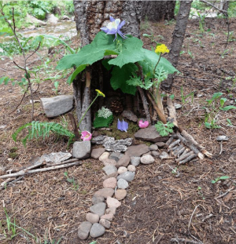
Bird kite
https://www.diythought.com/how-to-make-a-super-easy-bird-kite/
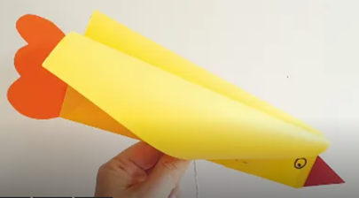
Frisbee
https://craftsbyamanda.com/paper-plate-frisbees/
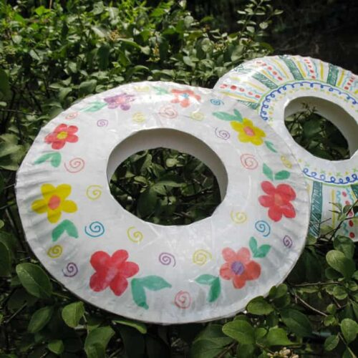

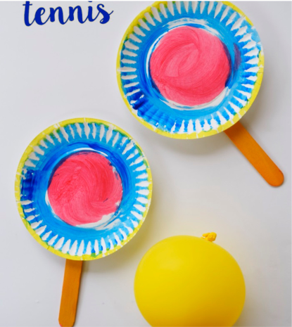
Tennis rackets
https://kidsactivitiesblog.com/77120/paper-plate-tennis/

