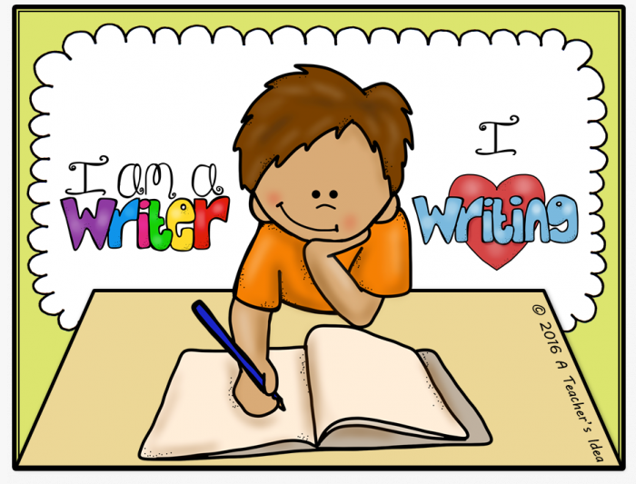
Year 1/2 English

A few weeks ago, we set you all a maths challenge. Those of you that took part did such a fantastic job we would now like to focus on English. You can choose two out of the four challenges but could do all four if you want a super challenge.
If you would like to take part in the challenge you will need your parents to take a photo of your work and e-mail Mrs Knight on donna.knight@hanslope.milton-keynes.sch.uk or you could complete the work using a computer and e-mail it to me directly. Every child that successfully completes the challenge will receive a certificate and be entered into a prize draw.
Due date: Friday 26th June.

Task one: Magical Creature
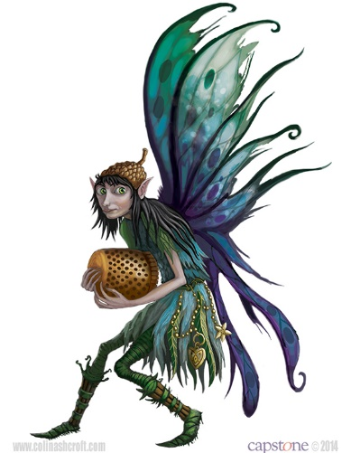

This is a picture of a garden fairy. Can you draw a picture of your own magical creature and describe what it looks like?
Example: Her wings were green and blue, hanging down to the floor.

Task two
Read the setting descriptions below and see if you can work out where they are?

Description one
The walls were tall and grey, made of stone. Harry walked across the large wooden bridge and below could see the deep motte. There was no water in there now, just long green grass. Circling around the towers, black birds were squawking to one another and then returning to their nests, nestled deep in holes in the walls. Guards stood tall and straight, making sure that no-one entered the tall gates.

Description two
Rubber rings and colourful noodles, were dotted around, abandoned by small children. The tiled floor was covered in water, which had settled there after many children had jumped off the sides and landed with a splash. It was hot but no one cared because they were able to cool off in the fresh water, their skin getting wrinkly.

Description three
Trees grew tall and blocked the sun, casting shadows on the ground. Rabbits hopped around, playing with each other as birds sat on branches, whistling merry tunes. Beautiful flowers grew in patches, creating a carpet of blue, green and specks of white. Twigs and sticks snapped under foot and children jumped from log to log.

Task Three
Rhyming
Words that rhyme have the same sound at the end for example grow and flow.
How many words can you list that rhyme with the following words?

See
Toe
Top

Task Four
I love traditional tales such as The Three Little Pigs or Little Red Riding Hood.
Some authors like to take these stories and then rewrite them, giving them a twist. An example of this has been included below.

Three little wolf cubs lived with their mother but they were lazy, never helping around the den. Finally, one morning, mother wolf had had enough of her cubs and decided that it was time for them to start life on their own. Sadly, the three brothers did not get along with each other and spent much of their time arguing and fighting. So as they left the den, carrying their clothes in a bag over their shoulders, they all headed in different directions.
The first wolf cub came across a pig, selling bundles of straw at the side of the road. The sky was grey and it looked as though it would rain at any moment. Because of this, the first wolf cub decided that the straw would be perfect for him to build a den with. It was also because he was tired and couldn’t be bothered to walk any more. He purchased the straw and quickly built a den in the ditch a few metres from the pig……………………………………………………………..

Choose a traditional tale and rewrite it giving it a twist.

Examples of Traditional tales:

Little Red Riding Hood,
The Billy Goats Gruff,
Goldilocks and the Three Bears,
Jack and the Bean Stalk,
The Ginger Bread Man,
Hansel and Gretel.

I can’t wait to see how you get on.
Good luck.

