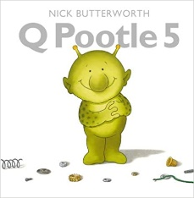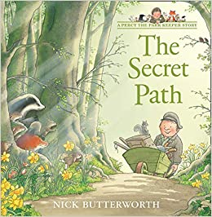 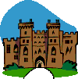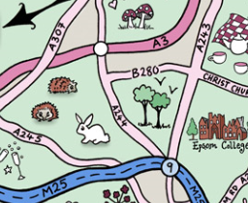

**This term Maths is focussed on our knowledge and understanding of number. We will be counting; adding and subtracting, using written methods and in our heads; using our knowledge of place value and practising number facts such as number bonds. We will be applying this knowledge of number to measure; order, represent numbers and estimate.**

**We will also learn the properties of 2D and 3D shapes and use these to sort and solve problems. We will cover any Year 1 objectives children may have missed where necessary.**

**English/Topic**

For further information on the skills taught in Year 2 please see the Curriculum Overview on the school website.

**Home Study!**

Find out about what life was like for your parents/ grandparents at school.

If possible, read any letters that come in the post (check with the person they are addressed to first) and see what they have in common or how they are different. You can bring examples to share if you like.

**Our Author Study this term is:**

Nick Butterworth

**We will start the year off with a wellbeing/ PHSE focus to help children settle back in to school, feel comfortable and know how to be successful learners. Where possible English lessons will be taught through topic. Our topic this half term is ‘Hanslope Detectives.’ We will be exploring how the last few months have been a historical event and creating our own time capsule to bury. We will learn about mapping skills and create our own treasure maps for the capsule. We will use our geographical skills to find out about the local area and create historical maps. We will also create narratives based on maps of magical worlds. We will look at the history of schools in the village, especially boarding schools and read and write letters. We will learn about Hanslope Castle and explore a range of narratives set in castles, and then create our own. In science, we will investigate a range of materials and their uses.**

**We will cover a variety of English skills through these topics, including: using punctuation correctly -capital letters, full stops, exclamation marks, question marks, commas and apostrophes; spelling more accurately; beginning to join our handwriting; and planning and editing our writing. We will also learn to include a wider range of vocabulary in our writing including noun phrases and use conjunctions to extend our sentences. We will cover any Year 1 objectives that the children may have missed where necessary.**

**Maths**

**Year 2 Curriculum News**