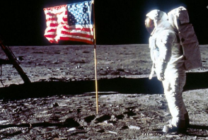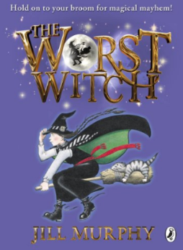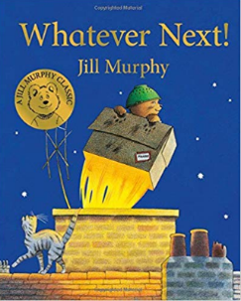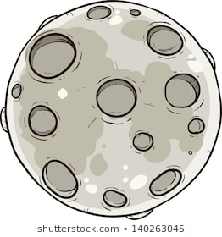

For further information on the skills taught in Year 2 please see the Curriculum Overview on the school website.

**Home Study!**

Find out what you can about the moon landing. Does anyone in your family remember it?

Choose an astronaut to find out more about. We will be looking at Neil Armstrong, Ed Dwight, Helen Sharman and Tim Peake. You could look at one of these in more detail or choose a different astronaut of your own.

**Our Author Study this term is:**

Jill Murphy

This term Maths continues to focus on our knowledge and understanding of number. We will be counting; adding and subtracting, using written methods and calculating in our heads; using our knowledge of place value and practising number facts such as number bonds.

We will be applying these addition and subtraction skills to measures including money.

**Maths**

Where possible English lessons will be taught through topic. Our topic this half term is ‘**Landing on the Moon – Who got their first?’** We will be exploring, reading and writing stories about space and recounting historical events, including the moon landing. We will research the lives of various astronauts and design, make and evaluate moon rovers, writing instructions for our designs. We will explore the earth from space using satellite photos and aerial photographs and learn the continents and oceans. We will also focus on the UK from above and learn the countries, capital cities and seas. We will also learn how to use algorithms and create code to tell the story of the moon landing.

We will cover a variety of English skills through these topics: using punctuation correctly including capital letters, full stops, exclamation marks, question marks, commas and apostrophes; spelling more accurately; beginning to join our handwriting; and planning and editing our writing. We will also use a wider range of vocabulary in our writing including noun phrases and suffixes, explore different sentence types and use conjunctions to extend our sentences. We will also practise our performance skills for our Christmas play.

**English/Topic**

**Year 2 Curriculum News**