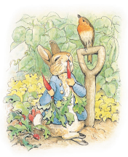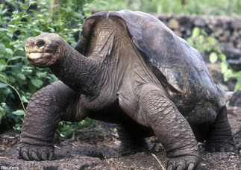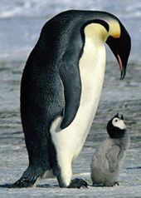

Where possible English lessons will be taught through topic. Our topic this term is **‘Survival of the Fittest’** where we will become explorers of the world starting first with Antarctic adventures and then moving onto Darwin’s discoveries. In History, we will be comparing the lives of two significant historical figures, explorers Charles Darwin and Roald Amundsen. We will learn why they were important, what they did and how they travelled.

In Geography, we will map their journeys, naming continents and seas along the way. We will compare the areas of the world they travelled to, learning which areas are hot or cold and relating this to their distance from the equator.

We will begin with Roald Amundsen and Antarctica and innovate a fairy tale to give it settings and characters from this region. We will also learn more about sentence types, conjunctions, description and suffixes basing some of our grammar on the book ‘The Emperor’s Egg.’ We will also read, explore and write descriptive poetry basing some of our work on the wonderful language of Helen Cowcher’s ‘Antarctica’ and Ruth Heller’s ‘Galapagos means Tortoises.’

As scientists we will explore a range of habitats and think about how different animals are adapted to their habitats. We will explore the food chains of these animals and their interdependence in their habitats. We will read, explore and write our own non fiction texts based around these animals.

As artists we will learn pulling out and texture skills with clay to explore animals’ patterns.

In RE we will continue to looking at the Christian and Jewish faiths, thinking about New Year, Creation and how the Christian church celebrates Easter.

We will be exploring, reading and writing recounts based on the book ‘Henry’s Map’ and journeys around the village, where we will use our Geographical skills to find out about the local area and draw maps. We will look at the history of schools in the villages, especially boarding schools and read and write letters. We will explore the impact of WW2 on Hanslope and create army trucks. We will learn about Castlethorpe Castle and explore a range of narrative’s set in castles then create our own. We will design historical items; compare and choose appropriate materials and write instructions for our designs. We will also learn about the patron saints and their correspondinmg countries.

We will cover a variety of English skills through these topics, including: Using punctuation correctly, including capital letters, full stops, exclamation marks, question marks, commas and apostrophes; spelling more accurately; beginning to join our handwriting and planning and editing our writing. We will also use a wider range of vocabulary in our writing including noun phrases and suffixes, explore and write different sentence types and use conjunctions to extend our sentences.

This term we will continue to build upon our knowledge and understanding of number. We will continue to practise addition and particularly focus on subtraction, multiplication and division.

We will be applying this knowledge of number by reasoning, finding the inverse, measuring and finding fractions.

We will begin to tell the time to the nearest 5 minutes and read scales to measure in a variety of contexts.

**Maths**

**Our Author Studies this term are:**

Beatrix Potter

Nick Butterworth

**Home Study!**

Find out about animals from both Antartica and Galapagos.

Hunt out mircohabitats in your garden or local area. Why do the creatures like it there? What is special about that habitat? Do they share it with any other creatures?

**English/Topic**

**Year 2 Curriculum News**