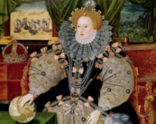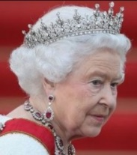

**Our Author Study this term is:**

Emily Gravett

**Year 2 Curriculum News**

**English/Topic**

This half term our topic is **‘Real Royals – Who are they? Who were they?’** where we will learn about different Kings and Queens, time periods and the current Royal family. In History, we will be comparing the lives of different monarchs. We will also explore how the UK has changed in different time periods.

We will read and write royal themed stories based on David Walliams the Queen’s Orangutang and write diaries as a member of the Royal Family on tour. We will continue have an emphasis on punctuating our sentences accurately with an increased focus on using exclamation marks, question marks, commas and apostrophes. We will also continue to learn to use a wider variety of conjunctions in our writing.

As scientists, we will concentrate on our working scientifically skills this term, thinking about asking and answering scientific questions and collecting data.

As artists, we will create self-portraits and look at a variety of portraits of the Queen as inspiration. As designers we will also look at the crown jewels and design ways to protect them.

In RE, we will continue to look at the Christian and Jewish faiths, thinking about whether stories can change people.

**Maths**

This term we will continue to practise our methods for addition, subtraction, multiplication and division. We will consolidate these calculation methods and apply these skills in a variety of contexts.

We will be learning about fractions of shapes and amounts and relating this to our work on division.

We will use positional language and relate this to our work on fractions making half, quarter amd three quarter turns.

**Home Study!**

Look out for any news on the royal family and who it involves.

Find out about a King or Queen you are interested in.