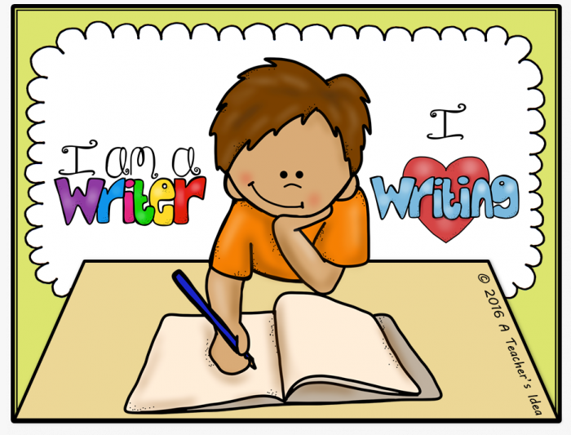
Year 3/4 English

A few weeks ago, we set you all a maths challenge. Those of you that took part did such a fantastic job we would now like to focus on English. If you would like to take part in the challenge you will need your parents to take a photo of your work and e-mail Mrs Knight on donna.knight@hanslope.milton-keynes.sch.uk or you could complete the work using a computer and e-mail it to me directly. Every child that successfully completes the challenge will receive a certificate and be entered into a prize draw.
Due date: Friday 26th June.

Task one: Setting description
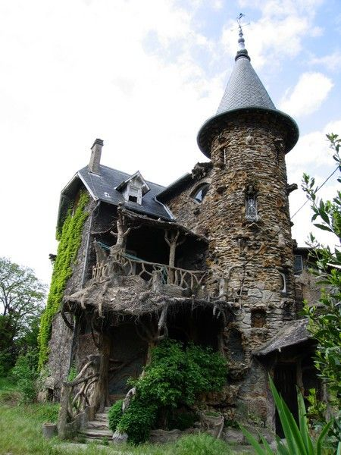

Write a description of this house, using interesting words and phrases. To challenge yourself even more describe the house using all of the 5 senses (see, hear, feel, taste, smell).
Example: As Lucy stared at the house, the sound of mice scurrying across broken floor boards, sent a shiver down her spine.

Task two
Read the setting descriptions below and see if you can work out where the character for each is.
Description one
As Philip walked alongside his mother, a rainbow of colour met his eyes. Looking around at baskets bursting with colour, his stomach began to rumble. The piece of paper in his mother’s hand rustled as she checked it once, twice, three times. They drifted up and down in straight lines, picking things up and adding them to the already gathered collection.

Description two
A man, towering above everyone, reminded Verity of an observant owl, scanning left to right. He had a whistle around his neck and his shorts were bright red, making him stand out. The place was full to bursting and a strong smell hung in the air, burning her nostrils. The tiled floor was slippery and her mother bellowed, “Verity, no running. You might slip.” She went there every Monday, after school. It was her favourite place because as soon as she entered the warm water, she felt like a mermaid.

Description three
The hairs on Charlie’s neck stood up on end as an electric pulse of excitement, travelled up his spine. Up, up, up he went, as slow as a snail. It felt as though he could almost touch the clouds when he suddenly stopped, with a bone curdling jerk. Grabbing his father’s hand, he could see people below him likes ants. Some of them stood still, in straight lines that seemed endless, snaking around corners, as far as his eyes could see. “Here we go,” giggled his dad. Rattle, rattle, crank, they started to move. “Ahhhhhhhhh,” Charlie screamed.

Task Three
A synonym is a word that is different but has the same meaning as another word for example, chilly is a synonym for cold.
List as many synonyms for said as you can think of.

Task Four
I have started a story. I would like you to finish the story, taking it in any direction that you want. I look forward to reading your ideas.

Gareth and Phoebe were walking in the woods with their parents. It was a scorching hot Summer’s day and they were feeling bored, hot and over the walk. “Mum! Can we go home now?” pleaded Gareth.
“No darling. Dad and I will set a picnic up underneath that tree. Why don’t you two stop complaining and paddle in the river while you wait.”
“Fine,” grumbled Phoebe. “But can we leave as soon as we’ve eaten. I want to complete the next level of my game”.
“Honestly,” mumbled dad, unrolling a chequered blanket from his back pack. “When I was young we loved spending the day in the woods. Off you go we’ll call you in a bit.”
Gareth and Phoebe slowly made their way towards the river bank, feeling utterly miserable and wanting to go home. Gareth picked up a round, smooth stone from the edge of the river and threw it into the water, causing a huge ripple on the surface. Suddenly Phoebe grabbed his arm and whispered, “Gareth, whatever you do don’t move. There’s a strange creature on the other side of the river bank and it’s watching us.”………………………………………..

Task Five

Write a poem based on this picture of a Summer’s day.
Example:
There’s something lovely about a Summer’s day,
As the birds sing, your worries seem to drift away.
A rainbow sheet of flowers covers the ground,
Children laughing and giggling is the only sound.

