Year 3/4 Maths Challenge

We have decided to run a maths challenge for those of you who want to give your brain a work out!
In order to complete this challenge, you will need complete the tasks below. You will need to prove that you have completed them by getting your parents to take a photo or you will have to prove it to your parents and then they will have to tell us you have completed them. Email Mrs Broughton.
Jenny.broughton@hanslope.milton-keynes.sch.uk
Every child who successfully completes the challenge will be given a certificate when back at school and put into a draw to win a voucher!
Due by Friday 15th May

Year 3/4 Maths Challenge
Complete all 5 problems below…

Task 1
These are anagrams of mathematical words! Can you decode them?
- Uhedrnd
- Danoditi
- Uymitpl
- Qserau
- Icelcr
Task 2
In a field there are 20 animals (donkeys, goats and rabbits) who between them eat 20 carrots. Each donkey eats 3 carrots, each goat eats 1.5 carrots and each rabbit eats half of a carrot.
How many of each kind of animal are in the field?
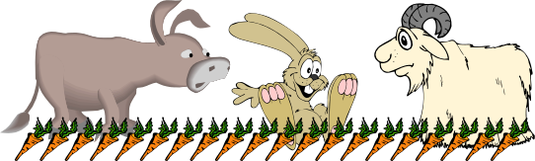

Task 3
Place each of the numbers 1 to 5 in the V shape below so that the two arms of the V have the same total.
How many different possibilities are there?
What do you notice about all the solutions you find?
Can you explain what you see?
Can you convince someone that you have all the solutions?
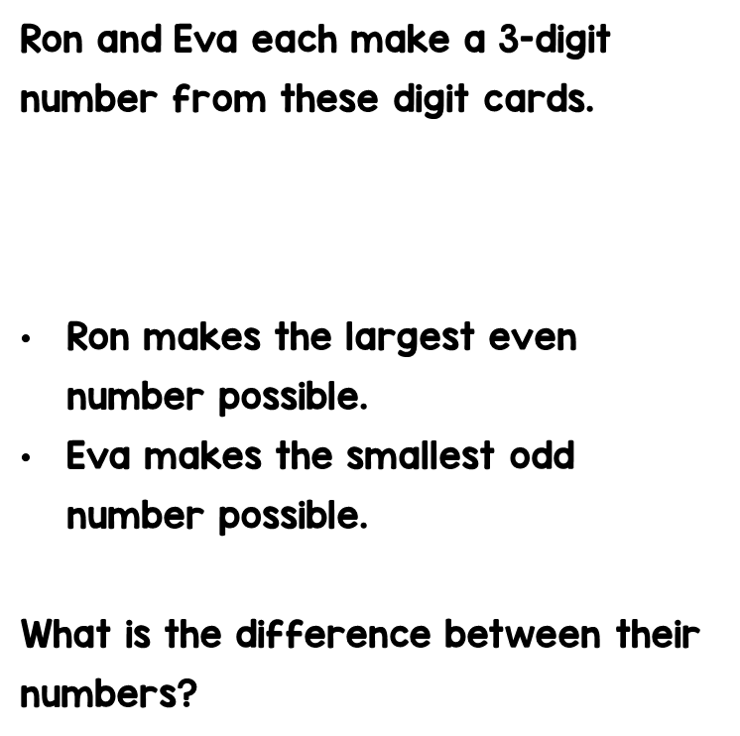
Task 4

Task 5

Good luck!

