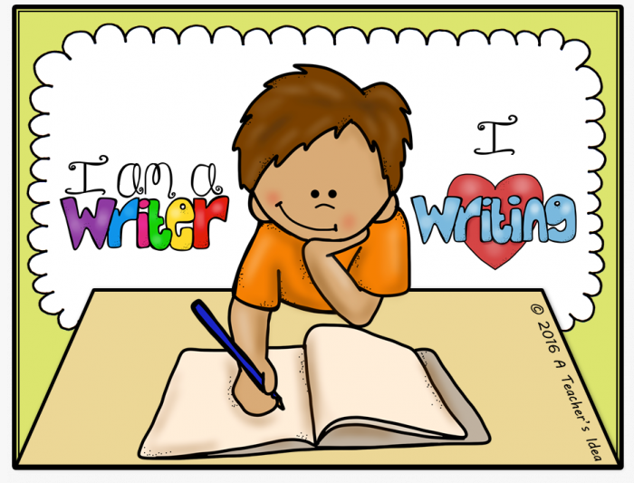
Year 5/6 English

A few weeks ago, we set you all a maths challenge. Those of you that took part did such a fantastic job we would now like to focus on English. If you would like to take part in the challenge you will need your parents to take a photo of your work and e-mail Mrs Knight on donna.knight@hanslope.milton-keynes.sch.uk or you could complete the work using a computer and e-mail it to me directly. Every child that successfully completes the challenge will receive a certificate and be entered into a prize draw.
Due date: Friday 26th June.

Task one: Setting description
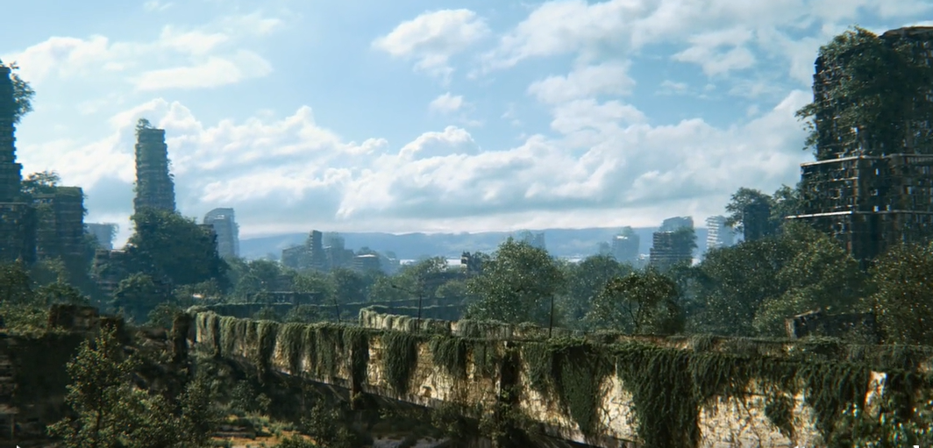

Write a description of this scene from Literacy Shed. It is a post-apocalyptic city. Nature has taken over now that humans appear to have abandoned it. Your challenge is to use figurative language in order to create mood and atmosphere.
Simile- Compares two things using like or as (The leaves covered the building like a curtain)
Metaphor- Describes on thing as something else. (The leaves are a carpet, smothering the buildings.)
Personification- Gives unanimous objects human qualities. (The buildings gasped for breath as the leaves suffocated them)
Oxymoron- two words to describe but one contradicts the other. (The city was quiet, a deafening silence filled the air.)
Hyperbole- an exaggeration that can’t possibly be true. The tall buildings stretched as high as the clouds.)

Task two
Create a poster based on the speech rules. This will help you with the next task.
For example:
New speaker, new line.

Make sure that your poster is neat, well presented and could be used for display.

Task Three
Watch the clip below from the Literacy Shed
https://www.literacyshed.com/ruin.html
Write a story based on the clip but ensure that there is a balance of speech, description and action. You will have to decide what the name of the main character is.
Take care with your use of punctuation, ensuring that speech is set out correctly.

Extra Challenge:
Use a range of punctuation to control the text.
Colon, semi colon, brackets, hyphen.

Task Four
Passive voice is when the order of the sentence changes. The subject of the sentence is performing the action.
Example: Active= The cat chased the mouse.
Passive= The mouse was chased by the cat.

Passive is also when the person or thing performing the action is not obvious.
Example: The rod was put into the water.

Read the sentences below and then rewrite them using the passive form.
- Mark ate the juicy apple.
- Julie put the key in the lock and opened the door.
- Mrs Knight opened the crisps and gobbled them up.
- Fish swam in the pond.
Challenge:
Can you come up with 5 passive sentences of your own?

Task Five
I have started a story based on a character called Rory. Your challenge is to complete the story starting from where I left off. You can go in any direction you like with the story. It could be a thriller, a funny story, a mystery, a love story, a story from another culture or even a story with a historical setting. You can also add in any characters that you like.

It was dark when Rory opened his eyes. Not the sort of dark, when you wake up in the middle of the night and the moonlight is creeping through the window. The sort of dark that is thick and heavy, stopping you from seeing your hand in front of your own face. As his brain processed this information, he realised it was cold. The type of cold that buried its way into your bones, chilling your every cell. At that moment he began to shiver uncontrollably. With every shiver, pain coursed its way through his body and he screamed in terrible, gut wrenching agony. “Calm down, calm down,” he whispered to himself in an attempt to gain control. As his breathing steadied, he could hear a strange shuffling sound, coming from the other side of where ever he was.
His heart fluttered like a small bird trapped in a cage and his pulse quickened. He held his breath, terrified to breath. Where was he? Closer came the noise. Where am I? Closer still………………………

