
Hello and welcome to Year 5! We hope you have all had an enjoyable summer break and are looking forward to coming back to school. Let’s find out what our first few weeks have in store…remember to check out the topic web for more details on the curriculum covered.

Who’s who:
Mrs Cunningham – class teacher.
One to one TAs – Mrs Baxter and Miss Harrison.


What's Coming up?
Our first topic this year will be:
Marvellous Maya
We will be investigating all the things that made the ancient Maya such a successful civilisation against all odds including, where the Maya lived, why they chose to settle where they did, what they invented and why they valued the cocoa bean as much as they did.

A day in Year 5
We will open the main KS2 corridor doors at 8:40am and be ready to welcome the children into school. Doors will close at 8.50am – the start of the new school day. Children register and order their lunch themselves on our class iPad.

P.E.

Our PE days for the first half term of the Autumn term are Thursday and Friday, and for the second Autumn they will change to Wednesday and Friday. On the days they have PE, children are expected to arrive in school wearing their PE kit (see list below) and keep it on all day. We will go swimming at Southam Leisure Centre in April/May.

Correct kit consists of:
- Red t-shirt
- Black shorts
- Black pumps/trainers
- For outside PE: plain trainers, change of socks and plain jogging bottoms, red or black hoodie/warm top (plain no logos).

Home time
At home time we will dismiss the children from the KS2 playground at 3:20pm. For safety we need to make eye contact with you to release your child to you – it’s a great way for me to put names to faces!

With the relevant consent to walk home paperwork completed, your child can be released from the classroom at 3:20pm to walk home or to walk to the KS1 playground.
Your child will only be allowed to walk home alone/to KS1 playground if the online consent form has been completed. Please find the link here: https://forms.gle/Tyr3brk77r4xmg6x6
Please inform me on Class Dojo if/when you have done this so I can keep my end of the day dismissal list updated.

If your child’s home time arrangements do change and if this is after 1pm, please let the school office know to ensure your message has been received as once I am in the classroom with the children after lunch, I can’t guarantee I will have read any Dojo messages until after school.

Home school partnership
Class Dojo will continue to be our primary method of communication and we will check this daily (please note: Dojo will not be consistently monitored after 4.30pm). I am available to speak with at morning drop off and after school at pick up for any quick catch ups or if you would prefer to phone or meet face to face please use dojo to arrange this in advance.

Homework
Homework will be set weekly via the Class Story on Dojo. It will be posted on a Tuesday and we expect children’s work to be uploaded to their portfolio by the following Tuesday for marking. All children are expected to complete homework.
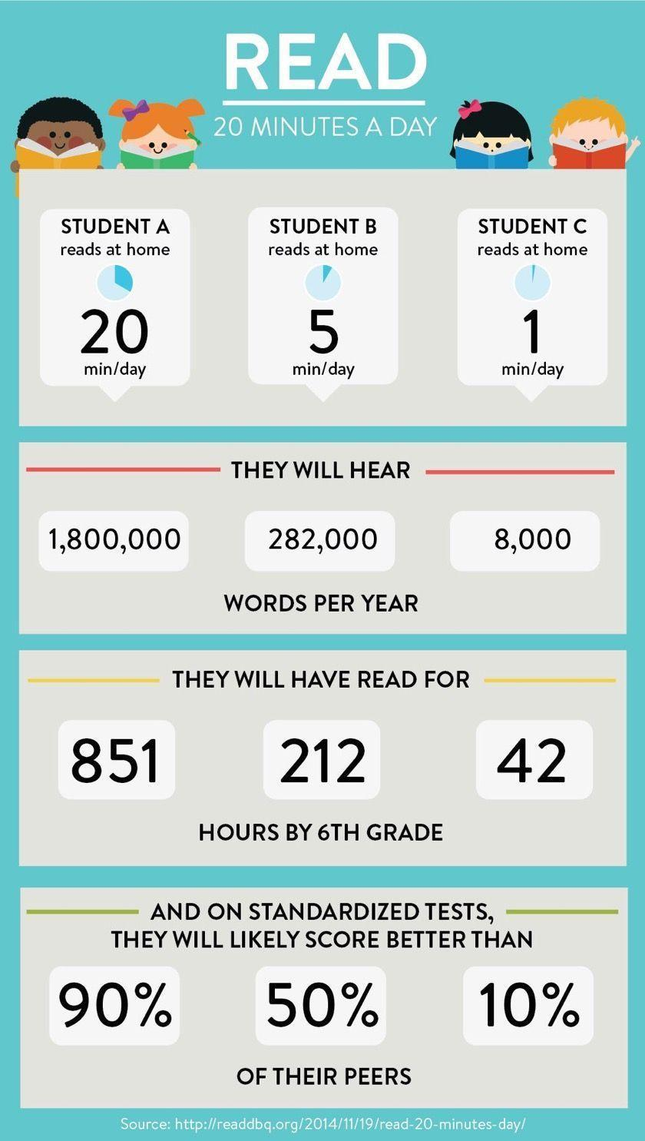
Daily reading
Reading with your child is one of the most valuable things you can do with them. In class, we will encourage children to have a reading book within their personal Accelerated Reading level from our reading corner. Children should be reading daily at home and recording their reading in their Reading Record which they must bring into school every day for us to look at.

We will keep you informed of the spelling we are learning however there will not be weekly tests.

Healthy Snacks

If you would like your child to have a breaktime snack please send them to school with a piece of fruit, a plain biscuit or cereal bar which they can keep in their tray. Please note – there is no ‘treat Friday’, it’s a health snack every day.

We look forward to working with you and your children

Kind regards

Mrs Rachel Cunningham and the wonderful Year 5 team!

Important Dates (more information to follow on Dojo):

Tuesday 1st September | Staff training Day
Wednesday 2nd September | Staff Training Day
Thursday 3rd September | Pupils return to school
Tuesday 8th September | Open classroom ‘Meet the teacher’ Presentation - KS2- 5pm
Thursday 17th September | Flu immunisations
Friday 2nd October | Harvest Festival All Saints 9.30am
Tuesday 6th October | Individual photographs
20th and 22nd October | Parents’ Evening
Thursday 22nd October | Break the Rules Day and break up
Friday 23rd October | Staff Training Day
2nd November 2026 | Pupils return to school
Wednesday 16th December | Christmas Dinner Day and Christmas Jumper Day
Friday 18th December | Christmas Service 9.30am All Saints
Friday 18th December | Break up

