

Harbury CE Primary School

Homework Policy July 2026

Why do we set homework for our children?
- It provides a valuable partnership between home and school, enables parents to enrich their
child’s learning journey
- It should help to inspire and motivate children to be life-long learners
- It helps children consolidate and reinforce skills and understanding covered in school
- It extends their learning.
- The habit of doing homework helps children learn to organise their time
- To encourage pupils, as they get older, to develop the confidence and self-discipline needed to study with increasing independence, and prepare them for the study skills needed in the next phase of their education.

How much time should be spent on home-learning?
As a guide, home-learning (including reading) should take the following amounts of time:
 | Reception | Year 1 | Year 2 | Year 3 | Year 4 | Year 5 | Year 6
Daily  Reading | 20 mins | 20 mins | 20 mins | 20 mins | 20 mins | 20 mins | 20 mins
Maths  Arithmagicians |  | 10 mins | 10 mins | 15 mins | 15 mins | 20 mins | 20 mins
Maths  Challenge |  | 15 mins  set fortnightly | 15 mins | 15 mins | 15 mins | 20 mins | 20 mins
English  Spelling |  | 5 mins | 5 mins | 10 mins | 10 mins | 10 mins | 10 mins
English Challenge |  | 15 mins  set fortnightly | 15 mins | 15 mins | 15 mins | 20 mins | 20 mins
Total time | 20 mins of daily reading | 30 mins  +20mins of daily reading | 45 mins  +20mins of daily reading | 55 mins  +20mins of daily reading | 55 mins  +20mins of daily reading | 1h10mins  +20mins of daily reading | 1h10mins  +20mins of daily reading
Year 1 maths and English challenges are set on alternate weeks. In Year 2 the children initially have homework set as in Year 1. This will gradually increase throughout the year, until by the summer term it is set according to the times in the table above.
Teachers will set out their expectations for homework each half term in the curriculum newsletter. The main focus will be linked to their learning in class. They may complete retrieval activities.
Homework should be completed to the same high standards that we expect of work done during school time.
In Key Stage 1, homework will be set via Class Dojo and can be returned in the same way. Homework books are used for children in Key Stage 2. Homework will be handed out each week and the children should complete their homework in their book and return it to school the following week. In year 6, as they approach their SATS, parents will be asked to help contribute towards CGP books which are very useful for homework. https://www.cgpbooks.co.uk/

Homework – help for parents and carers
Homework is set to help your child and we ask that you support your child with tasks by helping them choose an appropriate time and place to work
It is useful for teachers to see the process the child has undertaken – please encourage your child to show these and not to present just the completed task.
The school actively encourages parents to give their feedback to teachers on the completion of homework tasks. Please make a note on the homework if your child has needed support for the homework.

Reading
In addition to set tasks, we expect children to read daily at an age appropriate level. The research has shown that 20 minutes a day exposes children to a large range of vocabulary and improves reading fluency.
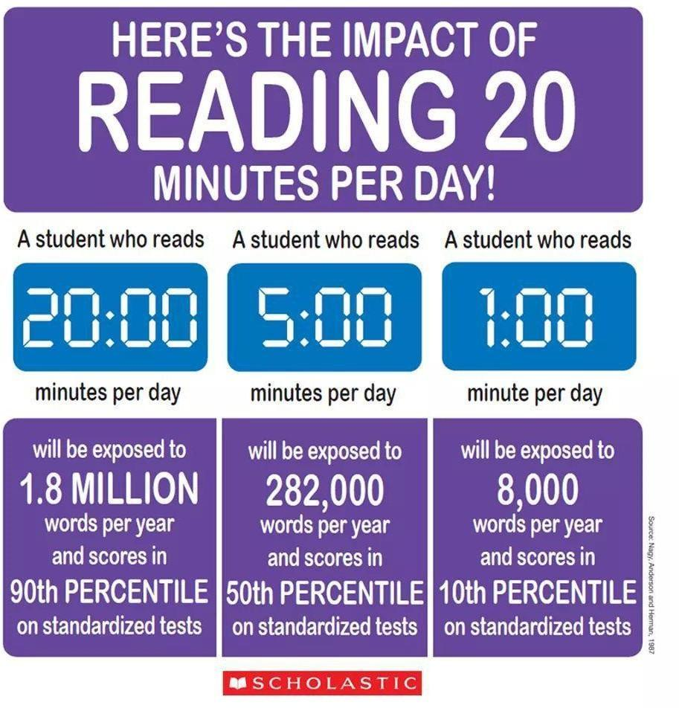
Reading should be a pleasure so please encourage them and try to find a bit of time to enable them to be read to and to talk about what they are reading. In Reception and Key Stage 1, we would expect parents to record reading in their child’s reading in the reading record. By Key Stage 2, children should be able to record their own reading their reading record. Please record all reading whether it’s books, magazine, journals, recipes etc.

Reception and KS1 phonics books
There is an expectation that parents/carers will read with their child as close to daily as possible. Books will be changed on a Thursday and given back to children on a Friday. It’s important to re-read books so children become more fluent with what they are reading. Books are matched to our phonics scheme RWI. Please share other books and stories with your child. Harbury library is a perfect place to choose new books.

Maths
Maths homework will be set to embed learning from maths lessons in school. There will be a mixture of fluency, reasoning and problem solving challenges. In addition to this, the children will also be set practice tasks on Arithmagicians. These tasks are designed to develop security in number facts and develop instant recall. The skills are organised for each year group to develop a solid foundation of number knowledge to build on. Each week for homework, the class teacher will direct which activity needs to be completed. The time spent on this is recorded in the app so teachers can monitor children’s engagement.
Spelling
Spelling homework will be focused on each year group’s list of high frequency or common exception words and learning and applying the spelling rules learnt in class. Whilst we regularly assess the children’s spelling in class, their homework will not have a test each week.
English
English homework is usually based around the book the children are currently reading in class although we may sometimes set a stand alone piece or base homework on the themes children are learning about in other areas of the curriculum. There will be a mixture of grammar, sentence and text level challenges.
Project/research homework
There may be occasions where class teachers ask the class to research or complete a project to support their learning in class.

Thank you for your support of the homework policy. Parent and pupil views are greatly valued and are taken into account when reviewing our homework policy.

