Pupil premium strategy statement Harbury CE Primary School
Pupil Premium Review is on page 9

This statement details our school’s use of pupil premium funding to help improve the attainment of our disadvantaged pupils.

It outlines our pupil premium strategy, how we intend to spend the funding in this academic year and the effect that last year’s spending of pupil premium had within our school.

School overview
Detail | Data
School name | Harbury CE Primary School
Number of pupils in school | 214
Proportion (%) of pupil premium eligible pupils | 11% (24 pupils)
Academic year/years that our current pupil premium strategy plan covers (3-year plans are recommended) | 2022-2025
Date this statement was published | December 2022
Date on which it will be reviewed | December 2025
Statement authorised by | L Bosley
Pupil premium lead | L Bosley
Governor / Trustee lead | S Johnson
Funding overview
Detail | Amount
Pupil premium funding allocation this academic year | £38,380
Recovery premium funding allocation this academic year | £3,770
Pupil premium funding carried forward from previous years (enter £0 if not applicable) | £0
Total budget for this academic year  If your school is an academy in a trust that pools this funding, state the amount available to your school this academic year | £42,150

Part A: Pupil premium strategy plan

Statement of intent
At Harbury CE Primary School our belief is that all pupils love, learn and grow together. Our high expectations are matched by an aspirational, bespoke curriculum; well trained staff; and families are supported to match the ambitions we have for our children. We believe that all children should have the opportunities to achieve all they can. Sometimes barriers can get in the way that prevent children from achieving this. Our ambition is to seek out these barriers and knock them down. Whether it be attendance or lack of a quiet space to complete homework. We get to know our families well through building relationships. We know that family situations can be difficult but we know the value of attending school each day and giving all pupils the opportunity to excel in a safe and secure setting.

Our focus for our vulnerable families is to provide an emphasis on the key skills- phonic knowledge and early reading, maths fluency, building key English skills including sentence structure and a focus on building spelling strategies. We also understand the importance of Social, Emotional Mental Health (SEMH) support for children and families. Our SENCo is highly experienced and has exceptional knowledge of our families here in Harbury. Additionally, we employ a learning mentor to support the SEMH needs of our families.

Our approach is to ensure quality first teaching for all children with a focus on areas in which disadvantaged pupils require the most support. This is proven to have the greatest impact on closing the disadvantage attainment gap and at the same time will benefit the non-disadvantaged pupils in our school. Implicit in the intended outcomes detailed below, is the intention that non-disadvantaged pupils’ attainment will be sustained and improved alongside progress for their disadvantaged peers.

Challenges

This details the key challenges to achievement that we have identified among our disadvantaged pupils.
Challenge number | Detail of challenge
1 | Disadvantaged pupils’ attainment is lower than expected. This is reflected in the KS2 and KS1 data from 2021
2 | Some year groups have a high level of disadvantaged pupils.
3 | Disadvantaged pupils’ maths fluency is below where it should be.
4 | Thrive profiles and teacher observations have shown that there is an increased number of children experiencing anxiety about coming to school, developing and maintaining friendships and accessing work at the expected standard. This anxiety hinders children’s ability to focus on work in class and to establish and maintain effective friendships
5 | There are a number of families who have attendance below 90%. This impacts on the progress these pupils make.

Intended outcomes
This explains the outcomes we are aiming for by the end of our current strategy plan, and how we will measure whether they have been achieved.
Intended outcome | Success criteria
Raise the % of disadvantaged children across the school achieving EXS in Reading, Writing and Maths. | End of year assessments show that the % of disadvantaged children achieving expected standard and at greater depth in reading, writing and maths across the whole school has risen.  Increase the percentage of disadvantaged pupils achieving the Times Table and the phonic screening test.
Ensure that every child receives quality first teaching every day. This will be evidenced through the monitoring cycle and teacher triangulation. | A comprehensive catalogue of CPD support and training accessed by teachers and teaching assistants. This will lead to improved achievement in reading, writing and maths.
Vulnerable children attend school regularly. | Increase attendance of vulnerable children to 90%+
Pupils access a wide range of enrichment experiences both in and out of school Children have the necessary skills, vocabulary and support to enable them to manage SEMH issues, including anxiety. | The THRIVE programme is used by all staff and all children who would benefit from it are identified and regularly supported.  THRIVE assessments show that key children are making progress.  All staff have received annual training in supporting SEMH issues, following a restorative approach to behaviour.  The PSHE curriculum supports all children to develop the vocabulary and skills to express emotions and manage feelings.

Activity in this academic year

This details how we intend to spend our pupil premium (and recovery premium funding) this academic year to address the challenges listed above.

Teaching (for example, CPD, recruitment and retention)
Budgeted cost All staff trained and upskilled in Thrive. 1 Leader Trained £1000, 2 Practitioners Trained: £2500
Cover cost for Thrive practitioners/ time for Thrive practitioners to complete their training £1000
Activity | Evidence that supports this approach | Challenge number(s) addressed
Introduce THRIVE programme across the whole school. Train two members of staff to become a THRIVE practitioner. | EEF_Social_and_Emotional_Learning.pd f(educationendowmentfoundation.org.uk) https://www.thriveapproach.com 1,2,3,5,6 | 1,2,3,4,5
Quality first teaching is a priority on SIP & PM target for all teachers.  Developed through regular CPD & mentoring.  Teachers to check-in 3x per lesson with PP. | Ensuring every teacher is supported in delivering high-quality teaching is essential to achieving the best outcomes for all pupils, particularly the most disadvantaged among them.  education/high-quality-teaching | 1,2,3,
Phonics, reading and maths workshops delivered to support parents in how to support their child with reading at home. | Workshops for all parents/carers. Target specifically disadvantaged groups to attend workshops.  Reading is prioritised with these groups of children.  This supports reading at home and will improve parent and pupil engagement with home reading.  Close monitoring allows early intervention.  education/oral-language-interventions  To promote reading in Year 4 with reading ambassadors. Target disadvantaged pupils to lead this reading group.  There is consistent evidence that reading to young children and encouraging them to answer questions and talk about the story with a trained adult, is an effective approach. Several studies show the benefits of programmes where trained teaching assistants have supported both oral language and early reading skills.  /early-years-toolkit/communication-and-language-approaches | 1,2,3
Enhancement of maths teaching for maths in KS2  RWInc training for key staff to support writing development.  Developing a whole school approach to writing. | The DfE non-statutory guidance has been produced in conjunction with the National Centre for Excellence in the Teaching of Mathematics, drawing on evidence-based approaches:  Maths_guidance_KS_1_and_2.pdf (publishing.service.gov.uk)  Whole school approach and strategies to develop writing transcription and fluency to develop stamina. Pupil confidence developed through consistent approach. | 1,2,3
Regular assessment points and 1:1 pupil progress meetings between teacher & HT ensures interventions are put in place. | Professional discussions during pupil progress meetings ensure progress is maintained, interventions are impactful and gaps are closed.  Standardised tests | Assessing and Monitoring Pupil Progress | Education Endowment Foundation | EEF | 1,2,3,

Targeted academic support (for example, tutoring, one-to-one support structured interventions)
Budgeted cost: TA interventions 5x afternoons a week £10,000
TA Interventions 3 afternoons a week £3000
Counselling sessions £150
Trips/wraparound and clubs £500
Purchase of apps Jigsaw/Nessy £2,000
Activity | Evidence that supports this approach | Challenge number(s) addressed
Individual & group targeted intervention delivered by experienced teacher or TA | Small group tuition offers an opportunity for greater levels of interaction and feedback compared to whole class teaching which can support pupils to overcome barriers to learning and increase their access to the curriculum.  https://educationendowmentfoundation.org.uk/education-evidence/teaching-learning-toolkit/small-group-tuition | 1,2
RWInc additional staff to allow personalised groupings.  Additional phonics sessions targeted at disadvantaged pupils and smaller groups. | Targeted phonics groups and interventions have a robust evidence base indicating a positive impact on pupils, particularly from a disadvantaged background.  Phonics | Toolkit Strand | Education Endowment Foundation | EEF | 1,2,
Purchase web apps  - Nessy  - Jigsaw | Parental engagement has a positive impact on pupil progress and helps to avoid widening attainment gaps  education-evidence/parental-engagement  Evidence that technology approaches are beneficial for writing and maths practice and engage pupils at home and in school.  education-evidence/digital | 1,2,3,4
Subscribe to STS to support specialist assessments and action planning. | Specialist teachers assess needs and train staff in school, therefore upskilling them and increasing their knowledge.  High quality small group interventions  education/oral-language-interventions | 1,2,3,4

Wider strategies (for example, related to attendance, behaviour, wellbeing)
Budgeted cost: Learning Mentor employed £20,000
Activity | Evidence that supports this approach | Challenge number(s) addressed
Learning Mentor employed for:  - Behaviour support  - Restorative approaches  - Nurture sessions  - Parental support  - Mental Health  - Social & emotional skills development  - Wellbeing | Social and emotional skills support effective learning and are linked to positive outcomes in later life. With the right support, children learn to articulate and manage their emotions, deal with conflict, solve problems, understand things from another person’s perspective, and communicate in appropriate ways.  This will also improve attendance of vulnerable groups.  education/3-wider-strategies | 1,2,3,4,5
Counsellor to support social, emotional and well-being. | Improve self -management of emotions and interaction with others. Has a positive impact on attitude to learning and social relationships which supports progress and attainment.  Social_and_Emotional_Learning. | 1,2,3,4,5
Introduction of the Thrive Approach, a developmental and trauma sensitive way of meeting the emotional and social needs of children. Training of 2 Thrive practitioners | The staff have the tools and training to support children’s social and emotional development which results in fewer disruptions in class and improved academic results.  Social_and_Emotional_Learning. | 1,2,3,4
Cultural capital experiences promoted in the curriculum.  Cost wrap around care for extremely vulnerable PP.  Reduction in cost of trips for PP.  Residential trip cost is reduced for PP  Sports clubs promoted to PP are encouraged to attend. | Learning is contextualised in concrete experiences and language rich environments.  OFSTED research (2019) places emphasis on improving cultural capital, particularly for disadvantaged pupils.  Enrichment activities offer children a context for leaning and a stimulus to trigger their interest which can be evidenced in pupil books and data.  education-evidence/physical-activity  Sports participation increases educational engagement and attainment. | 1,2,3,4,5

Total budgeted cost: £42,150

Part B: Review of outcomes in the previous academic year 2024-25

Pupil premium strategy outcomes
Challenge number | Detail of challenge
1 | Disadvantaged pupils’ attainment is lower than expected. This is reflected in the KS2 and KS1 data from 2021
2 | Some year groups have a high level of disadvantaged pupils.
3 | Disadvantaged pupils’ maths fluency is below where it should be.
4 | Thrive profiles and teacher observations have shown that there is an increased number of children experiencing anxiety about coming to school, developing and maintaining friendships and accessing work at the expected standard. This anxiety hinders children’s ability to focus on work in class and to establish and maintain effective friendships
5 | There are a number of families who have attendance below 90%. This impacts on the progress these pupils make.

Intended outcome | Success criteria
1.  Raise the % of disadvantaged children across the school achieving EXS in Reading, Writing and Maths. | Results  In year 6, pupil premium pupils achieved 83% ARE in reading with 33% GD. In maths, 50% ARE and 17% GD. Writing 50% achieved ARE.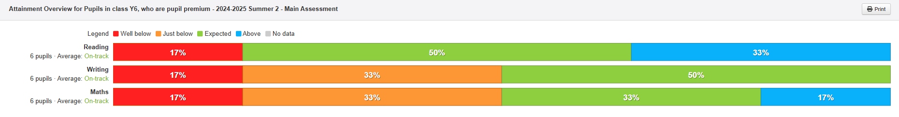  In all year groups:  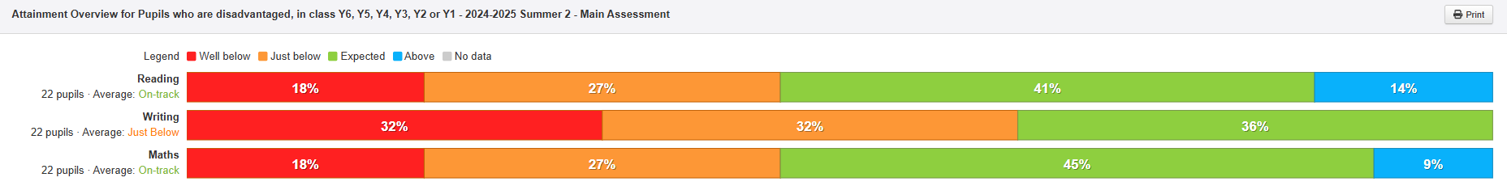Reading has been incredibly successful. Thanks to the raised profile across the school and the introduction of Accelerated Reader. As you can see 41% of disadvantaged pupils are ARE and 14% GD. Also, maths achievement for disadvantaged pupils has been successful with 45% ARE and 9% GD. This is because of the introduction of Big Maths and CLIC. Also, Number Stacks as an intervention.  Phonics scores in 2025 were 86% across year 1. Both disadvantaged pupils passed. However, pupils who joined in year 2 later on in the academic year one passed their retake and one didn’t pass their phonic screening.  MTC- Year 4  The one pupil who is PP in year 4 achieved full marks 25% on the MTC check. There are 5 others who scored between 2-19
2.  Ensure that every child receives quality first teaching every day. This will be evidenced through the monitoring cycle and teacher triangulation. | A comprehensive catalogue of CPD support and training accessed by teachers and teaching assistants. This will lead to improved achievement in reading, writing and maths.  We have raised expectations across the school with introducing retrieval. Following on from our Teaching and Learning day, this was found to be embedded and part of everyday practice.  CPD has been very successful especially whole school RWI phonics training- This has increased our phonics to 86%.  Reading CPD- Ruth Baker Lees  Maths CPD- Maths Hub  Writing CPD- Ruth Baker Lees
3.  Vulnerable children attend school regularly. | Increase attendance of vulnerable children to 90%+  Attendance for PP pupils is 89.9%. This is a dip from last academic year (23-24). This is due to one pupil who is on a reduced timetable and waiting for specialist provision. This is regularly monitored and checked by our attendance governor Claire O’Keeffe and our attendance office Emma Miles.  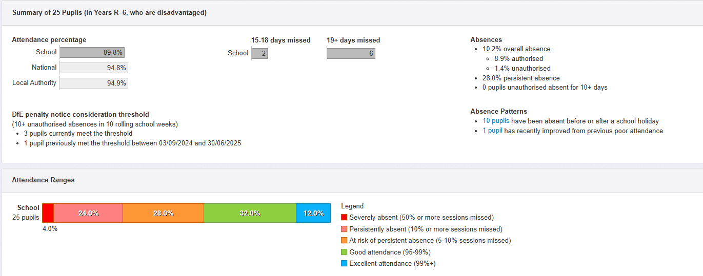
4.  Pupils access a wide range of enrichment experiences both in and out of school Children have the necessary skills, vocabulary and support to enable them to manage SEMH issues, including anxiety. | The THRIVE programme is used by all staff and all children who would benefit from it are identified and regularly supported.  THRIVE assessments show that key children are making progress.  All staff have received annual training in supporting SEMH issues, following a restorative approach to behaviour.  The PSHE curriculum supports all children to develop the vocabulary and skills to express emotions and manage feelings.  Thrive is now embedded at Harbury School and has gone from strength to strength. We now have two Thrive practitioners and they support 20+ pupils across the school.  All pupils have accessed whole school Thrive- thrive afternoons/Thrive assemblies. All children have had Thrive profiling from class teachers.  57% of pupil premium pupils accessed tier 1 of Thrive  28% have had Tier 5 Thrive (1-1 sessions)  This has been Thrive breakfasts, Thrive lunch club, Thrive 1-1 sessions and Thrive group sessions. Alongside this, Thrive regular check ins.  Our hope is to grow our Thrive more and introduce Thrive Family.  Zones of regulation embedded across the school.  Restorative practice embedded and new policies tweaked and reviewed regularly.

