Hardwick Green Primary Academy
Reception Long Term Plan 2023-24
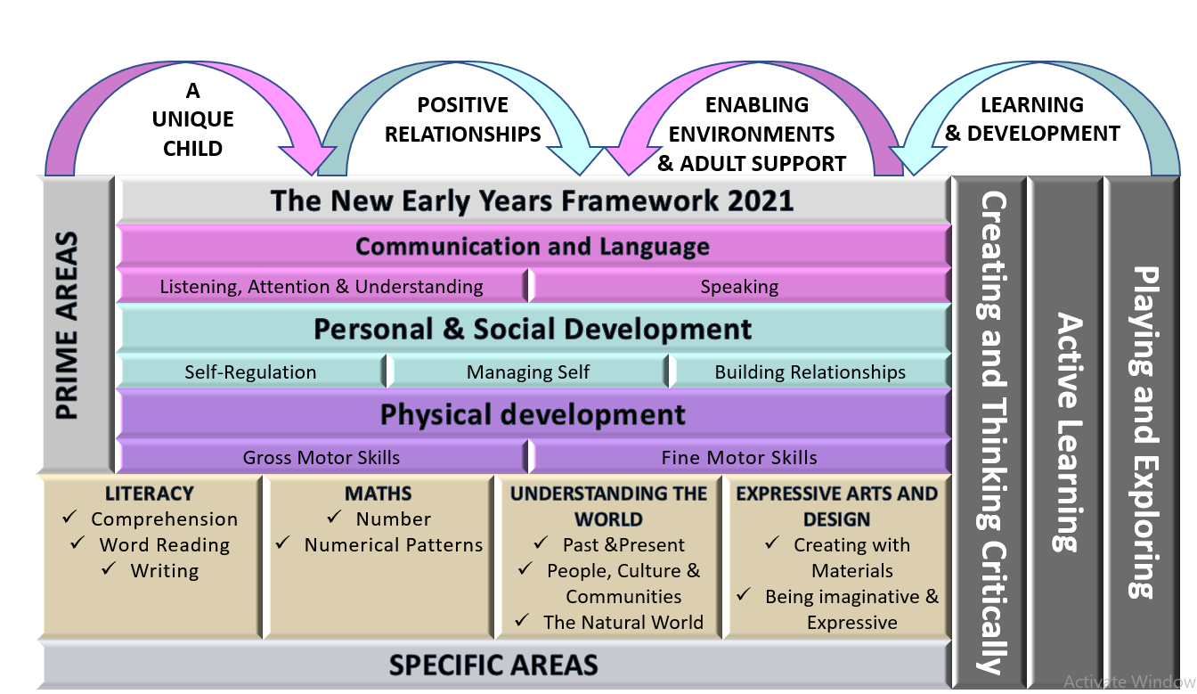

At Hardwick Green Primary Academy we offer a curriculum rich in wonder and memorable experiences. We work hard to provide a stimulating environment that provides exciting opportunities, promotes challenge, exploration, adventure and a real love of learning. It is our intent that all children develop physically, verbally, cognitively and emotionally in an environment which values all cultures, communities and people. We aim for our children to be confident and independent, to believe in themselves and interact positively with others.

Reception LTP 23-24 | Autumn 1  (7.5 weeks) | Autumn 2  (6.5 weeks) | Spring 1  (6 weeks) | Spring 2  (5 weeks) | Summer 1  (6 weeks) | Summer 2  (7.5 weeks)
Characteristics of Effective Learning | Playing and exploring: Children investigate and experience things, and ‘have a go’. Children who actively participate in their own play develop a larger store of information and experiences to draw on which positively supports their learning  Active learning: Children concentrate and keep on trying if they encounter difficulties. They are proud of their own achievements. For children to develop into self-regulating, lifelong learners they are required to take ownership, accept challenges and learn persistence.  Creating and thinking critically: Children develop their own ideas and make links between these ideas. They think flexibly and rationally, drawing on previous experiences which help them to solve problems and reach conclusions.
Overarching Principles | Unique Child: Every child is unique and has the potential to be resilient, capable, confident and self-assured.  Positive Relationships: Children flourish with warm, strong & positive partnerships between all staff and parents/carers. This promotes independence across the EYFS curriculum.  Enabling environments: Children learn and develop well in safe and secure environments where routines are established and where adults respond to their individual needs and passions and help them to build upon their learning over time.  Learning and Development: Children develop and learn at different rates. We must be aware of children who need greater support than others.  Play: At Hardwick Green Primary Academy we understand that play is an integral part of learning and this is at the heart of our early years curriculum. We believe that the correct mix of adult directed and uninterrupted child initiated play ensures the best outcomes for pupils. Warm and positive relationships between staff and children, consistent routines and strong relationships with parents are key. We recognise the crucial role that early year’s education has to play in providing firm foundations upon which the rest of a child’s education is successfully based.
Theme | Where do I belong? | Once upon a time  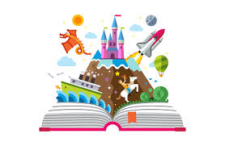 | Where in the world?  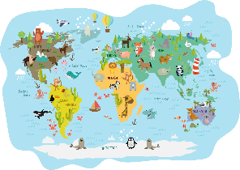 | All creatures great and small  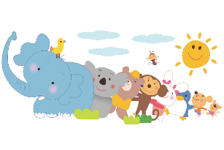 | Growing and farms  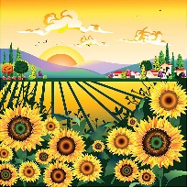 | Do you like to be beside the seaside?  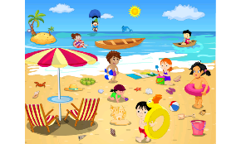
General themes  (other themes may emerge from children’s interests) | - All about me  - My family  - Our community – where we live  - Buildings  - Human and physical features of our local environment  - Our school  - Emotions  - Maps  - Space  - The world  - Weather | - Fairy tales  - The Gruffalo  - Woodland environments  - Baking  - Oral hygiene  - Christmas | - Contrasting environments  - Naming aspects of different environments  - Changing seasons  - Africa  - Antarctic  - Melting ice  - Weather  - Travel | - Animals – characteristics of animals and categories of animals  - Habitats  - Minibeasts  - Lifecycles  - Easter | - Food from farms  - Plants  - Growing from babies to adults  - Healthy eating  - Maps | - Seasides in the past  - Seaside activities  - Sea creatures  - Human and physical features of the seaside  - Floating and sinking
Power of Reading/High Quality texts | 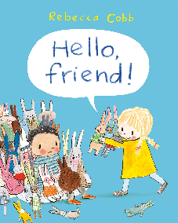  Hello, friend! By Rebecca Cobb  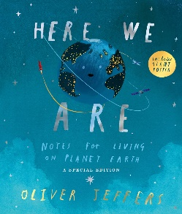  Here We Are by Oliver Jeffers | 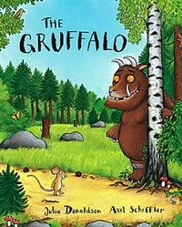  The Gruffalo by Julia Donaldson  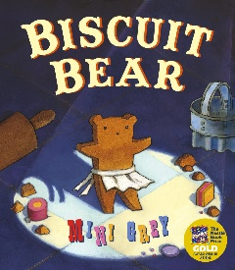  The Biscuit Bear by Mini Grey  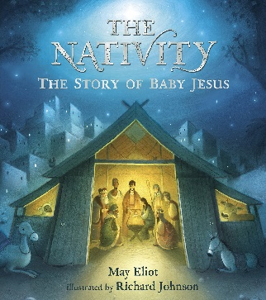  The Nativity | 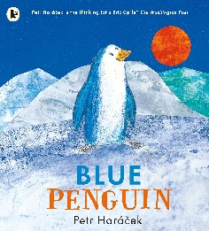  Blue Penguin by Petr Horacek 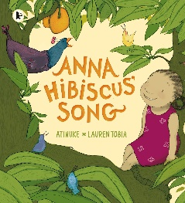  Anna Hibiscus Song by Atinuke | 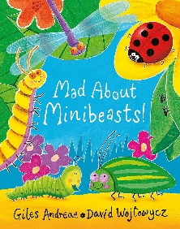  Mad About Minibeasts by Giles Andreae  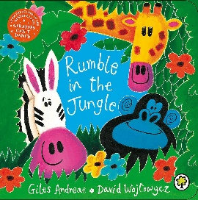  Rumble In The Jungle by Giles Andreae | 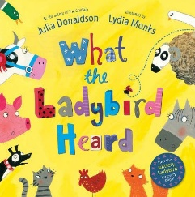  What the Ladybird Heard by Julia Donaldson  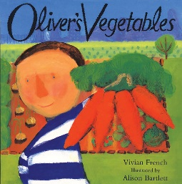  Oliver’s Vegetables by Vivian French | Billy’s Bucket by Kes Gray & Garry Parsons  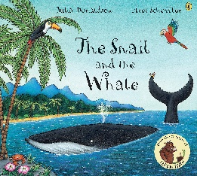  Snail and the Whale by Julia Donaldson
Tier 2/3 Vocabulary  (bold text denotes vocabulary from Power of Reading texts) | Friend  Sharing  Helpful  Excited  Quiet  Noisy  Class  Family  Community  Emotions  Planet  Earth  Country  Town  Street  Globe  Space  Moon  Land  Sea  Hot  Cold  Flat  Bumpy  Pointy  Dry  Wet  Volcano  Wonderful  Iceberg  Complicated  Constellation  Stars  Sun  Weather  Rainbow  Body  Skeleton  Healthy  Body parts (brain, heart, lungs etc)  Different  Extinct  Daytime  Night  Peaceful  Busy | Stroll  Wood  Underground  Terrible  Tusks  Claws  Jaws  Roasted  Sped  Treetop  Knobbly  Turned-out  Poisonous  Wart  Stream  Logpile  Prickles  Scrambled  Favourite  Scariest  Creature  Afraid  Bursting  Astounding  Story  Fiction  Woodland  Environment  Cooled  Appetite  Gazing  Mixture  Circus  Acrobats  Aeronaut  Looming  Clamber  Familiar  Plaster  Delicious  Baking  Temperature  Cooked  Carpenter  Amazing  Brightly  Mankind  Astonished  Decreed  Register  Inn  Stable  Peaceful  Manger  Shepherds  Flock  Expensive  Gold  Myrrh  Frankinsense  Foretold  Christians  Advent  Celebration | Penguin  Wandered  Beautiful  Rescued  Lonely  Ocean  Magical  Huge  Disappeared  Horizon  Antarctica  Frozen  Freezing  Melting  Winter  Weather  Seasons  Environment  Amazing  Africa  Mango  Cool  Veranda  Pounding  Yam  Scattering  Savannah  Continent  Contrast  Culture | Chirrup  Scuttle  Minibeasts  Slithering  Shelter  Scrummy  Dew  Feelers  Rotten  Pinchers  Trick  Army  Cocoon  Hive  Lifecycle  Chrysalis  Habitat  Characteristics  Waterhole  Lair  Fleas  Quivers  Mule  Ravenous  Galloping  Ferocious  Prowling | Pen  Hog  Handsome  Dainty  Fine prize  Cunning  Hefty  Lanky  Map  Directions  Crops  Produce  Bargain  Potatoes  Carrots  Leaves  Crinkly  Spinach  Rhubarb  Cabbage  Helpings  Beetroot  Plants  Stem  Roots | Persuaded  Aisle  Excitedly  Peering  Rock pool  String ray  Clown fish  Barracuda  Submarines  Pilchard  Sea lion  Walrus  Chuckled  Imagination  Shoe-horn  Seashore  Beach  Coast  Lighthouse  Cliffs  Pier  Coral reef  Soot  Dock  Foot (snail’s foot)  Hitch  Tide  Starlit  Frolicked  Fins  Speedboats  Earsplitting  Beached  Helpless  Human features  Physical features
Reading Skills Progression RWI | Word Reading  Develop their phonological awareness to:  - Spot rhymes in familiar stories and poems.  - Count or clap syllables in a word.  - Recognise words with the same initial sound.  Begin to read individual letters by saying the sounds for them.  Begin to blend sounds into words, so that they can read short words made up of known letter– sound correspondences.  Begin to read CVC words containing known letter-sound correspondences.  Comprehension  Asks questions about stories.  Repeat words and phrases from familiar stories.  Repeat new vocabulary in a context of a story.  Has favourite books and seeks them out, to share with an adult, with another child, or to look at alone. |  | Word Reading  Develop their phonological awareness to:  - Able to complete a rhyming string.  - Begin to use Fred fingers to identify how many sounds are in a word.  - Can supply words with the same initial sound for set 1 single sounds.  Recognise all taught Set 1 sounds including some digraphs.  Re-read phonetically decodable books to build up their confidence in word reading, their fluency and their understanding and enjoyment.  Blend sounds into words, so that they can read short words made up of known letter– sound correspondences.  Read simple sentences containing known letter-sound correspondences containing 1 or 2 common exception words.  Comprehension  Answer questions about a text that has been read to them.  Begin to predict what might happen next in a story.  Begin to use modelled vocabulary during role play for example in the Small World.  Seeks familiar texts or stories to re-read in the book area. Requests favourite stories and poems for example during Vote for a story. |  | Word Reading  Develop their phonological awareness to:  - Recognises and uses rhyme in daily conversation.  - Use Fred Fingers to segment and read words.  - Can identify words containing the same digraph or trigraph e.g ay- may, day, play.  ELG Word Reading:  - Say a sound for each letter in the alphabet and at least 10 digraphs.  - Read words consistent with their phonic knowledge by sound-blending  - Read aloud simple sentences and books that are consistent with their phonic knowledge, including some common exception words.  Comprehension  ELG Comprehension:  - Demonstrate understanding of what has been read to them by retelling stories and narratives using their own words and recently introduced vocabulary  - Anticipate – where appropriate – key events in stories  - Use and understand recently introduced vocabulary during discussions about stories, non-fiction, rhymes and poems and during role-play.  Can share a favourite book with a peer, retelling the story in their own way repeating known phrases from the text. ,
RWI Talk Through Stories | A Little Bit Brave  Ruby’s Worry  My Monster and Me  Room on the Broom | Can’t You Sleep, Little Bear?  Cottonwool Colin  Five Minutes’ Peace  Missing Richmond | Aliens Love Underpants  Gecko’s Echo  I’m in Charge  Lost and Found | Elmer  The Koala Who Could  The Lion Inside  The Squirrels Who Squabbled | Handa’s Hen  Sonya’s Chickens  Supertato  The Wonky Donkey | The Rainbow Fish  Hugless Douglas  The Giant Jam Sandwich  Tiddler
Typical Writing progression | Letter formation  Name Writing  Beginning to write CVC words in line with phonic knowledge | Letter formation  Name Writing  CVC words | CVC words with sentence starters  Captions | CVC words with sentence starters  Captions  Dictated sentences | CVC words with sentence starters  Captions  Dictated/independent sentences | Captions  Dictated/independent sentences
Maths  NCETM Mastering Number | Week 1-5  - Subitising  - Counting, Cardinality and Ordinality  - Composition  - Comparison | Week 6-10  - Counting, Cardinality and Ordinality  - Comparison  - Composition | Week 11-15  - Subitising  - Counting, Cardinality and Ordinality  - Composition  - Comparison | Week 16-20  - Counting, Cardinality and Ordinality  - Comparison  - Composition  - Subitising | Week 21-25  - Counting, Cardinality and Ordinality  - Subitising  - Composition  - Comparison | Weeks 26-31  - Review and assess – Comparison  - Review and assess- counting beyond 20  - Review and assess – patterns within numbers to 10  - Review and assess – automatic recall  - Review and assess – understanding of numbers to 10  - Review and assess – subitising on a rekenrek
Maths  White Rose | Getting to know you (2 weeks - baseline)  - Establish maths through routines (tens frame buses, 100 days in school, calendar activities)  Match, Sort & Compare (2 weeks)  - Match objects  - Match pictures and objects  - Identify a set  - Sort objects to a type  - Explore sorting techniques  - Create sorting rules  - Compare amounts  Talk about measure and patterns (2 weeks)  - Compare size  - Compare mass  - Compare capacity  - Explore simple patterns  - Copy and continue simple patterns  - Create simple patterns | It’s Me 1, 2, 3 (2 weeks)  - Find 1, 2 and 3  - Subitise 1, 2 and 3  - Represent 1, 2 and 3  - 1 more  - 1 less  - Composition of 1, 2 and 3  Circles and triangles (1 week)  - Identify and name circles and triangles  - Compare circles and triangles  - Shapes in the environment  - Describe position  1, 2, 3, 4, 5 (2 weeks)  - Find 4 and 5  - Subitise 4 and 5  - Represent 4 and 5  - 1 more  - 1 less  - Composition of 4 and 5  - Composition of 1-5  Shapes with 4 sides (1 week)  - Identify and name shapes with 4 sides  - Combine shapes with 4 sides  - Shapes in the environment  - My day and night | Alive in 5 (2 weeks)  - Introduce zero  - Find 0 to 5  - Subitise 0 to 5  - Represent 0 to 5  - 1 more  - 1 less  - Composition  - Conceptual subitising to 5  Mass and Capacity (1 week)  - Compare mass  - Find a balance  - Explore capacity  - Compare capacity  Growing 6, 7, 8 (2 weeks)  - Find 6, 7 and 8  - Represent 6, 7, and 8  - 1 more  - 1 less  - Composition of 6, 7 and 8  - Make pairs-odd and even  - Double to 8 (find a double)  - Double to 8 (make a double)  - Combine 2 groups  - Conceptual subitising  Length, Height and Time (1 week)  - Explore length  - Compare length  - Explore height  - Compare height  - Talk about time  - Order and sequence time | Building 9 and 10 (3 weeks)  - Find 9 and 10  - Compare numbers to 10  - Represent 9 and 10  - Conceptual subitising to 10  - 1 more  - 1 less  - Composition to 10  - Bonds to 10 (2 parts)  - Make arrangements of 10  - Bonds to 10 (3 parts)  - Doubles to 10 (find a double)  - Doubles to 10 (make a double)  - Explore even and odd  Explore 3D shapes (2 weeks)  - Recognise and name 3D shapes  - Find 2D shapes within 3D shapes  - Use 3D shapes for tasks  - 3D shapes in the environment  - Identify more complex patterns  - Copy and continue patterns  - Patterns in the environment | To 20 and beyond (2 weeks)  - Build numbers beyond 10 (10-13)  - Continue patterns beyond 10 (10-13)  - Build numbers beyond 10 (14-20)  - Continue patterns beyond 10 (14-20)  - Verbal counting beyond 20  - Verbal counting patterns  How many now? (1 week)  - Add more  - How many did I add?  - Take away  - How many did I take away?  Manipulate, compose and decompose (2 weeks)  - Select shapes for a purpose  - Rotate shapes  - Manipulate shapes  - Explain shape arrangements  - Compose shapes  - Decompose shapes  - Copy 2D shape pictures  - Find 2D shapes within 3D shapes | Sharing and grouping (2 weeks)  - Explore sharing  - Sharing  - Explore grouping  - Grouping  - Even and odd sharing  - Play with and build doubles  Visualise, build and map (3 weeks)  - Identify units of repeating patterns  - Create own pattern rules  - Explore own pattern rules  - Replicate and build scenes and constructions  - Visualise from different positions  - Describe positions  - Give instructions to build  - Explore mapping  - Represent maps with models  - Create own maps from familiar places  - Create own maps and plans from story situations  Make connections (1 week)  - Deepen understanding  - Patterns and relationships
Understanding of the World  Science  Geography  History  RE | Talk about who lives in our family Learn about different family dynamics.  Learn about other people in our community. (DM - Talk about members of their immediate family and community  Name and describe people who are familiar to them)  Learn about how we have grown and changed since being babies  Locate on a map and talk about our local community of Hardwick (DM - Draw information from a simple map.)  Learn that the United Kingdom is made up of 4 countries.  Discuss the human and physical features of our local environment.  Use an iPad to take photos of nature (DM - Describe what they see, hear and feel whilst outside.  Explore the natural world around them.)  Look at different environments in the world, including our own. (DM -Recognise some environments that are different to the one in which they live.)  Learn about the importance of recycling to look after our planet.  Explore the anatomy of a pumpkin and how the ingredients change when making pumpkin soup  Learn about and notice the signs of Autumn.  (DM - Understand the effect of changing seasons on the natural world around them.  Explore the natural world around them.)  Learn about the celebration of Diwali (DM – Recognise that people have different beliefs and celebrate special times in different ways.) | Use adjectives to describe the characters in the story, comparing and contrasting them.  (DM- Compare and contrast characters from stories, including figures from the past)  Draw a map of the route the mouse took in the Gruffalo (DM - Draw information from a simple map.)  Explore a woodland setting like in the Gruffalo. Discuss how this environment is different to the environment we live in.  (DM - Explore the natural world around them.  Describe what they see, hear and feel whilst outside  Recognise some environments that are different from the one in which they live.)  Learn the habitats of woodland animals. (DM - Explore the natural world around them)  Bake apple crumble and discuss the mixing and changing of ingredients.  Follow instructions to make shortbread biscuits  Learn the story of The Nativity  (DM -Recognise that people have different beliefs and celebrate special times in different ways)  Learn how Christmas was celebrated in the past compared to how it is celebrated now  (DM - Comment on images of familiar situations in the past.)  Learn how Christmas is celebrated in different ways around the world. (DM – Recognise that people have different beliefs and celebrate special times in different ways.) | Learn about and notice the signs of Winter (DM - Understand the effect of changing seasons on the natural world around them.  Explore the natural world around them.  Describe what they see, hear and feel whilst outside)  Observe how ice melts when it warms. (DM - Explore the natural world around them.)  Compare the Antarctic environment and African environment, including comparing to our own. (DM - Recognise some environments that are different to the one in which they live.)  Learn about the similarities and differences between life in UK and life in Africa. (DM - Recognise some similarities and differences between life in this country and life in other countries)  Learn about the celebration of Lunar New Year (DM – Recognise that people have different beliefs and celebrate special times in different ways.) | Learn the characteristics and categories of various minibeasts and animals. (DM - Explore the natural world around them)  Learn the habitats of minibeasts and animals. (DM - Explore the natural world around them)  Search for minibeasts in the outdoor area (DM - Explore the natural world around them.  Describe what they see, hear and feel whilst outside)  Learn about why bees are important for the environment (DM - Explore the natural world around them)  Learn about the lifecycle of a frog, hen and butterfly. (DM - Explore the natural world around them)  Learn about the celebration of Easter. (DM - Recognise that people have different beliefs and celebrate special times in different ways)  Learn about the celebration of Holi. (DM - Recognise that people have different beliefs and celebrate special times in different ways) | Draw a map of the farm in What the Ladybird Heard (DM - Draw information from a simple map)  Learn about where food comes from  Bake bread and explore the mixing and changing of ingredients  Plant potatoes  Learn about the parts of a plant and what is needed to grow a plant (DM - Explore the natural world around them)  Learn about making healthy food choices  Learn about various animals which live on a farm and the characteristics of these animals (DM - Explore the natural world around them)  Learn about the celebration of Eid. (DM - Recognise that people have different beliefs and celebrate special times in different ways)  Learn about how we have grown and changed since being babies | Learn about the human and physical features of the seaside  Learn about various sea creatures and their characteristics (DM - Explore the natural world around them)  Discuss natural resources which can be found at the seaside (DM - Explore the natural world around them.  Describe what they see, hear and feel whilst outside)  Explore objects which float and sink in water DM - Explore the natural world around them)  Learn about seasides in the past and how they are different to now  (DM - Comment on images of familiar situations in the past.)  Learn about a famous pirate from the past (DM - Compare and contrast characters from stories,  including figures from the past)
Art  Kapow | Drawing: Marvellous Marks  - Mark Making with Wax Crayons  - Mark Making with Felt Tips  - Mark Making with Chalk  - Observational Pencil Drawings  - Drawing Faces  - Drawing Faces in Colour  - Autumn Crafts: Nature Wreaths | Painting and mixed media: Paint my world  - Finger Painting  - Outdoor Painting  - Painting to Music  - Collage and Transient Art  - Landscape Collage  - Group Art  - Winter Craft: Threaded snowflakes  - Christmas Craft: Salt dough decs | Craft and design: Let's get crafty  - Cutting Skills  - Threading Skills  - Joining Materials  - Paper Snakes | Sculpture and 3D: Creation station  - Spring Craft: Petal Mandala Suncatchers  - Easter Craft: Egg Threading Clay  - Playdough  - 3D Landscape Art  - Designing Animal Sculptures  - Creating Animal Sculptures  - Painting Animal Sculptures | Craft and design: Let's get crafty  - Flower Designs  - Tissue Paper Flowers | Painting and mixed media: Paint my world  - Finger Painting  - Outdoor Painting  - Painting to Music  - Collage and Transient Art  - Landscape Collage  - Summer Craft: Salt Painting
Artist focus | Portraits by Pablo Picasso  Drawing or painting self-portraits, colour mixing  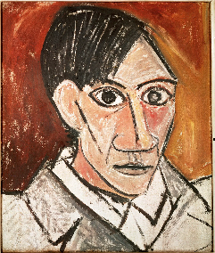  “Sunflowers” by Van Gogh  Observational drawing and painting, colour mixing  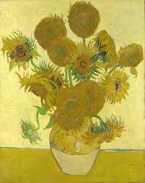  “Midnight Pumpkin” by Yayoi Kusama  Finger painting and printing different sized dots using various tools, colour mixing  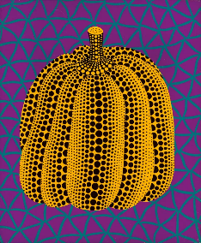 | Jackson Pollock  Using different methods to make firework paintings e.g. splatting, blowing, ‘drip painting’, colour mixing, working collaboratively  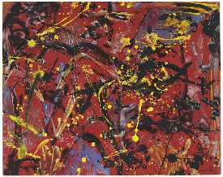  “Squares with Concentric Circles” by Kandinsky  Using shapes, colour mixing  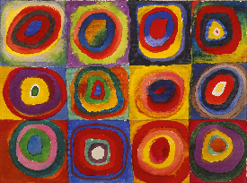  “Composition with Large Red Plane, Yellow, Black, Gray, and Blue” by  Piet Mondrian  Using shapes, colour mixing, drawing straight lines  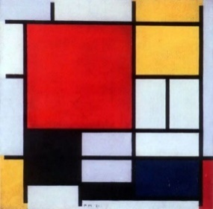 | “Starry Night” by Van Gogh  Oil pastels  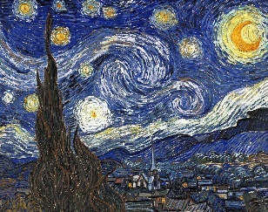  Esther Mahlangu  Making pictures with shapes  Printing on fabric  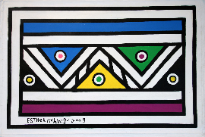 | “The Snail” by Henri Matisse  Collage, sticking, cutting  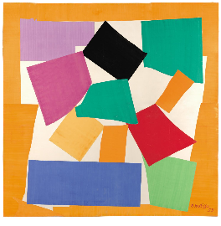 | Dennis Wojtkiewicz  Still-life fruit painting, colour mixing  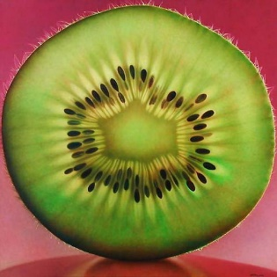 | “The Great Wave off Kanagawa” by Hokusai  Oil pastels, observing shapes  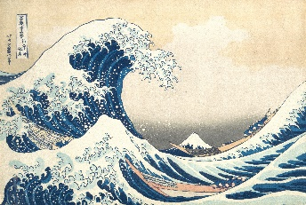
Music  Charanga | Autumn 1: Me! | Autumn 2: My Stories  ‘Our First Nativity’ songs | Spring 1: Everyone! | Spring 2: Our World | Summer 1: Big Bear Funk | Summer 2: Reflect, Rewind, Replay
PE  Complete PE | Dance – Nursery Rhymes | Locomotion – Walking 1 | Locomotion – Jumping 1 | Attack v Defence – Games for Understanding | Gymnastics – High, Low, Over, Under (Gymnastics Coach) | Ball Skills – Rackets, Bats and Balls
Computing | Information Technology |  | Digital Literacy (Safer Internet Day) |  | Computer Science
British Values  Assemblies, RE & Jigsaw | Fundamental British Values underpin what it is to be a citizen in a modern and diverse Great Britain, valuing our community  and celebrating the diversity of the UK. These are not exclusive to being British and are shared by other democratic countries.  Mutual respect: We are all unique. We respect differences between different people and their beliefs in our community, in this country and all around the world. All cultures are learned, respected, and celebrated.  Mutual Tolerance: Everyone is valued, all cultures are celebrated and we all share and respect the opinions of others. Mutual tolerance of those with different faiths and beliefs and for those without faith.  Rule of law: We all know that we have rules at school that we must follow. We know who to talk to if we do not feel safe. We know right from wrong. We recognise that we are accountable for our actions. We must work together as a team when it is necessary.  Individual liberty: We all have the right to have our own views. We are all respected as individuals. We feel safe to have a go at new activities. We understand and celebrate the fact that everyone is different.  Democracy: We all have the right to be listened to. We respect everyone and we value their different ideas and opinions. We have the opportunity to play with who we want to play with. We listen with intrigue and value and respect the opinions of others.
PSED  Jigsaw | Jigsaw  Being in My World  - I understand how it feels to belong and that we are similar and different  - I can start to recognise and manage my feelings  - I enjoy working with others to make school a good place to be  - I understand why it is good to be kind and use gentle hands  - I am starting to understand children’s rights and this means we should all be allowed to learn and play  - I am learning what being responsible means | Jigsaw  Celebrating Difference  - I can identify something I am good at and understand everyone is good at different things  - I understand that being different makes us all special  - I know we are all different but the same in some ways  - I can tell you why I think my home is special to me  - I can tell you how to be a kind friend  - I know which words to use to stand up for myself when someone says or does something unkind | Jigsaw  Dreams and Goals  - I understand that if I persevere I can tackle challenges  - I can tell you about a time I didn’t give up until I achieved my goal  - I can set a goal and work towards it  - I can use kind words to encourage people  - I understand the link between what I learn now and the job I might like to do when I’m older  - I can say how I feel when I achieve a goal and know what it means to feel proud | Jigsaw  Healthy Me  - I understand that I need to exercise to keep my body healthy  - I understand how moving and resting are good for my body  - I know which foods are healthy and not so healthy and can make healthy eating choices  - I know how to help myself go to sleep and understand why sleep is good for me  - I can wash my hands thoroughly and understand why this is important especially before I eat and after I go to the toilet  - I know what a stranger is and how to stay safe if a stranger approaches me | Jigsaw  Relationships  - I can identify some of the jobs I do in my family and how I feel like I belong  - I know how to make friends to stop myself from feeling lonely  - I can think of ways to solve problems and stay friends  - I am starting to understand the impact of unkind words  - I can use Calm Me time to manage my feelings  - I know how to be a good friend | Jigsaw  Changing Me  - I can name parts of the body  - I can tell you some things I can do and foods I can eat to be healthy  - I understand that we all grow from babies to adults  - I can express how I feel about moving to Year 1  - I can talk about my worries and/or the things I am looking forward to about being in Year 1  - I can share my memories of the best bits of this year in Reception
RE  Discovery RE | Discovery RE  Theme: Special People  Key Question: What makes people special?  Religions: Christianity, Judaism | Discovery RE  Theme: Christmas  Concept: Incarnation  Key Question: What is Christmas?  Religion: Christianity | Discovery RE  Theme: Celebrations  Key Question: How do people celebrate?  Religion: Hinduism | Discovery RE  Theme: Easter  Concept: Salvation  Key Question: What is Easter?  Religion: Christianity | Discovery RE  Theme: Stories  Key Question: What can we learn from stories?  Religions: Christianity, Islam, Hinduism, Sikhism | Discovery RE  Theme: Special places  Key Question: What makes places special?  Religions: Christianity, Islam, Judaism
Cultural Capital Opportunities (flexible to children’s interests and experiences) | Immersive space – space week  Cook pumpkin soup  Learn about the celebration of Diwali  Learn about Stevie Wonder | Bake apple crumble (Gruffalo crumble)  Visit from fire service for bonfire night  Trip to Hardwick Park (Cycle A)/Wynyard Woodland Park (Cycle B)  Learn about the origins of Bonfire Night  Learn about the origins of Halloween  Learn about the reasons for and observe Remembrance Day  Take part in a nativity play  Learn about the celebration of Christmas | Immersive Space – Africa and Antarctica  Adopt a penguin  Learn about the celebration of Lunar New Year | ZooLab visit (Cycle A)/Butterfly World & Preston Park (Cycle B)  InsectLore Caterpillars  Learn about the celebration of Holi  Learn about the celebration of Easter | Planting seeds  Farm trip (Cycle B)  Make vegetable soup  Learn about the celebration of Eid | Seaside trip (Cycle A)  Immersive space – under the sea
Events | Recycle Week  World Space Week  Black History Month  Diwali | Outdoor Classroom Day  Bonfire Night  World Science Day  Remembrance Day  Children in Need  World Nursery Rhyme Week  Christmas Stay & Play  Christmas Party  Nativity Play  Christmas Fair | Chinese New Year  RSPB Big Schools Bird Watch  Safer Internet Day  Random Act of Kindness Week  Pancake Day  Valentine’s Day | World Wildlife Day  World Book Day  Red Nose Day  Holi  Mother’s Day  Easter Stay & Play | Eid  World Maths Day  World Bee Day | Pride Month  World Ocean’s Day  Healthy Eating Week  Father’s Day  World Music Day  Y1 Transition  Sports Day

Early Learning Goals
Communication & Language | Personal, Social & Emotional Development | Physical Development | Literacy | Mathematics | Understanding The World | Expressive Art & Design
ELG: Listening, Attention and Understanding  Listen attentively and respond to what they hear with relevant questions, comments and actions when being read to and during whole class discussions and small group interactions.  Make comments about what they have heard and ask questions to clarify their understanding.  Hold conversation when engaged in back-and-forth exchanges with their teacher and peers  ELG: Speaking  Participate in small group, class and one-to-one discussions, offering their own ideas, using recently introduced vocabulary.  Offer explanations for why things might happen, making use of recently introduced vocabulary from stories, non-fiction, rhymes and poems when appropriate.  Express their ideas and feelings about their experiences using full sentences, including use of past, present and future tenses and making use of conjunctions, with modelling and support from their teacher. | ELG: Self-Regulation  Show an understanding of their own feelings and those of others, and begin to regulate their behaviour  accordingly.  Set and work towards simple goals, being able to wait for what they want and control their immediate impulses  when appropriate.  Give focused attention to what the teacher says, responding appropriately  even when engaged in activity, and show an ability to follow instructions involving several ideas or actions.  ELG: Managing Self  Be confident to try new activities and show independence, resilience and  perseverance in the face of challenge.  Explain the reasons for rules, know right from wrong and try to behave accordingly.  Manage their own basic hygiene and personal needs, including dressing, going to the toilet and understanding  the importance of healthy food choices.  ELG: Building Relationships  Work and play cooperatively and take turns with others.  Form positive attachments to adults and friendships with peers;.  Show sensitivity to their own and to others’ needs. | ELG: Gross Motor Skills  Negotiate space and obstacles safely, with consideration for themselves and  others.  Demonstrate strength, balance and coordination when playing.  Move energetically, such as running, jumping, dancing, hopping, skipping and climbing.  ELG: Fine Motor Skills  Hold a pencil effectively in preparation for fluent writing – using the tripod grip in almost all cases.  Use a range of small tools, including scissors, paint brushes and cutlery.  Begin to show accuracy and care when drawing. | ELG: Comprehension Demonstrate understanding of what has been read to them by retelling stories and narratives using their own words and recently introduced vocabulary.  Anticipate – where appropriate – key events in stories. Use and understand recently introduced vocabulary during discussions about stories, non-fiction, rhymes and poems and during roleplay.  ELG: Word Reading  Say a sound for each letter in the alphabet and at least 10 digraphs.  Read words consistent with their phonic knowledge by sound-blending.  Read aloud simple sentences and books that are consistent with their phonic knowledge, including some common exception words.  ELG: Writing  Write recognisable letters, most of which are correctly formed.  Spell words by identifying sounds in them and representing the sounds with a letter or letters.  Write simple phrases and sentences that can be read by others. | ELG: Number  Have a deep understanding of number to 10, including the composition of each number;  Subitise (recognise quantities without counting) up to 5  Automatically recall (without reference to rhymes, counting or other aids) number bonds up to 5 (including subtraction facts) and some number bonds to 10, including double facts.  ELG: Numerical Patterns Verbally count beyond 20, recognising the pattern of the counting system;  Compare quantities up to 10 in different contexts, recognising when one quantity is greater than, less than or the same as the other quantity.  Explore and represent patterns within numbers up to 10, including evens and odds, double facts and how quantities can be distributed equally. | ELG: Past and Present  Talk about the lives of the people around them and their roles in society.  Know some similarities and differences between things in the past and now, drawing on their experiences and what has been read in class.  Understand the past through settings, characters and events encountered in books read in class and storytelling.  ELG: People, Culture and Communities  Describe their immediate environment using knowledge from observation, discussion, stories, non-fiction texts and maps.  Know some similarities and differences between different religious and cultural communities in this country, drawing on their experiences and what has been read in class.  Explain some similarities and differences between life in this country and life in other countries, drawing on knowledge from stories, non-fiction texts and – when appropriate – maps.  ELG: The Natural World  Explore the natural world around them, making observations and drawing pictures of animals and plants.  Know some similarities and differences between the natural world around them and contrasting environments, drawing on their experiences and what has been read in class.  Understand some important processes and changes in the natural world around them, including the seasons and changing states of matter. | ELG: Creating with Materials  Safely use and explore a variety of materials, tools and techniques, experimenting with colour, design, texture, form and function.  Share their creations, explaining the process they have used;  Make use of props and materials when role playing characters in narratives and stories.  ELG: Being Imaginative and Expressive  Invent, adapt and recount narratives and stories with peers and their teacher.  Sing a range of well-known nursery rhymes and songs;  Perform songs, rhymes, poems and stories with others, and – when appropriate – try to move in time with music.

