
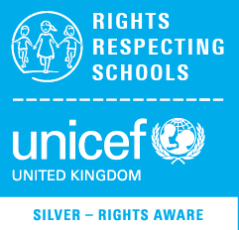
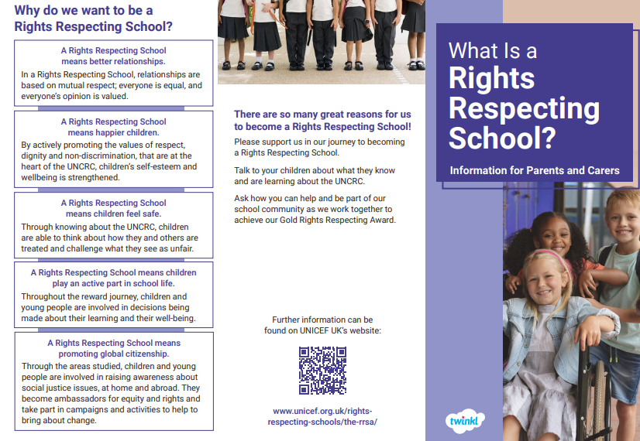
Harefield Primary School is a Silver accredited Rights Respecting School! We are working towards our Gold award. Come along to a parent forum meeting at 3.30pm on Monday 2nd December to hear what we have been doing, what our Pupil Voice Reps do and what we are campaigning about this year!

