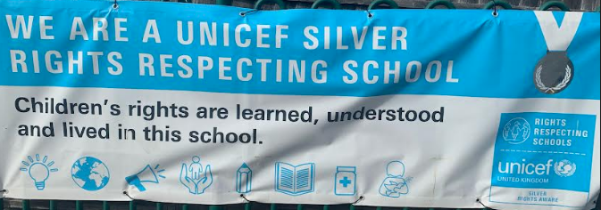

Rights Respecting School Update
We have some very exciting news! Recently our Pupil Voice Reps wrote to our local MP Darren Paffey, inviting him into school to talk to us about children’s rights and the work we have been doing as part of UNICEF’s “Outright” campaign. HE HAS ACCEPTED OUR INVITATION and will be visiting us later in March. He will be visiting our Breakfast club and talking to our Pupil Voice Reps about our food campaigning.
Meanwhile, we had another rights day back in January all about global citizenship and the global goals. We will be having another “rights” day in March entitled “I am a change maker” in which we will be considering skills needed to be a campaigner as well as what issues we are interested in. We will be learning about youth activists all around the world as well as a couple closer to home!
Mrs Heal

