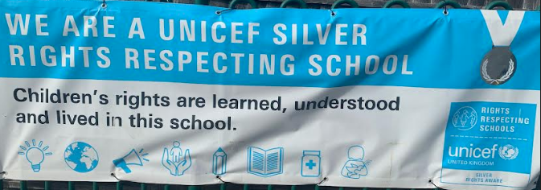

Rights Respecting School Update
On Wednesday 20th November it is World Children’s Day! We will be marking this event by having a morning of “Rights Respecting” activities across the whole school. Activities will include looking at the convention of rights, discussing how the UK is doing on protecting children’s rights and how “Democracy” works. The children will be taking part in a national live event online run by UNICEF. We will be taking part in UNICEF’s “Outright campaign” this year which will involve our Pupil Voice group campaigning to help food poverty. The children have come up with many ideas of how to do this and we will be creating our own “food bank” at school as part of this – look out for the posters and food crates as you drop off and pick up your children. Our Pupil Voice will be contacting our local decision makers to see if they can listen and support our campaigning.
Looking ahead – there will be a parent forum on Monday 2nd December 3:30pm where you are welcome to come along and learn more about Rights Respecting Schools and what it means to Harefield Primary.
Mrs Heal
