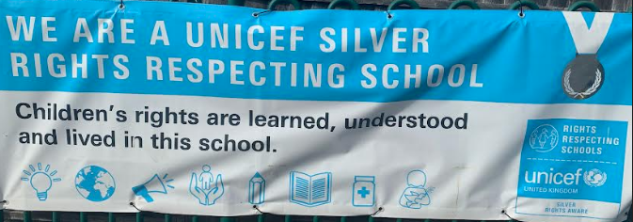

Rights Respecting School Update
We have been doing lots of important activities this half term as we start to work towards obtaining our Gold Award. We have created a “Whole School Charter” which has been signed by both children (our “rights holders”) and adults (our “duty-bearers”) and is displayed in our hall. Every class has also been busy creating their own class charters which everyone agreed to, signed, and displayed in their classrooms. The children then set to work, democratically electing a Pupil Voice Representative for each class. Our children produced very impressive manifestos, which included many brilliant ideas. We were very proud of how confident the children were at presenting these manifestos in front of their classes. Reps have met a few times now and have been creating suggestion boxes which all children can use so that they have a voice in what is happening in school. In the next few weeks, the reps will be giving the children questionnaires to fill in and we will start to put together a child friendly version of our School Development Plan. Mrs Heal
