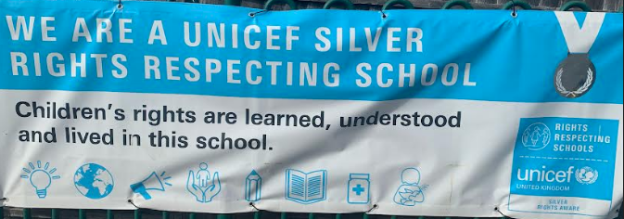

Rights Respecting School Update
The exciting year ahead!!!! Going for Gold!
This year we will be really going for gold! Our main aims this year are for our children to know as many of their rights as possible, for their voice to be heard in all areas of school life and to start campaigning on issues our children feel are important. We have already established a “You said, We did” board where our children’s ideas have been heard and the adults (“duty bearers”) have helped the children realise their ideas and suggestions. We will carry on with this, with energy, and our children will be able to voice their ideas and concerns through their class suggestion boxes. We will also be signing up to UNICEF’s “Outright Campaign” to get our children enthusiastic about local and global issues which are important to them.
Our “Green Team” of eco warriors will have plenty to do next year and we will also be setting up our own Harefield school newspaper so watch this space!
In the first few weeks of term children who wish to be a Pupil Voice representative this year will have the opportunity to create and share their manifestos and then each class will democratically elect their rep. We will be creating class charters as well as a whole school charter so they will be very busy!!!!
