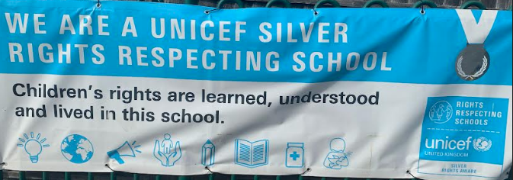

Rights Respecting School Update – Spring 2 2024
As we work towards obtaining our Gold Award the children and our Pupil Voice Representatives have been very busy over the past few weeks!
We started off this half term with a rights afternoon where the children focused on the article 17 “The right to have reliable information.” We have linked this with our school rule of “being safe.” We had an assembly about being safe online and the children did some follow up activities with their classes. At the end of this half term we will be having an afternoon across the school where we will looking at a new child safety initiative called “Clever Never Goes” which gives the children practical safety skills and confidence to engage with the outside world.
Our Pupil Voice Reps have been busy too! We have made lots of posters of children’s articles which we have been putting up all around our school and in our classrooms. See if you can spot some!
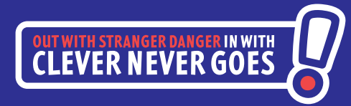
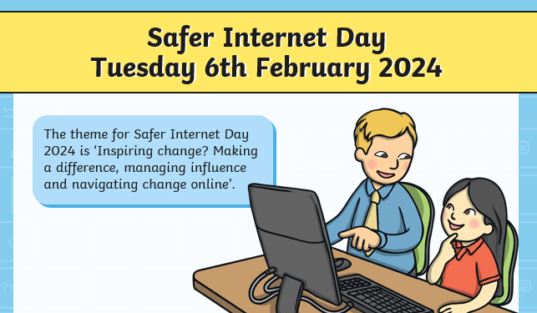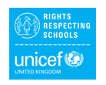
Mrs Heal

