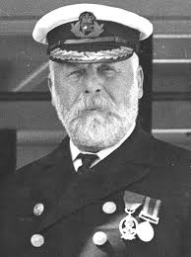
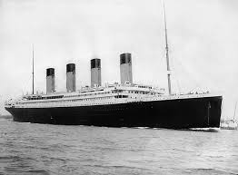
Year 3 Newsletter –
Autumn Term
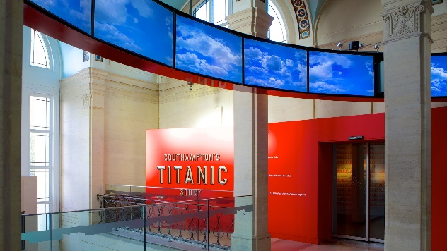
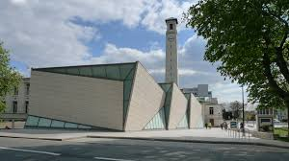
What we will be learning about this term:
What a wonderful start to the new academic year we have had! Welcome to year 3!
English – We will be writing our own versions of the stories “Leon and the Place Between”. The children will be learning to use expanded nouns phrases to create a setting description. We will be focusing on joining our handwriting and keeping it consistent and neat.
Reading – We will be focusing on developing our fluency and doing close reads of texts, thinking about the writer’s intent and what devices the writer uses. We will be reading the book ‘The lost spells’ by Robert Macfarlne and Jackie Morris.
Maths – We will be learning the place value of 3-digit numbers. We will begin to use the formal written methods for addition and subtraction with exchanging when necessary. The children will also be recapping the 2,5 and 10 times tables. If possible, please help support them by letting them access TT Rockstars at home.
Science – We will start the term by learning identifying and describing the functions of the parts of a flowering plant and identifying that animals and humans need the right types and amounts of nutrition in their diet.
Art – We will be studying the drawings by the artist Gustav Klimt. The children will begin to learn the artist and then use a range of lines to create tone and texture. The children will use a range of pencil grades before moving onto other materials such as chalk or oil pastels.
Design and Technology – We will be developing the importance of a healthy and varied diet. We are hoping to have a visit from a local baker who will tell the children about the bread making process. The children will then have the opportunity to try a range a range of different breads before designing and making their own bread roll.
History – We will be learning about the Titanic- We will start by placing the events of the sinking of the Titanic on a timeline, exploring the different classes on board the Titanic before finally examining evidence to consider who was to blame for the disaster.
Geography – We will be exploring mountains. We will consider what a mountain is, how they are formed and their physical features. Then, the children will look at how mountains impact the water cycle and how contour lines help us to understand mountain formations and the terrains. Finally, the children will then be planning a climb of Ben Nevis using an ordnance survey map.
PSHE – We will be learning about different aspects of keeping ourselves safe. The children will explore the terms ‘safe’ and ‘unsafe’ and identify situations which are safe and unsafe. We will also explore the terms ‘danger’ and ‘risk’. The children will come up with some suggestions about how we can keep ourselves safe. We will also explore how to keep ourselves safe online.
RE – We will be exploring the concept of ‘God’. The children will start by thinking about what a God is and the different types of Gods. The children will consider why God is important to many people from different religions. After term, the children will learn about Mary, the mother of God. They will consider how Christians show that they believe Mary is holy.
Computing – The children will be developing their understanding of digital devices, learning about inputs, processes, and outputs. Later in the term, the children will also be using ‘Publisher’ to help them become familiar with the term’s ‘text’ and ‘images’ and understand that they can be used to communicate messages. We will learn how font size, colour and type can improve documents.
Music – We will be listening to a range of African music. We will learn to perform together to create a simple repeated pattern and sing a well-known African call and response song using their voice in a controlled way.
PE – In outdoor PE, we will be developing our hockey skills focussing on controlling and travelling with the ball. Superstar sports coaches will be developing their gymnastic skills focussing on travelling in different ways and creating shapes using their bodies.
Spanish – We will introduce the children to the Spanish language by focussing on how to greet each other and say goodbye in Spanish. The children will also learn to ask and respond to ‘What is your name?’ and ‘How are you?’
Other – We will be creating our class charters and electing our Pupil Voice Representatives. Just before half term, we are hoping to have our trip to Sea City Museum – more details to follow. Southampton City Mission will also be coming in to hold a Question of Faith day to support the children’s learning in RE exploring the concept of God. Nearer to Christmas time, we will be making Christingles and we are hoping to visit St James Church in West End to take part in an ‘Experience Christmas’ workshop to explain and celebrate the Christmas story – more details to follow.

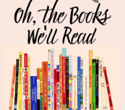
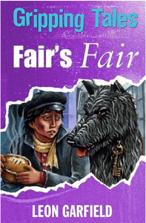
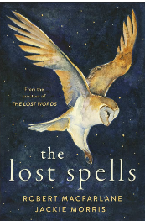
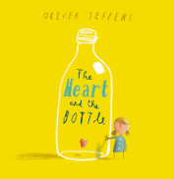
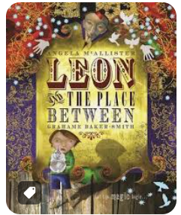
Thank you!
Thank you for all the amazing summer projects that have been handed in so far. From posters full of information about the Titanic to some amazing creative models of the ship itself. We appreciate you supporting your child’s learning and this will definitely help them get started with their history topic.
This term’s home-learning:
- Please can the children keep practicing their times tables.
- Read as often as possible and complete your child’s reading record book for them to bring into school. Ideally, we would recommend the children read at least 3 times a week at home.
Key Dates/ Other things to look forward to:
- Question of Faith day on God (Tuesday 15th October).
- Visit to Sea City Museum (Tuesday 22nd October - class 1 and Wednesday 23rd October – class 2) – more details to follow.
- Visit St James Church, West End (Friday 22nd November) – more details to follow.
- Visit from a local baker – date to be confirmed – more details to follow.

