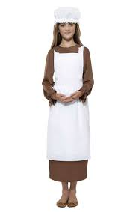
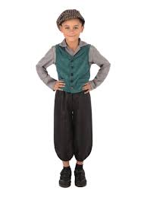
Year 4 Newsletter –
Autumn Term
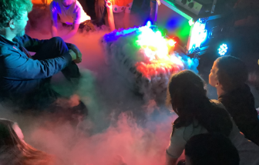
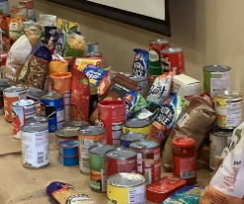
What we will be learning about this term:
What a wonderful start to the new academic year we have had! Welcome to year 4!
English – We will be writing our own versions of the stories “Tar Beach”, “The Mermaid of Zennor” and “The Dream giver.” We will be focusing on joining our handwriting and keeping it consistent and neat.
Reading – We will be focusing on developing our fluency and doing close reads of texts, thinking about the writer’s intent and what devices the writer uses. We will be reading the books, “Gregory Cool,” “Malala’s Magic Pencil” and “The Iron Man.”
Maths – We will be learning the place value of numbers up to a thousand and comparing numbers and putting them in order. We will learn about area and in particular rectilinear shapes. We will learn the multiples of 3, 6, 9, 11 and 12 and their inverse division facts.
Science – We will start the term by learning how to classify living things and rocks. We will be experimenting by making shadows and will also create our own classification branching databases.
Art – We will be studying the drawings by the artist Leonardo Da Vinci. We will be practising different shading, hatching and cross-hatching techniques and will use them to sketch mechanical objects in the style of Da Vinci.
Design and Technology – We will be learning about lots of different aspects of food safety. We will also be practicing using pivots, levers and linkages.
History – We will be learning about the Victorians – in particular Victorian education reform, washing, the industrial revolution and medicine. Watch out for our Victorian day in Autumn 2 when the children can dress up as Victorian children for the day!
Geography – We will be learning about natural disasters such as earthquakes and volcanoes and where most of them are located.
PSHE – We will be learning about different aspects of keeping ourselves safe and looking after our health and well-being. We also will be learning about personal space and internet safety with regards to images.
RE – We will be learning about the concepts of Rituals and Imagery.
Computing – We will be learning about data logging.
Music – We will be learning how to use the app “garage band” and digital music technology.
PE – We will be learning how to line dance. We will also be doing gymnastics, football attacking skills and improving our fitness.
Spanish – We will be learning how to talk about ourselves - Me Presento.
Other – We will be creating our class charters and electing our Pupil Voice Representatives. We will also have a visit from the “Explorer Dome” and will learn about the Earth (see photo). We will be making Christingles nearer to Christmas time.

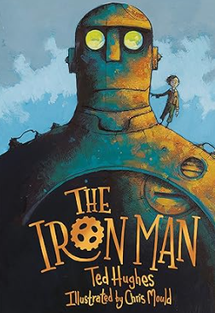
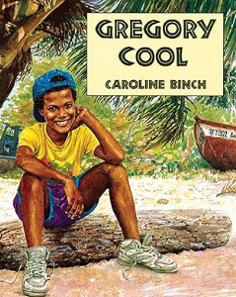
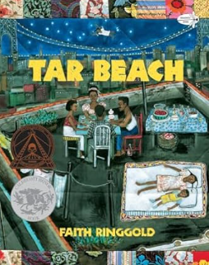
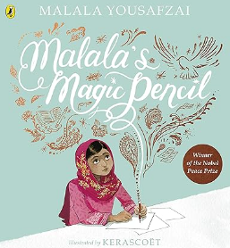

This term’s home-learning:
- Please can the children keep practicing their times tables. There will be a multiplication check at the end of the year.
- Keep reading your library books and bring them in to be changed – we go to the library weekly.

Key Dates/ Other things to look forward to:
- Question of Faith day on Rituals (September 24)
- Victorian theme dress up day (Wednesday 13th November)
- Science Explorer Dome (Autumn 2)

