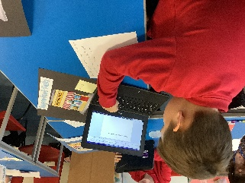
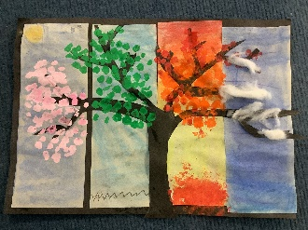
Year 5 Newsletters –
Autumn Term
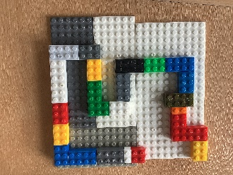
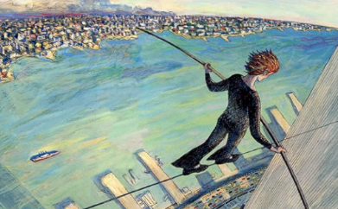
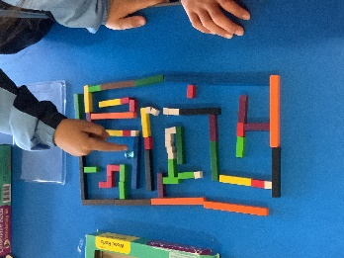
What we will be learning this term:
English – We will be writing an information text about Phillipe Petit, a memoir of Katherine Johnson and a science fiction story based on the text Robot Girl.
Reading – We will be focusing on developing our fluency. We will read the books, The Man Who Walked Between the Towers, The Girl Who Walked on Air, Everest, Hidden Figures, Robot Girl and The Giant’s Necklace.
Maths – We will be learning to use roman numerals, the place value of numbers up to a million and comparing numbers and putting them in order. We will also be learning about multiples, factors, prime numbers, square and cube numbers. Before moving on to, addition, subtraction and multiplying by 10, 100, 1000. Finally, we will look at equivalent fractions and converting improper fractions.
Science – We will start the term by learning about a variety of different life cycles. We will then investigate which solids dissolve in water and ones that don’t. We will also be learning about how the Earth moves around the sun, gravity and air resistance.
Art – We will be studying the sketches done by the artist Paul Cezanne. We will be practising different shading techniques and will use them to sketch a still-life of fruit and vegetables.
Design and Technology – We have designed and made a maze using cardboard and pieces of wood that we have cut ourselves.
History – We have been learning about the Tudors that lived in Tudor House.
Geography – We have been learning about the five major biomes and the weather, climate, vegetation and wildlife that live there.
PSHE – We have been learning about different aspects of keeping ourselves safe and looking after our health and well-being.
RE – We have learning about the concept of Rituals and Faith.
Computing – We have been learning to make a Multi-media video.
PE – We have been learning a street dance. We have also been doing gymnastics, football attacking skills and improving our fitness.
Music – We have been learning to compose a piece of music using digital technologies.
Spanish - Weather- Que Tiempo Hace?
This half term’s optional home-learning project:
Project about the solar system using their art skills of 3D objects.

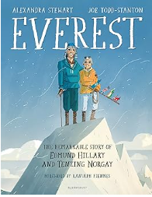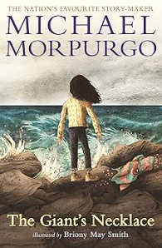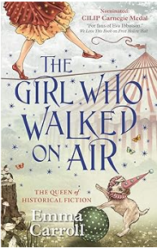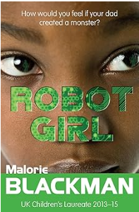
Key Dates
Thursday 3rd October Poetry day
Wednesday 9th and 10th October Parents evening
Tuesday 22nd October Harvest assembly
Wednesday 23rd School Disco
Things going on
Wildgrounds Day: Making biomes in a box, mud masks, fire building and frame making.
Walk the Walls in Southampton to look at the impact of the Tudors.

