Welcome to Reception! We’re so excited to have you and can’t wait to share all the fun activities we have planned this term.
We do our best to support all the children through their transition into school and are here to talk if ever you need us. No matter how big or small.
Year R Newsletters – Autumn Term
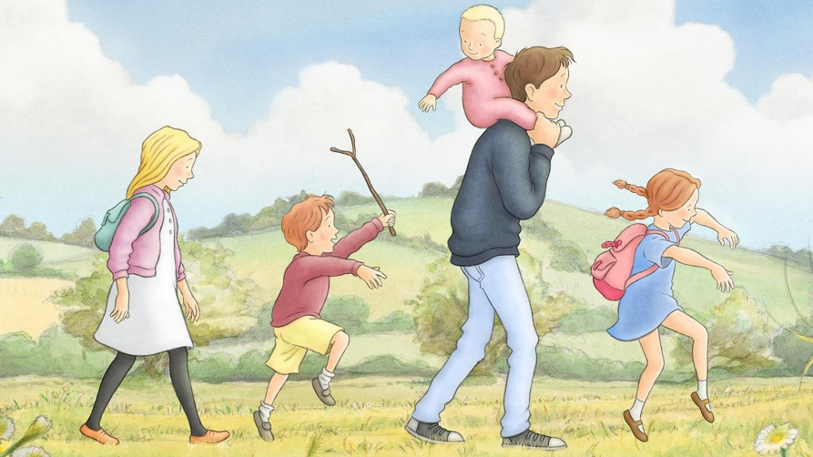
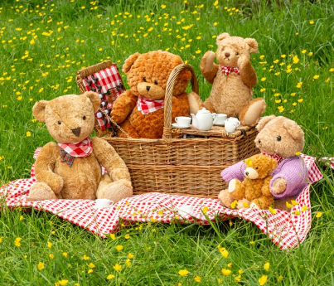
This half term - Autumn 1: Ready, Teddy, Go!
This half term children will learn the Reception rules, routines, and expectations in our classrooms. We will learn about British Values and how we all have rights. We’ll discuss a few key rights from the UN conventions Rights of the Child and make a class charter. We will talk about the days of the week and sequence our daily events during our morning meetings and practise our name recognition and writing daily as part of self-registration.
We will learn about each other and create family portraits to share with the class, talking about our similarities and differences. We will read ‘Brown Bear, Brown Bear, What do you See?’ By Bill Martin Jr. and create our own class books based on the story, using our own pictures instead of the animals. We’ll also read ‘Polar Bear, Polar Bear, What do you Hear?’ By Bill Martin Jr., creating sounds to go along with the story using our voices.
We will read the book ‘We’re Going on a Bear Hunt’ by Michael Rosen and create landscape pictures using different textures. We will create simple maps of the school and go on a bear hunt around the school grounds! We’ll also read other versions of the story including ‘We’re Going on a Lion Hunt’ by David Axtell and ‘We’re Going to Find the Monster’ by Malorie Blackman, creating sounds to go along with the stories using instruments and body percussion.
We will read ‘Goldilocks and the Three Bears’ and talk about the differences in size, using the compare bears as supporting manipulatives. We will learn the song ‘The Teddy-Bear’s Picnic’ by Henry Hall and go on a teddy bear’s picnic in our forest school, looking for signs of autumn.
We will also sing number nursery rhymes up to 5 such as ‘5 Little Ducks’ and ‘1 man and his dog’, counting forwards and backwards.
We’ll begin Little Wandle Phonics, learning Phase 2 sounds.
We have story time daily to enrich our curriculum with a wide range of vocabulary. These stories are as well as our key texts, which we read multiple times throughout the week until we know them off by heart. Our books this half term will focus on: families, bravery, belonging, nursery rhymes, bears, diversity & inclusion.

Next half term - Autumn 2: Colour and Light
This half term children will learn about different emotions using the book ‘Colour Monster’ by Anna Llenas, and about some of the things we can do to keep our bodies mentally and physically healthy. We will learn about our right to have freedom of thought and religion.
We will read ‘Pete the Cat: I love my white shoes’ by Eric Litwin and practise using the correct colours for the pictures we create. We will learn how to create 3D models, using the book ‘Elmer’ by David McKee as inspiration to make junk modelling and collage elephants.
We will learn about some of the special celebrations which take place at this time of year: Diwali, Guy Fawkes, Hannukah and Christmas, reading a range of fiction and non-fiction books. We’ll look at how these are celebrated including the use of fireworks and lights. We’ll create fireworks pictures using 2D shapes and Christmas artwork involving ABA patterns. We will also experiment with a light box and shadows. We will visit St James’, our community Church, and learn why it’s a special place to Christians.
We will explore the concept of whole and part when talking about numbers and sing nursery rhymes up to 10 such as ‘10 in the bed’ and ‘1 elephant went out to play’. We’ll also practise singing songs for our Winter Concert and then perform in costume!
We’ll use our Phase 2 sounds to help us write letters to Santa, then walk to the Taunton Drive post box to send them to the North Pole.
We have story time daily to enrich our curriculum with a wide range of vocabulary. This half-term we will have lots of fiction and non-fiction stories available, including books about: different festivals and celebrations, colour, imagination, art & creativity, seasons and emotions.



Key Dates
- 9th-20th September – Transition Weeks
- Friday 20th September – Letters going home with confirmed Class, Teacher & TAs.
- Monday 23rd September – First ‘official’ week of school!
- Week of 7th October – Parent’s Evening to let you know how your children have settled
- Thursday 24th October – Curriculum Day: Teddy Bears’ Picnic. More information to come.
- Friday 25th October – INSET – school is closed to students.
- 26th October – 3rd November – HALF TERM
- Monday 4th November – First day back at school
- Friday 29th November – Trip to St James’ Church
- 21st December – January 5th – WINTER BREAK
- Monday 6th January – First day back at school

Keep an eye out for Seesaw login information.

