Autumn Term

Class Welcome
Morris Class have had a wonderful first term back. Our highlights have included exploring the new sensory room, swimming and taking part in our community visits. We enjoyed a fantastic trip on an adapted canal boat along the River Stort, and this week we were excited to watch the Harlow pantomime. We have now started our Christmas activities and can’t wait for you all to join us for our Merit Assembly.
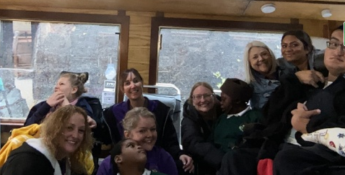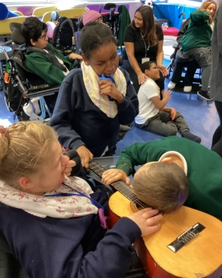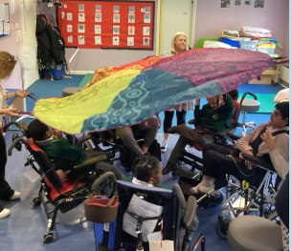

Communication and interaction

In our communication and interaction sessions, we have been enjoying sensory stories, massage stories, TacPac and our phonics activities. We love exploring a range of sensory items and choosing our favourites. Some of us are drawn to the different smells, while others prefer items we can explore with our hands. TacPac sessions continue to be a wonderful way to start the day, offering us a gentle sensory experience that promotes engagement and wellbeing.
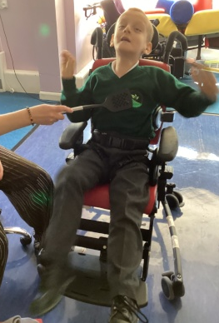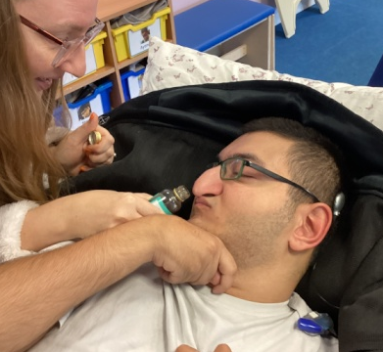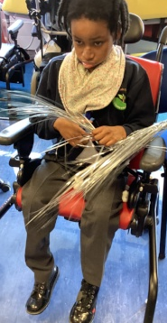

Cognition and Learning
In our cognition and learning sessions we have explored so many exciting activities this term. We have been developing our cause-and-effect skills through switch work, taking part in hands-on maths experiences, and engaging with music and sensology to deepen our understanding of the world around us. Each activity has been thoughtfully linked to our topic of ‘Feelings,’ helping us explore our emotions through sound, touch and interactive play.
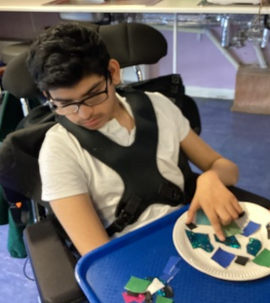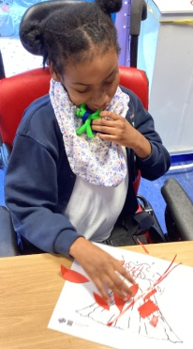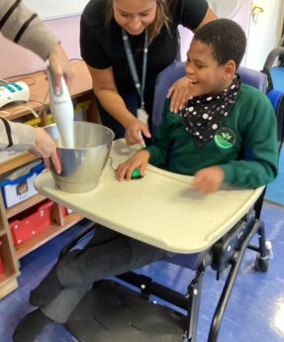

Independence, social and emotional development
In our independence, social and emotional sessions we have been building important everyday skills. The pupils have been developing their self-care routines during hygiene activities, practising washing, brushing and becoming more confident with familiar bathroom tasks. Our community visits have helped us explore new environments, meet new people and practise social skills in real-life situations. In food tech, we have enjoyed exploring ingredients, making simple recipes and experiencing different tastes and textures.

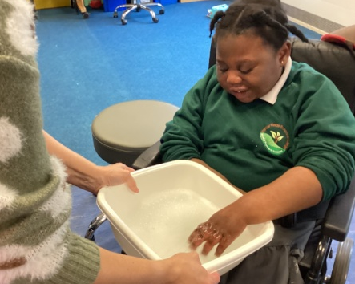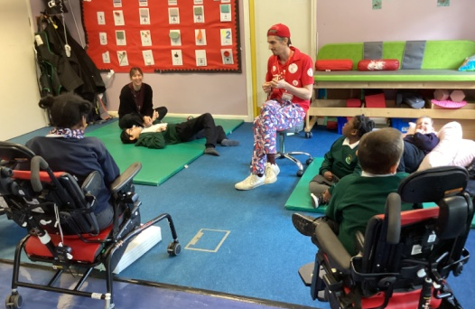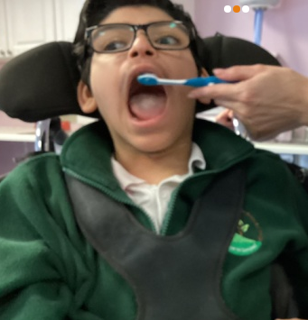

Physical and Sensory
In our physical and sensory sessions Morris Class have been fully engaged in a wide range of activities. During PE we have enjoyed parachute games that encourage movement, teamwork and lots of smiles. Swimming has given pupils the chance to relax, stretch and experience the water in a calming, supportive environment. Our art sessions have been linked to our topic of ‘Feelings,’ giving pupils the chance to explore emotions through colour, texture and creative mark-making. Reflexology has provided gentle sensory input to support regulation and wellbeing, and we have also loved spending time in the sensory room, where lights, sounds and tactile resources help us to relax, explore and engage at our own pace. Pupils have also been working on their individual physiotherapy programmes, helping them build strength, improve mobility and develop confidence in their physical skills.
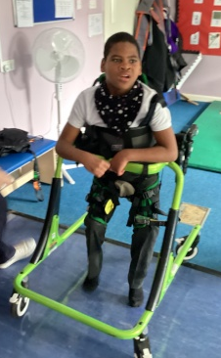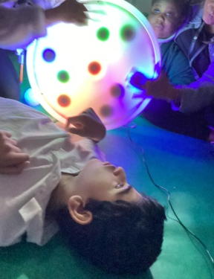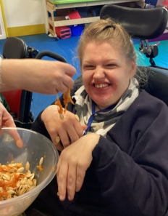

Special news and upcoming events
Christmas Jumper & Dinner Day - Friday 12th December
Merit Assemblies PMLD: Thursday 18th December, 2pm
Christmas Grotto - Wednesday 17th December
Harlow Brass Band - Friday 19th December
End of Term – Friday 19th December 1.30pm

From all of us in Morris Class, we wish you a very Merry Christmas and a wonderful 2026.

