Earwig for parents & carers | Earwig Academic Special Schools & SENCOs Software
Earwig for parents and carers
Welcome to Earwig.
If you’re here, it’s probably because you have received a message from your child’s school to let you know that they use the Earwig system to track pupil progress and would like to share some of this information with you.
‍
As part of the process of capturing teaching evidence to monitor performance in the school, teachers notes on how your children are progressing and take lots of photos or videos. When these notes and media are organised into a timeline, they form a valuable record of each child's learning journey and help with moderating standards and reassuring Ofsted.
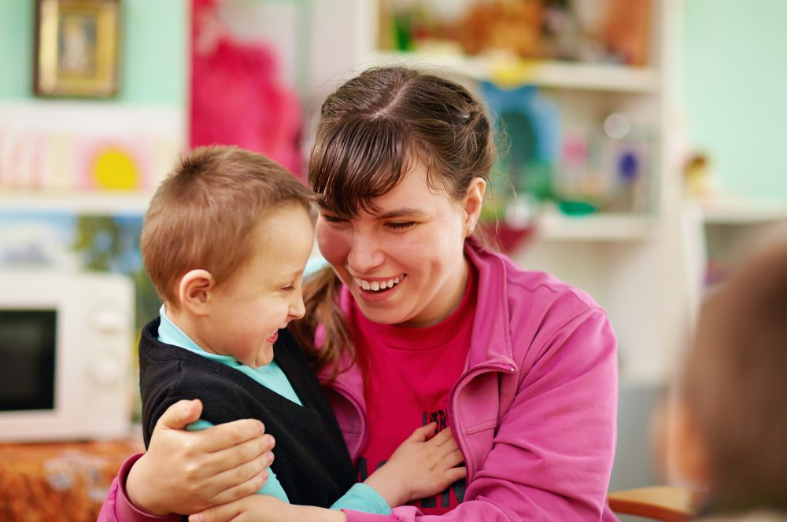
The school also recognises the importance of engaging you, the parents, carers and guardians in the education of the children under your care. The more integration there is between learning in school and learning at home, the better the children will do, especially children with special needs.
‍
The Earwig system allows your child’s school to share selected images, video and documents created during the school day with you. You will see these encapsulated in an ‘Earwig record’. Each of these records provides context for the image, video or document. It will usually include commentary from the teacher and other information about how that pupil did on that occasion. These records are presented as a timeline so you can see your child’s progress over the school year.
‍
Alternatively, you can view the images, videos and documents in your own ‘Earwig gallery’ where you can download high resolution copies and even order prints of these if you wish.
‍
Your ‘Welcome to Earwig’ email will contain your login details. These will allow you to access your child’s timeline and gallery online, through any browser or through the Earwig parent app. To activate the app on any handheld device, just go to the App Store and search ‘Earwig Parents'.
‍
You can comment on individual records and discuss these with the teacher in a chatbox. You can also use photos and videos of learning and achievement at home to create your own Earwig records to add further to the information and value of your child’s learning journey.
To see an example of a parent timeline, go to https://earwig.uk.com and log in using 'example@lhdemo.parent' and 'password'.
Read more on homeschooling or EOTAS
How safe is it?
SAFETY IS THE PRIORITY - For any system dealing with images of children, safeguarding is a key priority. The whole Earwig system is closed user group and no-one gets in without a login approved by the school. You can see Earwig's Child Protection Policy here.
‍
Parents can only see records tagged to their own children and any children who are ‘no photos’ for any reason are automatically excluded.
‍
How will my child benefit?
SUPPORTING THEIR LEARNING - Research suggests that strong parent engagement in learning can improve performance by up to 15%. This is because knowing that parents and teachers are in sync makes children feel secure and the reinforcement of messages and learning activities helps children to improve faster.
ADDING HOME OBSERVATIONS - Capturing evidence of what your child is doing at home to support their learning at school also helps provide and all-round view of their progress and achievements and gives school staff and other professionals a better view of their capacities and achievements.
‍
How much will it cost me?
EARWIG FOR PARENTS IS FREE - Access to the pupil timelines, including images and video, is free to parents while your child is at that school. You can also download low resolution images to your heart's content.

To view an example of a parent account
Go to https://earwig.uk.com and log in using 'example@lhdemo.parent' and 'password'.
Example of a parent log in:
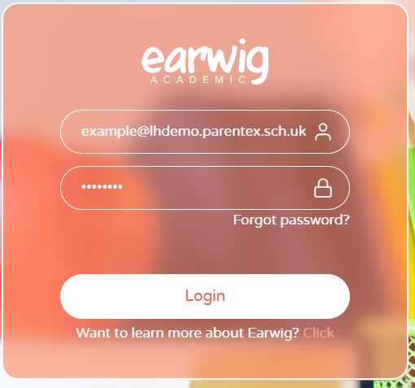

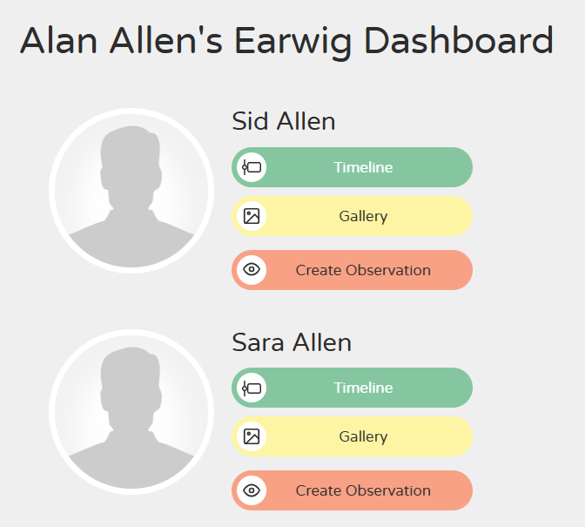

Viewing the timeline and writing a comment
Click the green ‘Timeline’ button to view your child’s timeline.

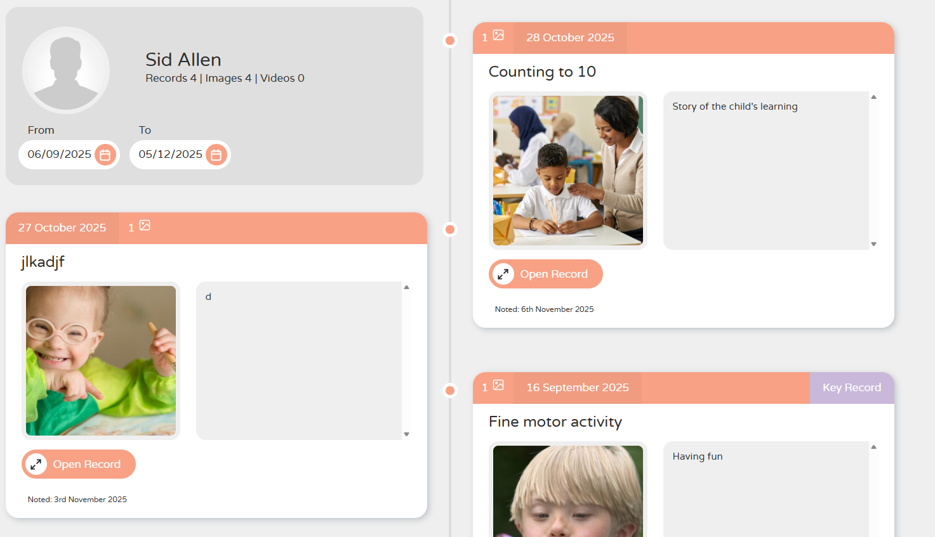
Click ‘Open record’.
Click ‘Conversation’.

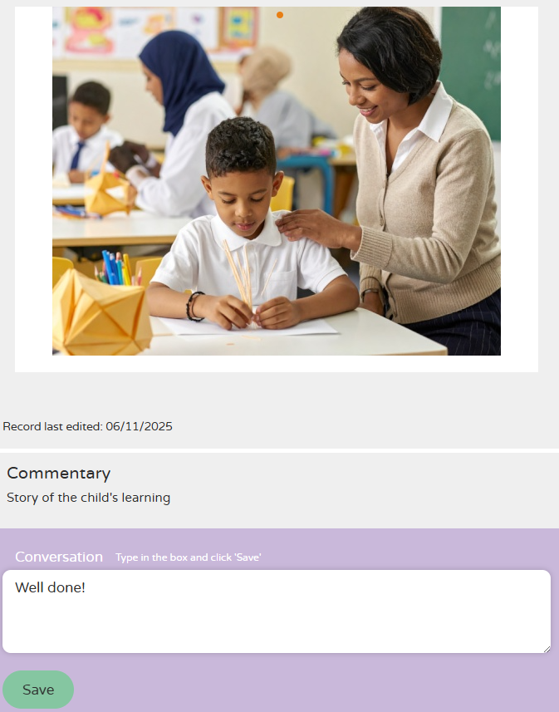
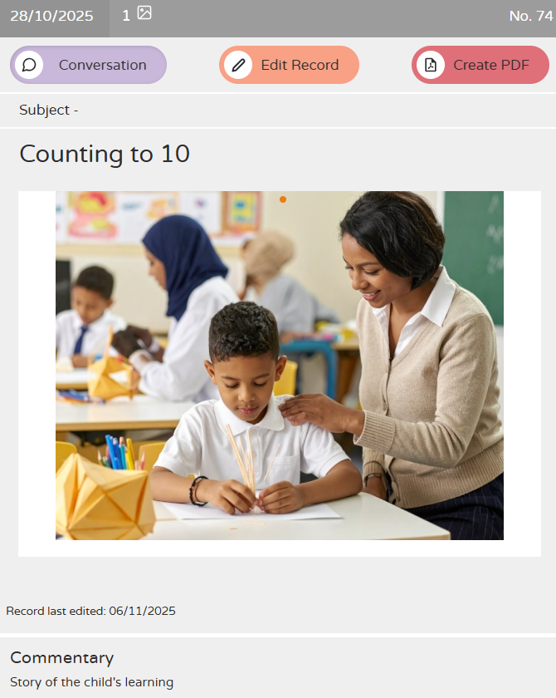
Type your comment in the box, then click ‘Save’.
Viewing all images
Click the yellow ‘Gallery’ button to view your child’s photos.

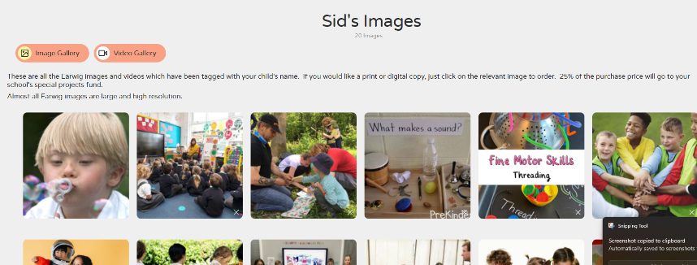

You can view your child’s photos without the commentary.

Creating an observation

Click the orange ‘Create Observation’ button to post on your child’s timeline.

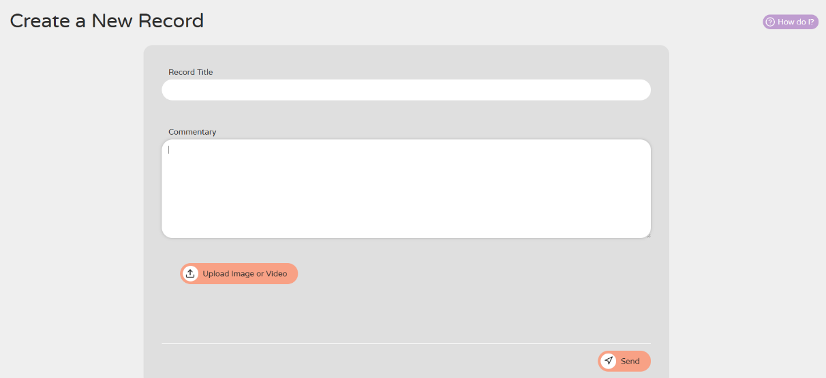

Click the ‘How do I?’ button if you need further guidance.

Type the commentary and upload any images or videos you would like to add (you do not have to include photos/videos, it can just be text).
Click ‘Save’ when you are finished.

