Harrow Lodge Primary School



PLAY POLICY


DUE FOR REVIEW: February 2027

RESPONSIBLE PERSON(S): MS CLARKE

INTRODUCTION

At Harrow Lodge Primary School, we aim to create a welcoming, caring environment where relationships are based on the value of respect and aim to develop positive self-esteem in each child. The opportunity to build good relationships through play and break times and lunch times is fundamental to each child’s happiness, well-being and successful learning. All staff are committed to maintaining high expectations of play as an essential contribution to the educational experience at Harrow Lodge Primary.
At Harrow Lodge Primary we recognise that play is an essential part of a happy and healthy childhood. As a school, we endeavour to provide consistently high quality, sustainable play opportunities for all children. These inclusive opportunities in play are achieved by offering carefully considered outdoor spaces, equipment and toys that offer a rich choice of accessible play experiences for every child. We believe that play helps to create children who are independent, confident, imaginative, adaptable, social and able to assess risks.

1. COMMITMENT

Harrow Lodge Primary undertakes to refer to this play policy in all decisions that affect children’s play. Our school is committed to providing the strategic and operational leadership needed to provide and maintain quality play provision for all of our children.

2. RATIONALE

At Harrow Lodge Primary, we believe that all children need opportunities to play that allow them to explore, manipulate, experience and affect their environment. We believe play provision should be welcoming and accessible to every child, irrespective of gender, sexual orientation, economic or social circumstances, ethnic or cultural background or origin, or individual abilities.

The OPAL Primary Programme rationale is that “… better, more active and creative playtimes can mean happier and healthier children, and having happier, healthier, more active children usually results in a more positive attitude to learning in school, with more effective classroom lessons, less staff time spent resolving unnecessary behavioural problems, fewer playtime accidents, happier staff and a healthier attitude to life.”

At Harrow Lodge Primary the opportunity to develop play opportunities also enables our children to live our core values in a number of different ways at break times and lunchtimes. The way that they conduct themselves inside the classroom, by demonstrating our school values, is replicated in the way that they play together.

RESPECT – respecting the boundaries that are put in place and to respect the equipment that the children have opportunities to use. Respect for other children when they are playing with equipment.

EMPATHY – playing with children of all changes will build an understanding of all ages and stages.
ASPIRATION – imaginative and creative playtimes will lead to happier children which will result in a more positive attitude to learning and better attainment in lessons.
CONFIDENCE – having the confidence to try something new and to develop confidence in taking risks. Creative play develops children’s social interaction skills, basic communication skills and confidence.
HONESTY – creative play allows children to express their emotions and feelings. Through this they’ll be able to articulate their thoughts and feelings more easily as they grow up.

3. DEFINITION AND VALUE OF PLAY

Play is defined as a process that is intrinsically motivated, directed by the child and freely
chosen by the child. Play has its own value and provides its own purpose. It may or may not
involve equipment or other people.

We believe play has many benefits, including:

- Play is critical to children’s health and wellbeing, and essential for their physical, emotional, social, spiritual and intellectual development.
- Play enables children to explore the physical and social environment, as well as different concepts and ideas.
- Play enhances children’s self-esteem and their understanding of others through freely chosen social interactions, within peer groups, with individuals, and within groups of different ages, abilities, interests, genders, ethnicities and cultures.
- Play requires ongoing communication and negotiation skills, enabling children to develop a balance between their right to act freely and their responsibilities to others.
- Play enables children to experience a wide range of emotions and develop their ability to cope with these, including sadness and happiness, rejection and acceptance, frustration and achievement, boredom and fascination, fear and confidence.
- Play encourages self-confidence and the ability to make choices, problem solve and to be creative.
- Play maintains children’s openness to learning, develops their capabilities and allows them to push the boundaries of what they can achieve.

4. AIMS

In relation to play our school aims to:
● Ensure play settings provide a varied, challenging and stimulating environment.
● Allow children to take risks and use a common-sense approach to the management of these
risks and their benefits.
● Provide opportunities for children to develop their relationships with each other.
● Enable children to develop respect for their surroundings and each other.
● Aid children’s physical, emotional, social, spiritual and intellectual development.
● Provide a range of environments that will encourage children to explore and play
imaginatively.
● Provide a range of environments that will support children’s learning across the curriculum
and learning about the world around them.
● Promote independence and teamwork within children.
● Build emotional and physical resilience.

5. RIGHTS

Our school recognises the UN Convention on the Rights of the Child, which includes the right
to play, recreation and leisure (Article 31) and the right of children to be listened to on matters
important to them (Article 12). We acknowledge that we have a duty to take these rights
seriously and listen to children’s views on their play.

Alongside the rights of the children, we want all children to follow the school core values and
also to aspire at break times and lunch times to the school’s vision of ‘Challenge for all,
achievement for all.’ It is our belief that all children can aspire to this at Harrow Lodge Primary.
Children’s achievements at break times and lunch times will be acknowledged and
highlighted to show the value of good play.

6. BENEFIT AND RISK

‘Play is great for children’s wellbeing and development. When planning and providing play
opportunities, the goal is not to eliminate risk, but to weigh up the risks and benefits. No child
will learn about risk if they are wrapped in cotton wool.’
Managing Risk in Play Provision: An Implementation Guide (Play Safety Forum, 2012)

The school will use the Health and Safety Executive guidance document Children’s
Play and Leisure – Promoting a Balanced Approach September 2012 (Appendix 1) as the
principal value statement informing its approach to managing risk in play.

Our role as play providers is to facilitate the maximum amount of enriching opportunities for
children to encounter. They need to learn to manage risk for themselves in an environment
that is as safe as it needs to be, rather than completely devoid of risk. The benefit to
children of challenging play opportunities should be balanced with any potential risk when
carrying out risk assessments. We will adopt a risk-benefit approach and will practice
dynamic risk management (Appendix 2) to manage our duty of care to protect and provide
for our children’s needs. This approach will encourage the children to identify and manage
risks in an environment where adults are present to support this.

Risk-taking is an essential feature of play provision and of all environments in which
children legitimately spend time at play. Play provision aims to offer children the chance to
encounter acceptable risks as part of a stimulating, challenging and managed play
environment. As outlined in the play sector publication ‘Best Play’, play provision should
aim to ‘manage the balance between the need to offer risk and the need to keep children
and young people safe from harm’.

7. SUPERVISION

The law requires that children in school have supervision but for primary school playtimes
there are no stated ratios. During the school day there should be one or more adults present
outdoors. The school recognises OPAL’s three models of supervision: Direct, Remote and
Ranging. Except for new children in reception, whose skills and orientation in the school
environment need to be assessed, the school does not believe direct supervision is possible
or beneficial. Supervisors will use ranging and remote supervision models, so that children
can quickly find an adult and adults can patrol large sites to gain an awareness of the kinds
of play and levels of risk likely to be emerging.

The structure of Harrow Lodge Primary Play Team is as follows:
- Head Teacher
- The Curriculum Lead for Play (DHT) – Leads on strategy
- Play Co-ordinators x 2 – Leads on operational delivery
- Play Champion Governor/Parent
- The Play Workers (MDAs)

8. THE ADULT’S ROLE IN PLAY

The school will help children maximise the benefits they can gain from play by the provision
of trained staff who are informed by and work in accordance with the Playwork Principles.
(Appendix 3) Staff will use and refer to these principles when appropriate interventions are
needed, and ultimately will strive for facilitating an environment that nurtures children’s self
directed play.

The playworker’s core function is to create an environment that will stimulate children’s play
and maximise their opportunities for a wide range of play experiences across the 16 play
types. (Appendix 4) A skilled and experienced playworker is capable of enriching the child’s
play experience both in terms of the design and resources of the physical environment and
in terms of the attitudes and culture fostered within the play setting. Playworkers are a
channel of access to new materials and tools and they can act as a stimulus to children to
explore and learn. They are also available to participate in the play if invited.

9. EQUALITY AND DIVERSITY

Through providing a rich play offer meeting every child’s needs we will ensure all children,
regardless of age, gender, race, disability or other special needs, can develop and thrive,
build strong relationships and enjoy school.

10. ENVIRONMENT

We believe that a rich play setting should ensure that all children have access to stimulating
environments that are free from unacceptable or unnecessary risks and thereby offer children
the opportunity to explore for themselves through their freely chosen play.

We will strive to continually improve the quality and diversity of our school’s grounds to
enhance play. We will use the document ‘Best Play’ to guide us on what a quality play
environment should contain

APPENDIX 1 – Children’s Play and Leisure – Promoting a Balanced Approach

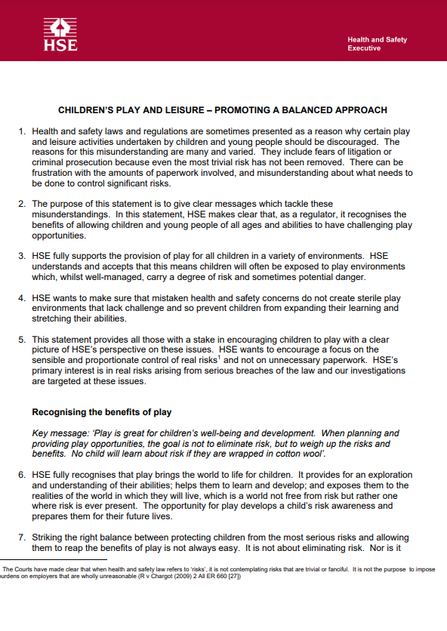
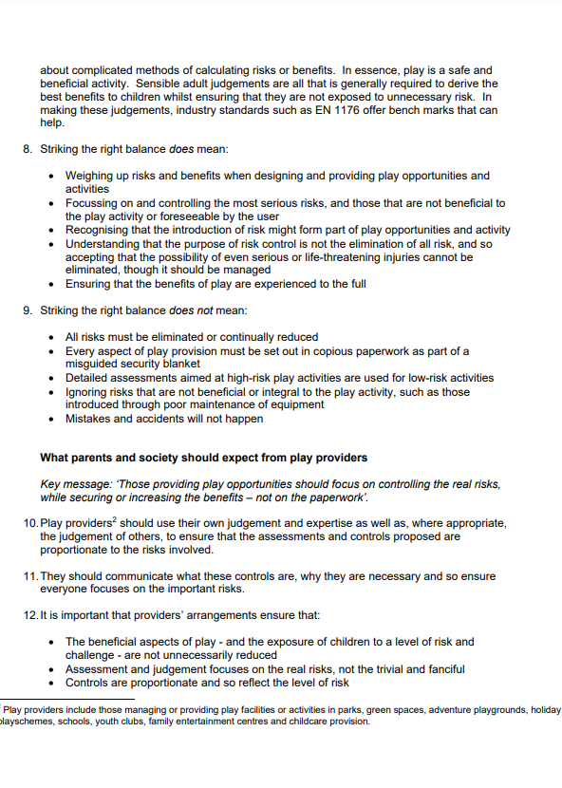
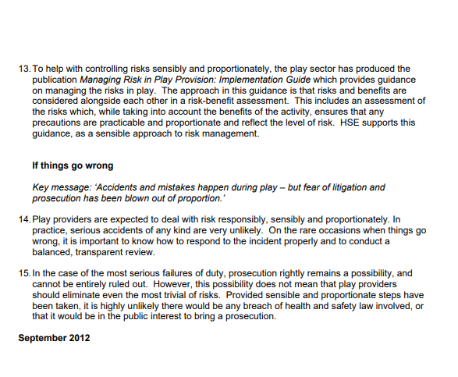

APPENDIX 2 – Benefit Risk Assessment Record Sheet

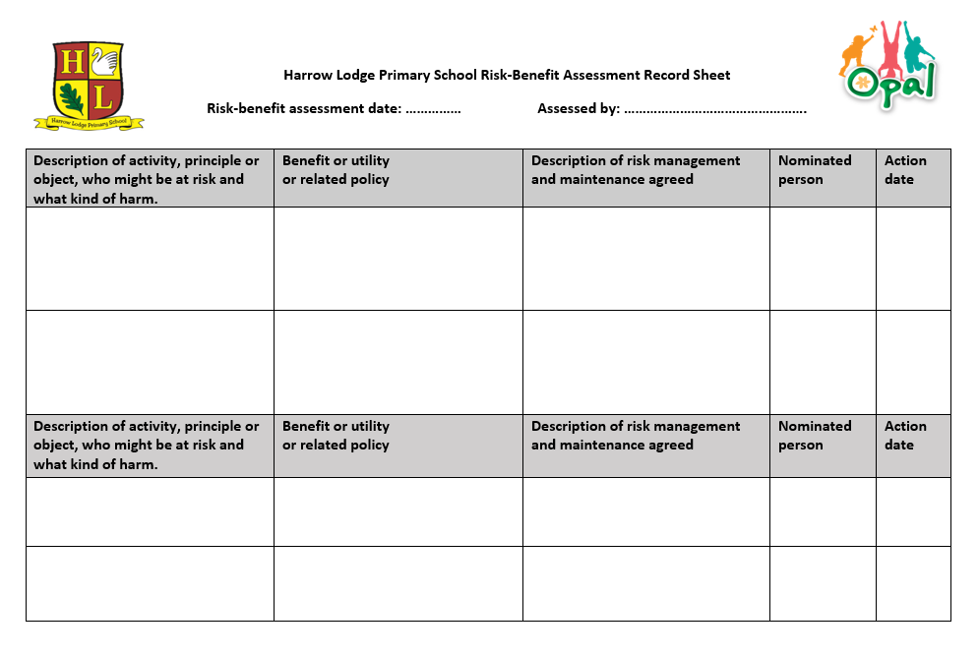
APPENDIX 3 – Playwork Principles

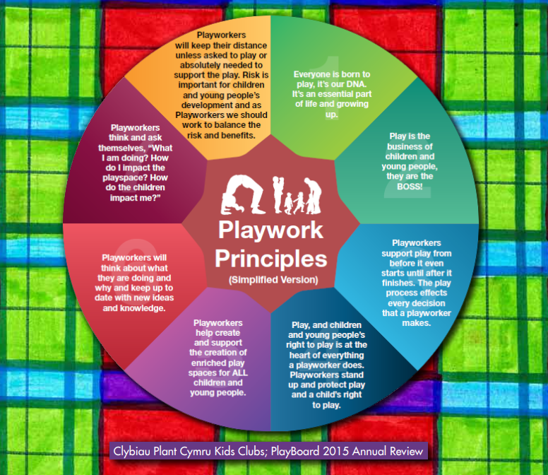

APPENDIX 4 – 16 different play types

