
Welcome to Year 6
Your child is going to be in 6JA.
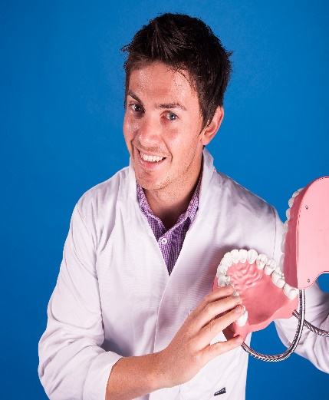
My new teacher is Mr Adams.


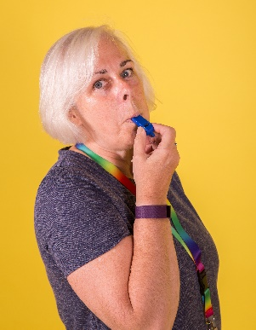

The teaching assistants in year 6 are Ms Oates and Mrs Matthews
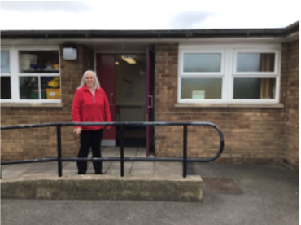  The door into school. | 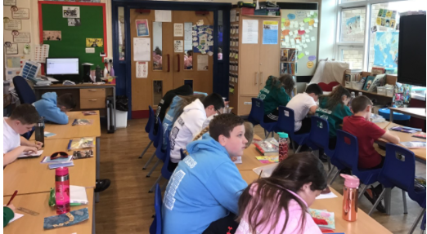  This is my new classroom.
The school door opens at: 8.45am The end of the school day: 3.15pm
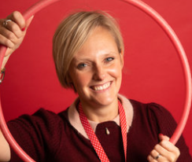


Mrs Galt- Principal Mrs Holloway – Vice Principal

